Career/ PSE Guidance Newsletter Scholarship & Bursary Reminder!
Grads are encouraged to visit the District Scholarship site
every week. http://aesdscholarships.weebly.com/
Here are some scholarships that Trimble and MHS students have frequently received (application forms available from Ms. W. or aesdscholarships.weebly.com/):
Name | Due Date | Amount | Specific Criteria
Great Moncton Women’s Progress Club | May 1 | $500 | Females going to college or university
Hugh MacKay/James MacMurray | May 1 | $3500 (renewable) | Business student attending Maritime university
Oulton College Memorial Scholarship | May 1 | $1000 | Future Oulton College student
Outdoor Enthusiasts | May 1 | $200
St. James Gate Travis Theriault Memorial Scholarship | May 1 | $1000
Cdn. Federation of University Women | May 4 | $1200 | Females going to university
Alana Greene Memorial Bursary | May 15 | $500 | Female going to Crandall University
Rotary Club of Moncton Memorial Scholarships | May 15 | $1500 | James Roberts – HTHS student  Ralph Fitch – MHS students
Royal Cdn. Legion Moncton Branch #6 | May 15 | $1250 (x 12!)
Magnetic Hill Lions Club | May 22 | $500 | Must live in Mag Hill area
NBCC Foundation Scholarship | May 27 | $1000 | Future NBCC student
NB Command Royal Cdn. Legion | July 15 | Not specified
Open Scholarships Each high school selects recipients to many local scholarships. To be considered, complete this application and return to Ms. Williams by the due date.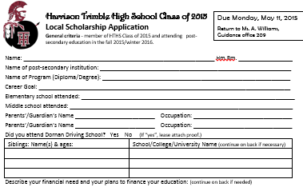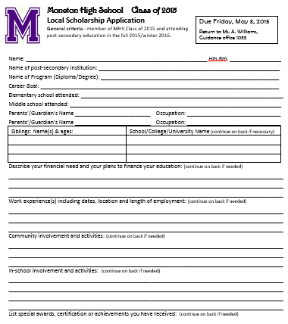

Student Loan Information Session
HTHS Tuesday, May 5
MHS Thursday, May 7
Time: lunch hour
See Ms. W. to register
www.studentaid.gnb.ca/

Open Scholarship is
found on the District Scholarship site under
Local Area Scholarships.

