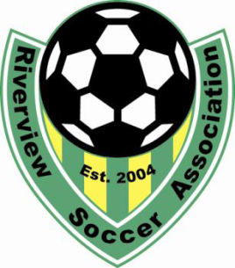
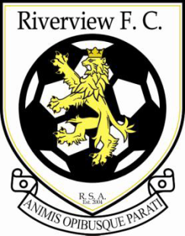
RIVERVIEW SOCCER ASSOCIATION
UPCOMING EVENTS
PLAYER REGISTRATION
If you are born in 2013 and earlier, you are eligible to play soccer with RSA
On-line Registration at riverviewsoccer.com
In person registration at the Chocolate River Station
April 29rd & May 13th From 9 am – 1 pm
Tryouts: Competitive teams, U10 to U18
Players MUST be registered with Riverview Soccer to be eligible to participate in tryouts. Players can register online or at one of the in person registrations. There will be no player registrations for the season taken at tryout times. There is a tryout fee that has to be paid prior to stepping on the pitch. Players are encouraged to attend all sessions, so the evaluators can have the best opportunity to evaluate each player. Again this season the tryouts will be held at the Moncton Sports Dome on Russ Howard Drive.
**** Please arrive half an hour prior to your session to sign-in and pay tryout fee
ESL Division 1: FEE $40
Tryout Schedule
May 01 6-7 pm U10B May 02 6-730 U12G May 04 6-730 U12B & U14B
7-8 pm U12B 730-9 U14G & U16/18G 730-9 U16/18B
8-9 pm U14B
May 08 6-7 U12G May 09 6-7 U10B May 11 6-730 U12G & U14B
7-8 U12B 7-8 U16/18G 730-9 U14G
8-9 U14G 8-9 U16/18B

*** should players chose to try out for more than one division 1 team, they will be required to pay an additional $40 Tryout fee

For further information
riverviewsoccer.com or riverviewsoccer2014@gmail.com

