Say Goodbye to Picky Eating!

Do you have a picky eater at home? If mealtimes are a struggle, try these tips to help your child develop better eating habits. It’s never too late to start having a healthier and more enjoyable family mealtime!

**There is a division of responsibility..**

**The Parent’s job is to decide:**

**What, When and Where.**

**What** food and drinks are served at meals and snacks. Make only one family meal. Use Canada’s Food Guide when planning meals. **When:** Offer meals and snacks at the same time every day. Your child is more likely to try new foods when he is hungry at meal time.

**Where:** Children eat better when the family eats at the table together.

**The Child’s job is to decide:**

**If and How Much.**

**If** he is going to eat. Your child will eat if he is hungry. Even if it’s not the favorite foods. Try not to worry, your child will not starve himself.

**How Much:** Let your child trust his tummy.Your child knows when he is hungry or full.

Healthy Schools = Better Learners

Healthy Students = Better Learners

Nutrition Basics for the School Year

Choose lean **meat** and **alternatives.**

**Your child will eat better and be more willing to try new foods if he sees others at the table eating the same foods. Family members, including other siblings, are important role models for healthy eating.**

***Support your child, eat meals together! Having meals with your child can help start a lifelong healthy habit.***

Vitalité Health Network, Public Health, Moncton References: <http://www.dietitians.ca/>, <http://www.eatrightontario.ca>

**\*\*Please know that the term “he” applies to boys and girls**

Be a role model

Choose lower fat **milk** and **alternatives.**

Is your child a Picky Eater?



Choose **vegetables** and **fruit** prepared with little or no added fat, sugar and salt.

Healthy Eating Tips

Choose **grain products** higher in fibre and lower in fat, sugar and salt.

Healthy Students = Better Learners

**Funny Face Pizza**

Ingredients:

1 Whole wheat English muffin

2 Tbsp (30 mL) Sodium reduced pasta or pizza sauce

¼ cup (60 mL) Grated part skim mozzarella cheese

2 Small green pitted olives, cut in half

Half Red bell pepper, sliced

¼ cup (60 mL) Grated carrots

Directions:

1. Split English muffin in half and place on small baking pan. Spread each with sauce.
2. Sprinkle each with cheese and place 2 olive halves on each muffin for eyes. Use 1 red pepper slice on each for a mouth.
3. Place in 350 degrees F (180 degrees C) toaster oven or oven for about 5 minutes or until cheese is melted and English muffin is crispy.
4. Place each on a plate and sprinkle top with carrots for hair and serve each with remaining red peppers.

##### Easy Kid-friendly Ideas to help your Child eat more Vegetables and Fruit

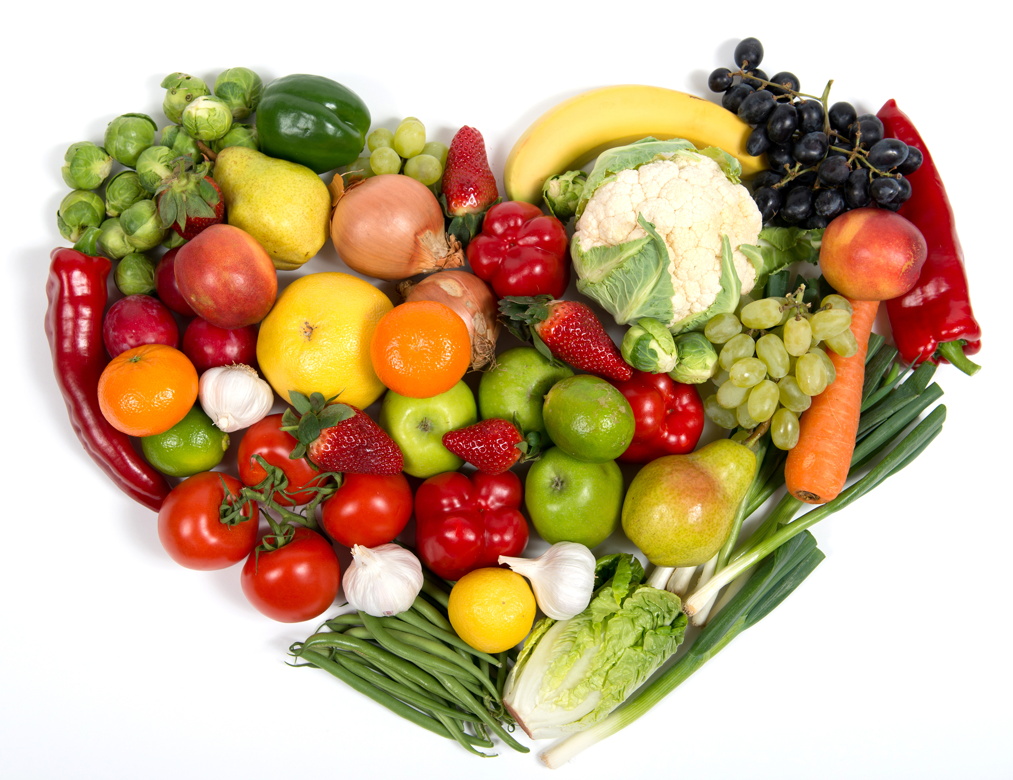

Five tips to get your child to love their vegetables and fruit:

1. **Lead by example:** Family members are important role models for healthy eating. Keep ready to eat fruit and vegetables where your kids can access them for a quick snack.
2. **Get your kids involved:** Take your kids grocery shopping, involve them in preparing lunch, let them choose which vegetables and fruit they want packed.
3. **Introduce new vegetables and fruit with familiar foods:** Take the pressure off by serving a new food alongside familiar vegetables and fruit.

1. **Try, try again:** Don’t give up. Most children need to be introduced to a new food 8 to 10 times before they will try it.
2. **Add variety:** Buy vegetables and fruit in season. During the winter months frozen vegetables and fruit tend to be a better buy and they are just as nutritious.

##### 

##### Frog Smoothie

##### In a blender, combine: 1 ½ cups (375 mL) vanilla soy beverage + 1 cup (250 mL) lightly packed spinach + 1 ripe banana + ½ cup (125 mL) fresh or frozen raspberries + ½ cup (125 mL) fresh or frozen blueberries + 2 ice cubes.

##### Puree until smooth, pour into glasses and enjoy!

* Frog Smoothie: Appeal to your kid’s sense of humour. Add spinach to your child’s fruit smoothie.
* Super Fruit Face: Let your child use new fruits to build a face on a plate of yogurt.
* Colorful layered sandwich: Add shredded carrots and sliced tomato to an egg salad sandwich.
* Funny Face Pizza: Your child can add his own vegetables to make a unique pizza.

Vitalité Health Network, Public Health , Moncton References: <http://www.dietitians.ca/>, http://www.eatrightontario.ca