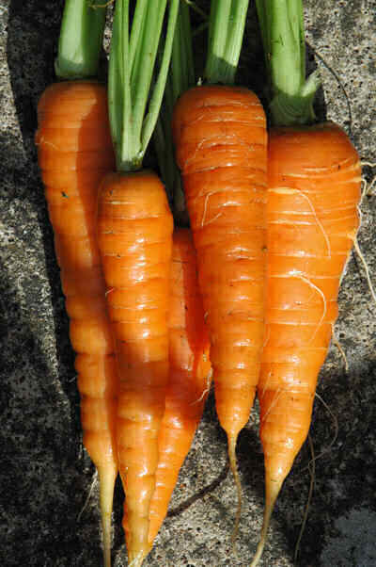

Why Are Balanced Complete Meals Important?

All 4 food groups provide us with a variety of vitamins, minerals and nutrients. A healthy well-balanced diet is an essential part of living a healthy life! When choosing food, pick a variety of foods from each of the food groups!

**Vegetables & Fruit** 🡪 The largest part of the rainbow which means we need the most of these in the day.

*Family challenge:* Get your kids to pick out a new vegetable for the family to try!

**Grain Products** 🡪 The food group that provides us with our energy to learn and play outside!

*Family Challenge:* Try to make ½ of your grain choices whole grains.

**Milk & Alternatives** 🡪 The food group that helps us grow strong bones and muscles.

*Family Challenge:* Choose lower fat milk products.

**Meat & Alternatives** 🡪 The food group that helps us grow, repair and rebuild muscles.

*Family Challenge:* 1 night try a meat alternative such as beans, lentils and tofu.

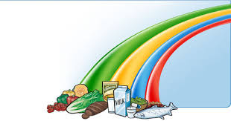Healthy Schools = Better Learners

Healthy Students = Better Learners

Nutrition Basics for the School Year

Choose lean **meat** and **alternatives**

**Balance = Combination of 3-4 food groups per meal**

**Choose or Send;**

**Main Entrée + 1 of these**  **+ 1 of these**

Hamburger Small Salad Milk

Pizza Apple Slices Yogurt

Sandwich Vegetable Sticks Fortified Soy

Fresh Fruit Beverage

Left over veggies

Vitalité Health Network, Public Health, Healthy Learners in School Program. References: <http://www.dietitians.ca/>, <http://www.hc-sc.gc.ca/fn-an/food-guide-aliment/educ-comm/index-eng.php>

Get creative with your kids and make your own combinations!

How to Balance Your Hot Lunch

Choose lower fat **milk** and **alternatives**

Choose **vegetables** and **fruit** prepared with little or no added fat, sugar and salt

Healthy Eating Tips

Choose **grain products** higher in fibre and lower in fat, sugar and salt

HealthyStudents = Better Learners

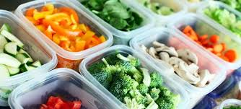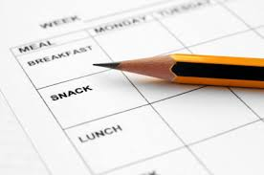

Vitalité Health Network, Public Health, Healthy Learners in School Program. References: <http://www.dietitians.ca/>, <http://www.hc-sc.gc.ca/fn-an/food-guide-aliment/educ-comm/index-eng.php>,

1. **Create a Meal Plan-** Encourage the entire family to get involved, use weekly flyers to build meals around items on sale or special
2. **Make a List and Stick to It-** Go to the grocery store/market with a list built around your meal plan
3. **Stock Up-** Items like canned/dried beans and lentils and low sodium canned tomatoes are great to have in your pantry to add to soups, salads, sauces and salsas
4. **Pre-Wash and Cut**- Wash and cut fruits and vegetables at the start of the week to make them more convenient to add to lunches and snacks
5. **Plan for Leftovers-** Leftovers are great for lunch or even breakfast the next day

##### Keep Lunch Safe

##### To keep food cold, use frozen bread for sandwiches, pack a frozen juice box or freezer pack with the lunch. Pack cold foods directly from the refrigerator.

##### To keep hot foods hot, use an insulated bottle or thermos. First, fill it with boiling water and let it stand for a few minutes. Then empty the bottle and fill it with the hot food.

- Whole wheat english muffin pizza

- Build your own taco (replace meat with lentils for a

meatless option)

- Sliced ham/turkey or grilled chicken with cheese and

crackers

- Homemade pancakes/waffles

- Homemade mac and cheese with low fat cheese

- Quesadilla on whole grain tortilla with low fat cheese,

black beans and vegetables

- Grilled cheese with whole grain bread

*Add raw vegetables or fruit and a low fat milk products to balance the meal.

Be creative, add lots of color and variety! Use these meal ideas to get started.

##### How to Pack a Healthy Lunch from Home

##### Make Lunch Something to Look Forward to!

Taking a moment each week to plan meals and snacks ahead of time will help you and your family eat well, save money and have more time to spend together!

Healthy meals provide kids with the energy they need to do well in school and other activities during the day. Busy lives make it hard to provide healthy meals and snacks all the time.

##### 5 Tips for Planning Ahead

##### Meal Planning = healthy eating and less stress!