+

Apohaqui Elementary School
School Improvement Plan
2023-2024
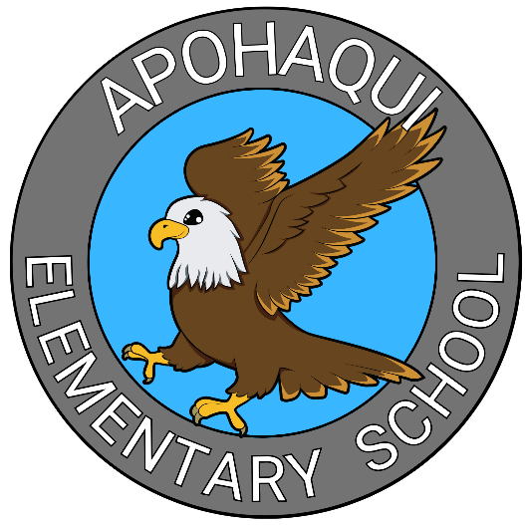

Mission:

- The mission at Apohaqui Elementary School is to engage all learners, promote academic excellence, and develop individual growth in a safe, nurturing environment.

Vision:

- A.E.S. encourages all members of our school community to meet their full potential.

At A.E.S. We:

- Believe each learner has a unique identity that should be honoured and respected;
- Create safe and positive learning spaces where we nurture a sense of belonging, and celebrate learners’ strengths, interests, needs, abilities, home languages, and cultures;
- Value the family and communities of our learners- ensuring what and how we teach has meaning and creates connections with their wider lives;
- Strive to develop the four aspects of our learners’ wellness- mind, body, spirit and heart;
- Support the personal fulfillment, growth, and agency of all learners to make life better for themselves and others.

Ends Policy #1

- To increase the agency of our learners by embedding the vision, shared tenets and pedagogies of the Holistic Curriculum

Vision
- All learners will develop learner agency.

Shared Tenets
- Wabanaki History and Culture
- Identities
- Inclusion and Equity
- Lifelong Learning
- Relationships and Connections
- Sustainable Futures
- Well-Being

Pegagogies
• Holding Each Learner in the Highest Regard
• Safe and Positive Spaces for Learning
• Direct Instruction
• Experiential Learning
• Play and Inquiry-Based Learning
• Relevant Learning

Goal Area #1 Strategies

- Direct Instruction- Teachers will continue to grow their knowledge and skills in the area of direct instruction for math and literacy. They will develop high impact strategies such as prior knowledge activation, foundational skill building, gradual release of responsibility, modelling, formative assessment and targeted intervention.
  - Professional Learning from EECD/ASD-S (Building Blocks of Reading modules; EGLA PL)
  - ASD-S Coaching from Literacy (UFLI) and Math Leads
  - On-going professional dialogue during bi-weekly PLCs
  - On-going examination of the components of the Holistic Curriculum to ensure we are following its vision, shared tenets and pedagogies.

- Experiential Learning- Teachers will gain an understanding of how to create a learning environment where learning can be done through experience, trial-and-error, and reflection. They will develop the skills to set up an environment where learners are supported in practicing perseverance in the learning cycle through taking learning risks, making mistakes, and applying corrective feedback.
  - Professional Learning from ASD-S Coaches on how students can become involved in the planning of experiential learning; how to encourage risk taking and learning from mistakes; and how to assess and provide feedback.
  - Staff presentation from Centres of Excellence on Experiential Learning opportunities (teachers to then engage with the various centres to create experiential learning opportunities for students).
  - Engaging members of the Apohaqui community to offer experiential learning opportunities (Hot Air Balloon visit; Career Week).
  - Invite Science East Planetarium Display.
  - Borrow Science East STEM packages for students
  - Creation of School Garden

DISTRICT IMPROVEMENT PLAN ALIGNMENT:
• Ends Policy #2- Improve student engagement and achievement by embedding research based best practices in a variety of learning environments.

10 YEAR EDUCATION PLAN ALIGNMENT 3, 4, 5, 7 and 9
• Objective #3- Improve literacy skills for all learners
• Objective #4- Improve numeracy skills for all learners
• Objective #5- Improve learning in, and application of, the arts, science, trades and technology for all learners
• Objective 7: Ensure all learners develop the knowledge, skills and behaviours needed to continually adapt to, and thrive in, their environment
• Objective #9- Foster leadership, active citizenship and an entrepreneurial mindset

Ends Policy #2

AES will build a positive learning and working environment for our staff and our learners by implementing a PBIS framework where AES Eagles are safe, respectful and responsible.

Goal Area #2 Strategies
- Ongoing positive data collection and behaviour data collection to be used to plan for and create interventions and instruction
- Creation and sharing of PBIS Expected Behaviour Posters
- Creation of PBIS Ballots to celebrate students who are demonstrating expected behaviours
- Student co-constructed class expectations
- Positive Office Visits
- Positive home communication
- Supporting student self/co-regulation to set them up for success with expected behaviours. Support strategies include sensory breaks, sensory room, Zones of Regulation instruction, Zones Check-in (How are you Feeling Today) posters/table strip, guidance lessons and groups, social skills groups.

- DISTRICT IMPROVEMENT PLAN ALIGNMENT:
• Ends Policy #3- Engage system’s leaders in improving mental health and resiliency for both learners and staff through proactive strategies such as Positive Education and Social Emotional learning.

10 YEAR EDUCATION PLAN ALIGNMENT 3, 4, 5, 7 and 9
• Objective 7: Ensure all learners develop the knowledge, skills and behaviours needed to continually adapt to, and thrive in, their environment
• Objective #9- Foster leadership, active citizenship and an entrepreneurial mindset

