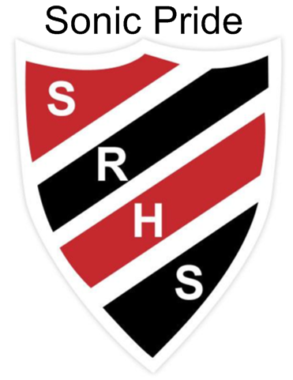October 15 - 19 at SRHS

Grad photos continue this week at SRHS.

**Monday**

*Ladies Soccer v SHS 5:00 p.m.*

*Boys Basketball Open Gym 7 – 9 p.m.*

**Tuesday**  Allergy Awareness during G3

*3:30 – 4:30 p.m. Learning Center is open.*

*Girls Basketball Open Gym 6:30 – 8:00 p.m*

**Wednesday** Period 2 St Thomas Presentation in Rm 1196 (Sign up in office)

**Thursday** G3 schedule today

Sexual Health Nurse @ SRHS this morning.

*Boys Basketball Open Gym 7 – 9 p.m.*

**Friday** Grads Flannel Day

Period 3 St Mary’s Presentation in Rm 1196 (Sign up in office)

*Track and Field Provincials Eric Vershoor & Alexis Moffett will represent us in Moncton*

Men’s Football vs St Macs @ 1:00 p.m. on Saturday

**Vincit qui se vincit – To conquer, one must conquer oneself**