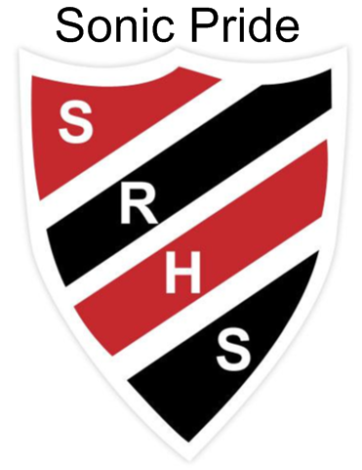 December 16 - 20 at SRHS

**Final Week of 2019 for our Sonics prior to our Holiday break!**

**Monday** Red & Green Day

Learning Center 3:30 – 4:30 p.m.

5:30 p.m. SJHS vs. JV Ladies Basketball Team

7:15 p.m. SJHS vs. Varsity Ladies Basketball Team

**Tuesday**  PJ Day & Christmas Tree Bowling at lunch

G3 Day

**Wednesday**Sled Pull

**Thursday** Ugly sweater & Candy Toss at Lunch

G3 Day

6:30 p.m. Grad Winter Formal at JJs

**Friday** a.m. Christmas Breakfast & Variety Show

p.m. Choice of Special activities for each period

**Wishing all our Sonics the best of the Holiday season and a Happy New Year!**

**Vincit qui se vincit – To conquer, one must conquer oneself**