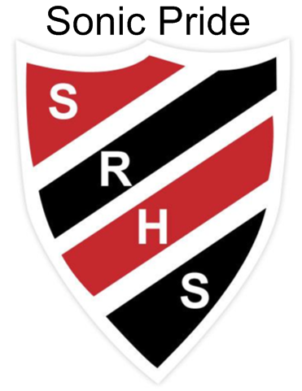 May 27 - 31 at SRHS

May is **Food Allergy Awareness Month** with the theme of *Give and Go*

Monday Breakfast Club

Tuesday G3 Schedule

*Learning Center 3:30 – 4:30 p.m. Exam Preparation*

WednesdayBreakfast Club

**Purple Day** Sweet Caroline Foundation <http://www.sweetcarolinefn.ca/>

*7 P.M. Activity Awards Night SRHS Theatre*

Thursday **No G3 today – Altered schedule attached below**

P.M. - Final Spirit Assembly & Teacher Student Basketball

*Learning Center 3:30 – 4:30 p.m. Exam Preparation*

*Grad Banquet 6:00-8 PM at All Seasons*

Friday Breakfast Club

Period 1 SMS Grads of 2023 Visit

12:00 p.m. Disability Awareness walk

Free Meal at noon

**Amos Tucker Prize for an Extraordinary Teacher Submissions Due**

Future events: **SRHS Night of Musical Entertainment** on June 4th at 7pm

**Vincit qui se vincit – To conquer, one must conquer oneself**

**Schedule for Thursday May 30th**

Period 1 8:43 – 9:23

Class movement 9:23 – 9:28

Period 2 9:28 – 10:08

Class movement 10:08 – 10:13

Period 3 10:13 – 10:53 *\*Coop students will still be at their work placement during this period*

Class movement 10:53 – 11:00

Period 4 11:00 – 11:40

Class movement 11:40 – 11:45

Period 5 & Announcements 11:45 – 12:25

Noon 12:25 – 1:25

1:25 p.m. Be in your Thursday Period 4 Class (Period 5 on M, W & F) for attendance & participation in Teacher Student Basketball Game or Spirit Assembly for the afternoon.