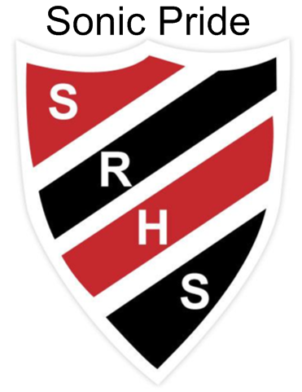 May 6 - 10 at SRHS

Monday Student Free Day – Teachers in Meetings

Grade 12 OP Interviews

Tuesday G3 Schedule

Grade 12 OP Interviews

*Learning Center 3:30 – 4:30 p.m.*

*5:30 p.m. SRHS Men’s Rugby vs. KVHS* Boys Rugby

WednesdayBreakfast Club

Grade 12 OP Interviews

Grad Gown Fitting in Lobby

**Thursday** G3 Schedule

Grade 12 OP Interviews

**Friday** Grade 9 UNB Math Competition

Grad Gown Fitting in Lobby

Grade 12 OP Interviews

*Come out to AX, the Arts and Culture Centre of Sussex, to welcome artists from schools across the region. The exhibition of student art will launch on Saturday, May 11, at 2:00 p.m., featuring works from students working in various mediums at schools in Sussex and beyond. The works will be in the gallery until May 18.*

**Vincit qui se vincit – To conquer, one must conquer oneself**