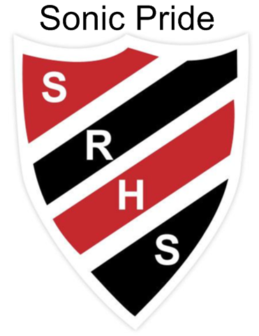September 30 – October 4th at SRHS

*The* ***ORANGE SHIRT*** *raises awareness of the residential school experience and in wearing it we demonstrate that communities are coming “together*

*in a spirit of reconciliation and hope because every child matters”.*

***Spirit week @ SRHS***

*Child Studies Sugar Baby project will have babies in class Sept 30th -Oct 4th*

**Monday** Orange Shirt Day

Siblings pics for Yearbook in Mme. Belliveau’s room

Last day to purchase yearbooks at the low price of $65.

*Improv Team practice is Monday 3:30-5pm Room 1122*

*Ladies’ Soccer KV @ SRHS 5:30 p.m.*

**Tuesday**  Guest @ SRHS to celebrate our grant from the Brewer Foundation

(G3 Day) 1st Hot Lunch – Chili, Rolls & Corn on the cob

Socktober Spirit Week Event

*Grad Capture the Flag & BBQ 5:00-7PM ($5 sign up in the lobby by noon)*

*.*

**Wednesday**  Camo Day Spirit Week Event

Multicultural Friendship Group meeting at lunch Room 1122

*Men’s Soccer SdeC @ SRHS 5:30 p.m.*

**Thursday** Dance Off Spirit Week Event

(G3 Day)

**Friday**  Improv lunch in Rm 1122

**Check out the Sonics in action this weekend in Sussex**

**Ladies’ Soccer SJHS @ SRHS TBA - Men’s Soccer StSt @ SRHS 11 a.m.**

**1st Home Game for Football JMH @ SRHS 1 p.m.**

**Vincit qui se vincit – To conquer, one must conquer oneself**