|  |  |
| --- | --- |
| MCBD05097_0000[1] | **Sussex Corner Elementary School**  **School Supply List**  **Grades Four and Five English Prime and French Immersion**  **2019-2020** |

* 1 hard plastic portfolio duo-tang (a duo-tang with pockets on the inside)
* 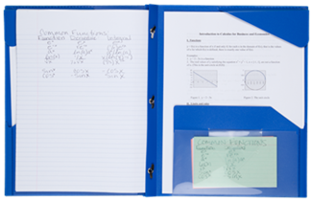4 large good quality white erasers
* 1 pair of metal scissors
* 1 ruler (30 cm)
* 2 highlighters
* 2 jumbo glue sticks
* 1 box of markers
* 2 black Sharpies permanent markers for art
* 1 pkg. loose-leaf paper (200 pages)
* 12 duo-tangs (3 red, 3 blue, 3 green, 3 yellow)
* 48 pencils (sharpened)
* 1 duo-tang with pocket folders
* 4 Hilroy scribblers of 32 pages (no coil please)
* 1 package of 24 pencil crayons
* 1 pencil sharpener with cover for shavings
* 2 large pencil cases (one for pencils & one for markers)
* 1 large sketchpad with coil binding (Dollar store) 8 ½ x 11
* 2 boxes of Kleenex
* 1 pair of sneakers for indoor
* 1 pkg. of whiteboard markers (Expo & chisel tip)
* Lunch box and book bag
* 1 Set of Headphones
* 1 Red and 1 blue Pen
* Optional: USB stick
* $20 Registration Fee - Please see the web address below for SchoolCashOnline

|  |  |
| --- | --- |
| [banner.jpg](https://asd-s.schoolcashonline.com/)  **https:** **//asd-s.schoolcashonline.ca** | Please register to pay school fees on-line at the following address. If you select “yes” to receive e-mails, you will be notified when an item is available for you to purchase. |

**PLEASE Note: Due to allergies, no scented supplies, please!**