|  |  |  |
| --- | --- | --- |
|  |  |  |
| Magazine: Flat Stanley finds weight-loss hope at Subway C8 | Sports: Minions promote health benefits of running amok D7 | High school pals reunite at middle school B5 |
| TELEGRAPH-JOURNAL | | |

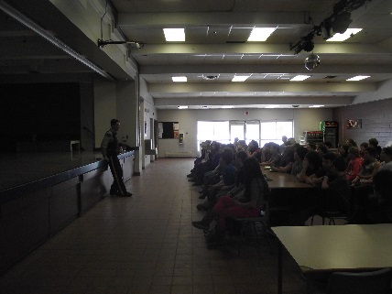

Library hours in NB are about to change.

**Sunday library hours – is it too little, too late?**

Fredericton: More libraries in New Brunswick will likely soon change to allow people to peruse the stacks on Sundays, the first step in switching the hours of the old-fashioned institutions which typically run 10 to 5 when most people work and can’t go.