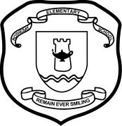September 24, 2013

Dear Parents and/or Guardians,

**[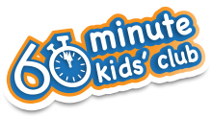](http://60minkidsclub.org/)**

We are excited to introduce the ***60 Minute Kids Club Challenge*** to Rothesay Elementary School families. It is a program designed to encourage elementary students develop healthy choices.

Over the sixty day period from October 1st to December 1st, students create online accounts (with your help), and track their healthy choices in the following five areas:

1. Choose nutritious snacks and meals, aiming for five to ten servings of fruit and vegetables every day
2. Get at least 60 minutes of physical activity every day
3. Drink lots of water, instead of other sugary drinks
4. Get a good night’s sleep
5. Decrease screen time to two hours or less every day

Not wanting to forget the adult members of the family, you can participate in the challenge along with your student(s) by creating your own account on the 60 Minute Kids Club website. There is a non-student section for you; please do not create your personal account in the same section as the children do. As well, there are additional resources available on the site to support you in developing a healthy active family. The opposite side of this letter contains further details about the program and signing your student up for the challenge.

We will have a kick off assembly on Thursday, September 26th. Be sure to ask your student(s) about it. Check out the 60 Minute Kids Club website and youtube channel at <http://60minkidsclub.org/> or <http://www.youtube.com/user/60minkidsclub>. If you would like further information, feel free to contact me at [marilyn.dunnett@nbed.nb.ca](mailto:marilyn.dunnett@nbed.nb.ca) or 849-5990.

***Be sure to get your child(ren) signed up and ready for the start of the challenge on October 1st.*** We would love to have every child participate, and are looking forward to developing healthy habits together!

Sincerely,

Marilyn Dunnett

Community School Coordinator