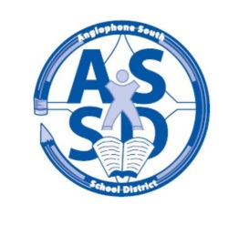

School Closures Due to Inclement Weather

Anglophone South School District is committed to the safe and efficient transportation of students and recognizes that it may be necessary to cancel a bus run(s), close school(s), or delay school opening to ensure students are not endangered by hazards brought on by poor weather or road conditions. Our decisions must be made prior to 6:30 am and they are based on the forecasts we have, and information we are able to collect on road conditions.
The following options are considered when deciding what to do during inclement weather situations:

- Schools are open as usual in which case no announcement will be made.

- All schools are closed for the day with an appropriate announcement being relayed to:
  - the local radio stations prior to 6:30 a.m.,
  - the District website (www.asd-s.nbed.nb.ca)
  - follow us on twitter http://twitter.com/ASD_South
  - the District Information Phone line ( toll free: 1-855-535-7669 [SNOW] )
Parents are encouraged to access the above noted methods early in the morning, particularly on days when the weather is inclement.

- Schools are closed by Education Centre:
  - Hampton Education Centre
  - Saint John Education Centre
  - St. Stephen Education Centre
Schools within an Education Centre may be closed depending on conditions.

- School bus runs are delayed one hour. On these occasions, all schools will open at their regular time to receive students. Students arriving late will not be penalized.

- Schools may be closed early on days when the weather conditions are anticipated to deteriorate significantly during the day. Every effort will be made to notify parents by telephone for students in Kindergarten to Grade 5. We use media, voice mail and email. Families are reminded of the importance of ensuring alternate arrangements are in place for their child(ren) in cases when they or another adult will not be available to be home.
During the winter months, there may be occasions when the condition of a particular road along a bus driver’s route is hazardous. Individual school bus drivers have a responsibility to recommend to their supervisor either the cancellation or delay of their individual bus runs should they have a safety concern. Whenever possible, notice of a late bus or a cancelled bus run will be announced on the radio and posted on the Website.
While the loss of valuable instruction time is always a concern, the safety of students is paramount. The decision to close schools is always made with this in mind.

If schools remain open, and as a parent/guardian you feel that conditions in your area are not safe for your child to go to school, then ultimately you have the final decision whether or not to send your child to school. Absences on these days will not be a factor in a student’s attendance record.

