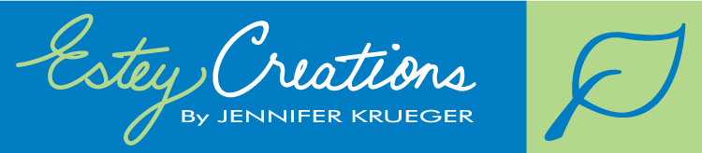
P.O. Box 442 Station A, Fredericton NB, E3B 4Z9. (506) 638-9194
After School Art Program
The Classes:
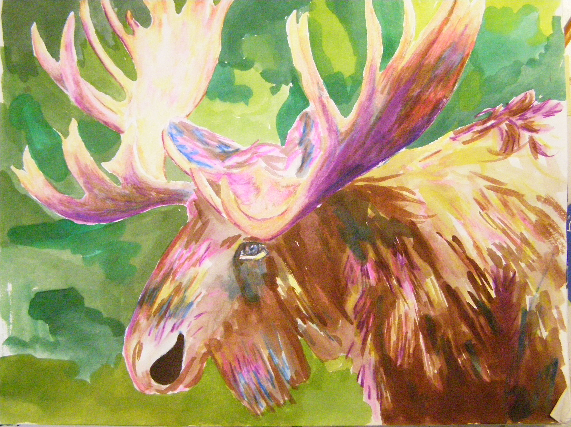
This class is open to children in grades 3, 4, & 5 at QES. Students will learn how to draw and paint a wide variety of subjects including people, animals, cartoons, landscapes and more! For example, the students will learn how to give their characters emotions, how to create perspective, and tips for colouring. They will learn to draw in a cartoon style as well as more realistic drawing. Students will work with a variety of mediums.
All supplies will be provided and are included in the cost of the course. Students will receive a hard cover sketchbook on the first day of class and need to bring this sketchbook with them every week. The program is 10 classes long on Tuesdays beginning Tuesday March 12th through to May 14th. Classes are right after school until 4:15pm. The fee is $170 +tax per child. Class maximum is 25 so early registration is encouraged. Family and returning students discounts are available.
Call Jennifer at 638-9194 to register.
The Creator:
Jennifer Krueger is the owner and operator of Estey Creations. Jennifer has created and instructed art classes for Art Smarts, The Beaverbrook Art Gallery, the art of cartooning in Toronto, and of course her own curriculum at the Estey Creations After School Art Program in New Brunswick. Jennifer creates all curriculums and coaches instructors on great teaching techniques.
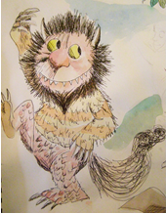
The Instructor:
Artist Heather Guzik will lead this class. Heather has incredible artistic talent as well as the ability to communicate different approaches to art ensuring inspiration for everyone!
If schools are closed for any reason, there will be no art that day, and the program will be extended by one week to make up the time.
Check out www.esteycreations.com for more info!

