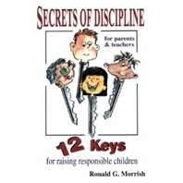
Secrets of Discipline Parent Sessions

LET US HELP YOU PUT SECRETS OF DISCIPLINE INTO ACTION IN YOUR HOME
If you would like to deal effectively with defiance, decrease stress through the use of prevention and teach courtesy and respect to your children, then come and learn very valuable tools and strategies that can be used in your home. These parent sessions, offered by HALL and KV3C will
provide practical and effective strategies to implement the book “The Secrets of
Discipline” by Ronald Morrish.

Hampton - Tuesdays, May 14, 21, 28 and June 4 from 7-9pm, being held out of the Hampton Elementary School. To register for Hampton sessions, contact
(506)832-5665 or email haforll@nbnet.nb.ca.

KV3C - Wednesdays, May 15th, 22, 29 and June 5th from 7-9pm, being held in the Quispamsis Elementary School Library. To register for Quispamsis sessions contact Melissa at (506) 849-7266 or email kv3c@nb.aibn.com.

This program is free from support from community groups, including The Sussex
Community Foundation.

