

Science Resource Package: Grade 3

Exploring Soils:
Investigating Soil Composition

New Brunswick Department of Education
December 2009
Acknowledgements

The Department of Education of New Brunswick gratefully acknowledges the contributions of the following groups and individuals toward the development of the New Brunswick Science Resource Package for Grade 3 Exploring Soils: Investigating Soil Composition:

- The Science Resource Package Development Team:

  - Stacey Brown, District 8
  - Raylene Hayman, District 10
  - Renee Landry, School District 6

- Science East:

  - Michael Edwards, Director of Programming
  - Karen Matheson, Director of Education

- Kathy Hildebrand, Learning Specialist, Science and Mathematics, NB Department of Education

- Science Learning Specialists and science teachers of New Brunswick who provided invaluable input and feedback throughout the development and implementation of this document.

Note that at the time of posting, all URLs in this document link to the desired science content. If you observe that changes have been made to site content, please contact Kathy Hildebrand katherine.hildebrand@gnb.ca, Science Learning Specialist, at the Department of Education.

2009
Department of Education
Educational Programs and Services
Table of Contents
Rationale 1
Background Information 3
Prior Knowledge: 3
Common Misconceptions: 3
Did You Know? 3
Instructional Plan 5
Access Prior Knowledge 5
Activity - The Four Senses of Soils 5
1st Cycle 7
Exploring Earth’s Soils Activity 7
Reflection: Class Discussion 8
Reflection: Journal 9
2nd Cycle 10
Characteristics of Soils Activities 10
Reflection: Class Discussion 13
Reflection: Journaling 14
Think like a scientist 15
3rd Cycle 16
Soil and Water Activity 16
Reflection: Class Discussion 17
Reflection: Journaling 18
Think like a scientist 18
Supporting Class Discussion 20
Materials List 22
Student Version of Outcomes 23
Letter to Parents 24
Characteristics of Soils Activities 25
Soil and Water Activity 289
Observation Chart Sheet 30
Observation Checklist 31
Checklist Sheet 32
Student Record 33

Rationale
This resource package models current research in effective science instruction and provides an instructional plan for one topic selected from the Grade 3 Atlantic Canada Science Curriculum. This curriculum includes STSE (Science, Technology, Society and Environment) outcomes, Skills outcomes, and Knowledge outcomes – all of which are important for building a deep understanding of science and its place in our world.
As has been true of our ancestors, we all develop “explanations” about what we observe which may or may not be valid. Once ideas are established, they are remarkably tenacious and an alternate explanation rarely causes a shift in thinking. To address these misconceptions or alternate conceptions, students must be challenged with carefully selected experiences and discussion.
A key part of this instructional plan is accessing prior knowledge. It is recorded in a way that it can and will be revisited throughout the topic. The intent is to revise, extend, and/or replace students’ initial ideas with evidence-based knowledge.
Science is not a static body of facts. The process of exploring, revising, extending, and sometimes replacing ideas is central to the nature of science. Think of science as an ongoing evidence-based discussion that began before our time and that will continue after it. Science is often collaborative, and discussion plays a key role. Students’ learning of science should reflect this as much as possible.
The intent of this instructional plan is to encourage a constructivist approach to learning. Students explore an activity, then share, discuss and reflect. The telling of content by the teacher tends to come after, as an extension of the investigation (or experience) explored by the students.
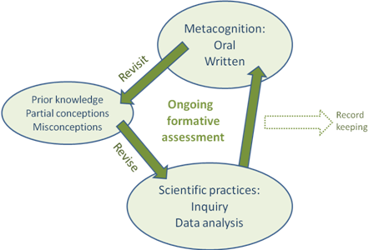
The learning is organized into cycles. The partial conceptions and misconceptions are revisited in each cycle so that students’ ideas will be revised. Each cycle will result in deeper and/or extended learning.

Hands-on activities are part of the instructional plan. Inquiry activities tend to be most structured in the first cycle. The teacher provides the question to investigate and gives a procedure to follow. In subsequent cycles, less structure tends to be given. For example, students may be given a question and asked to develop an experimental plan which they then implement. The goal is to move towards open inquiry in which students generate a testable question, develop an experimental plan using available materials, implement the plan, record relevant observations, and make reasonable conclusions. The included activities are meant to start this journey.
Discussion and written reflections are key parts of the lessons. Discussion (both oral and written) is a vehicle that moves science forward. For example, when scientists publish their evidence and conclusions, other scientists may try to replicate results or investigate the range of conditions for which the conclusion applies. If new evidence contradicts the previous conclusions, adjustments will be required. Similarly, in this instructional plan students first do, then talk, then write about the concept. A section on supporting discussion is included in this resource package.
Assessment tasks are also included in the instructional plan and assess three types of science curricular outcomes: STSE, Skills, and Knowledge. These tasks are meant to be used as tools for letting the teacher and the students know where they are in their learning and what the next steps might be. For example: Has the outcome been met or is more learning required? Should more practice be provided? Is a different activity needed?
When assessment indicates that outcomes have been met, it will provide evidence of achievement. This evidence may be sufficient and further formal testing (paper-pencil tests) may not be required to demonstrate that outcomes have been met.

Background Information

Prior Knowledge:
Students may realize that:
- Soil is dirt and/or mud
- Things grow in it
- Soil has animals such as worms, ants that live in it

Common Misconceptions:
- Dirt is dirt. Soil is all the same regardless of where it you find it.
- Soil goes all the way through the center of the Earth. Students may try to pretend to dig to China.
- Soil is dead and unchanging.

Did You Know?
Soil is made up of broken down rocks, organic matter (decayed plants and animal material), water and air. It is formed very slowly. The rate depends on the conditions in an area, but common rates are one centimeter every 100 to 250 years. Soil is therefore not a very renewable resource.
The main components of soil are clay, silt and sand. These are defined by the size of the particles. Clay has the smallest particles and sand the largest. Different types of soil have differing proportions of these, as well as differing amounts of organic matter. Some soils can support a lot of weight and are good for building on, some are good for growing crops, some are good for retaining water. Soils types can be determined by feeling the texture. See this site for information http://www.fieldmuseum.org/undergroundadventure/teachers/pdfs/Texture_by_Feel_Analysis.pdf
Soils contain visible living things such as worms and smaller microorganisms that may make them unsafe for examination in the classroom. One example is toxoplasmosis, a parasite (dangerous to pregnant women) that may be found in cats and shed in their feces, and which could potentially be in garden soil.
Soils can be collected from around student homes, but it would be a good idea to freeze the soil for 2-3 days before the students use it for activities. This will kill microorganisms and eliminate the need for gloves and serious cleaning when performing activities. Hands should still be kept away from faces and always washed after handling soil. If time between the various activities exceeds several days, refreezing or storing the soil in the freezer would be a good idea. The website http://school.discoveryeducation.com/schooladventures/soil/field_guide.html provides pictures and information on the types of microorganisms that may be found in soil.
This is an excellent website for learning about soils – where they come from, components of soil – sand, silt, clay, humus and what lives in there.
http://school.discoveryeducation.com/schooladventures/soil/
Interested in knowing what percentage of the Earth is soil? This website uses an animated apple to show how much soil is on the Earth. There is also a section on “How does your Garden Grow?” that explains what plants need to grow and how Nitrogen, Phosphorus and Potassium are used.
http://soil.gsfc.nasa.gov/app_soil/hmsoil.htm
This site has a variety of info for teachers and has interactive fun parts for students. Information includes: background information about soils, soils of the world, and properties of soils.
http://www.soil-net.com/
Provincial Soil – this section has been taken from the Government of New Brunswick’s website detailing the provincial logo, flag, bird, tree, flower and soil.
http://www.gnb.ca/cnb/logos/logos/alllogos-e.asp

“The Holmesville Soil Series is the most prevalent soil type in New Brunswick. It is a sandy loam-to-loamy soil with less than 20 per cent clay, and 15-30 per cent coarse fragments. The parent material of the soil is a moderately compact glacial till.
Holmesville is located in Carleton County near Florenceville. The Holmesville Soil is a fertile soil that provides high yields of both agriculture and forest crops. Soil is important to any location as it is the one place on this planet where the rocks and minerals are in contact with the atmosphere, hydrosphere, and biosphere, and where the nutrients that enter the food chain are produced and/or recycled.
The Holmesville Soil Series was proclaimed the New Brunswick provincial soil on Feb. 13, 1997.”

◉ Instructional Plan

 Access Prior Knowledge

 Activity - The Four Senses of Soils
Cross-curricular links:
ELA
3a. Students will be expected to:
Use basic courtesies and conventions of conversation in group work
To determine the level of knowledge and any misconceptions:
Prepare a class chart with four of the five senses listed (not taste).
Ask students to work in pairs or small groups to brainstorm words or phrases that describe what soil is like. For example, soil sounds crunchy, looks red, feels slippery, etc.
Students can also be asked to explain how they know these things (their source of information like their parents, TV, or books). Students can record their answers on a four-tab foldable before the discussion to share their answers with the class.
To make the foldable:
Fold a sheet of paper in half. Make sure there is a visible crease line in the middle. Unfold.
Fold the outside edges to the center fold line.
Cut each folded flap in half to make four flaps. Label each with one of the senses. Students can write their thoughts under the flaps.
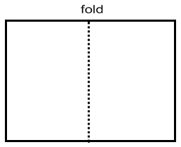
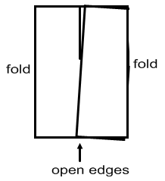
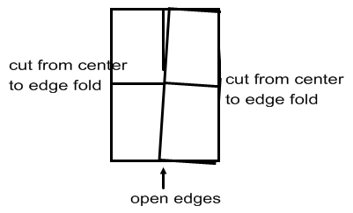

✓ Assessment:
Note the concepts and misconceptions students are expressing. You will need to know these to plan effective questions for subsequent activities and discussions so that students will examine and adjust their alternate conceptions.

Storage options for foldables:
- Insert into a large zippered plastic bag. The bag can be hole-punched and put inside a duotang or binder. A strip of wide tape folded over the left edge of the bag before punching the holes will keep the bag from ripping
- Glue into notebooks or duotangs
- Display them on bulletin boards

Post student versions of curricular outcomes on chart paper (see page 20). Inform students that these outcomes will be addressed over the next portion of the unit. Point out to students which outcomes are being addressed in each activity.

 Teacher note: To help keep the students clean, ask them to bring in a shirt from home (like dad’s old shirt) or a second hand shirt. This can be their “science shirt” that they wear when they are doing messy science activities.

Students often think that scientists wear lab jackets as part of the job (a stereotype). The purpose for lab jackets is to protect clothing when working with messy or dangerous samples, but they are not worn all of the time.

1st Cycle

✪ Curriculum Outcomes
100-36 Explore and describe a variety of soils and find similarities and differences among them
100-37 Investigate and describe soil components
201-5 Make and record relevant observations and measurements, using written language, pictures, and charts
203-1 Communicate questions, ideas, and intentions while conducting their explorations
203-3 Communicate procedures and results, using drawings, demonstrations, and written and oral descriptions

 Exploring Earth’s Soils Activity
Safety note on the handling of soil: wash hands after handling or wear gloves. Samples can also be placed in a freezer for 3 days to kill off living organisms that may be in the soil. Hands and desks should still be cleaned after touching soil in case there are chemicals in the soil.

Materials:
Baggies
Newspapers
Magnifying glasses
Optional: teacher brings samples that they know
have a lot of clay, a lot of sand, a lot of silt

Ask students to bring in baggies of different types of soil from home or to collect soils from the school yard. (A letter asking parents to help their children collect a soil sample has been included on page 24).
Place newspapers on the desk and ask students to scoop one handful of the soil sample onto the newspaper.
Students will investigate their soil samples for several minutes, using their four senses. Students should be provided with magnifying glasses so they can take a closer look.
Then have students rotate around the room to compare their soil samples with their classmates.
Similarities and differences among the soils can be recorded on the foldable. Horizontal folds can be used to separate the “differences” comparisons making a grid chart.
Cross-curricular links:
ELA
8a. Students will be expected to:
Use writing and other forms of representation to
- generate and organize language and ideas
- record experiences
- explore how and what they learn
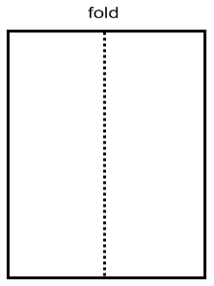
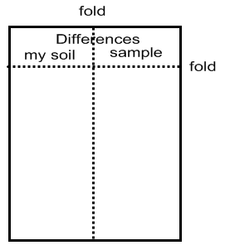
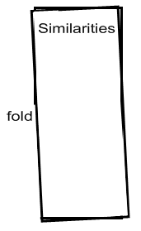

✓ Assessment:
During the student activity, make notes on outcomes (or parts of outcomes) you observe being addressed. Process skill outcomes are part of the curriculum and should be assessed. Using the observation chart or the checklist (see pages 30 to 32) on a clipboard may be helpful to you. Develop your own code for quick notes.

A suggested code:
√ observed and appropriate
WD with difficulty
A absent

This chart may be used on multiple days, using a different coloured pen or pencil each day and putting the date in the corner. You may not have a symbol or note for every child every day. Some teachers like to focus on a group or two each time. However you choose to make note of your observations, you will always have a sense of who you need to take more notice of and who might need extra support. The information will also help you when it is reporting time.
Cross-curricular links:
ELA
1. Students will be expected to:
a. Describe, share, and discuss thoughts, feelings, and experiences and consider others’ ideas
b. Ask and respond to questions to clarify information and to explore possibilities or solutions to problems
c. Express and explain opinions and respond to the questions and reactions of others
d. Listen critically to others’ ideas and opinions
2. Students will be expected to:
a. Participate in conversation, small-group and whole group discussion, understanding when to speak and when to listen
b. Adapt volume, projection, facial expression, gestures, and tone of voice to the speaking occasion

Health
Demonstrate the ability to interact effectively with others, showing an insight into their emotions and the ability to express their feelings clearly (Explain the importance of communication skills, as well as demonstrate the effective use of these)
Show respect for and attempt to understand the ideas, opinions and feelings of others

 Reflection: Class Discussion

- Ask students:
What was the same in the soil samples? What were some differences you noticed?
What were the different textures, colours and smells of the soils?
- Introduce students to the vocabulary used to describe different soil components such as: sand, silt, clay, rock, humus, organic matter
- Revisit the “Four Senses of Soil” chart created in the Accessing Prior Knowledge activity (page 5). Ask: Are there any items that should be added to or revised. Is there other information we could add? Remind your class about respectful discussion. The discussion tips on pages 20-21 may be helpful.
A useful resource at this time is a storybook “The Scoop on Soils” available (in French as well as English) from http://www.globe.gov/fsl/html/templ.cgi?EG_soil&lang=en&nav=1 to print or display electronically. Three children follow a dog and see the soil profiles in different locations by examining the holes the dog digs. There is also background information on soils and activities.

The section Soil Profile in the Bill Nye video “Rocks and Soil” found at http://learning.aliant.net/ may be useful at this time.
To access the video, type the title into the search box. Videos are available free of charge at this site. You will need to register, however registration is free. If you try to watch the video without logging in, you will be prompted to do so. Note that a table of contents opens beside the video so that you may select only certain sections for viewing if you wish. There is also an option to watch the video full screen.

 Reflection: Journal
Cross-curricular links:
ELA
8a. Students will be expected to:
Use writing and other forms of representation to
- generate and organize language and ideas
- record experiences
- explore how and what they learn

Explain with words and pictures which other soil sample in the classroom is most like yours.

✓ Assessment:
Journal entries should not receive a score or mark. A positive comment followed by a question to refocus attention or suggest the next step in learning is very effective.
Note whether students recognize that not all soils look the same.

 2nd Cycle
✪ Curriculum Outcomes
100-36 Explore and describe a variety of soils and find similarities and differences among them
100-37 Investigate and describe soil components
100-38a Describe the effect of moisture on characteristics (e.g., cohesion-ability to hold together, texture, colour of the soils)
200-1 Ask questions that lead to exploration and investigation
200-3 Make predictions based on an observed pattern
201-3 Use appropriate tools for manipulating and observing materials and in building simple models
201-5 Make and record relevant observations and measurements, using written language, pictures, and charts
203-1 Communicate questions, ideas, and intentions while conducting their explorations
203-3 Communicate procedures and results, using drawings, demonstrations, and written and oral descriptions

 Characteristics of Soils Activities
Cross-curricular links:
ELA
2c. Students will be expected to:
Give and follow instructions and respond to questions and directions
3a. Students will be expected to:
Use basic courtesies and conventions of conversation in group work
Math
SS4 Demonstrate an understanding of measuring mass by:
- Estimating mass using referents
- Measuring and recording mass
SP2 Construct, label and interpret bar graphs to solve problems.

These activities can be done by students with their own soil samples or you can make a point of choosing soil samples that appear different from each other. They are set up as stations to reduce the amount of equipment needed. Depending on class size, you may wish to have two of each station.

During these activities encourage students to use the vocabulary: rocks, sand, silt, clay, organic matter

Station 1 – Can you make soil balls?

Materials | Test | Teacher note
Tray or newspaper  Soil that is sand or mostly sand  Soil that is clay or mostly clay  Soil that is loam  Water | Put a small pile of soil on the tray.  Add a small amount of water so the soil is damp.  Try to roll a small ball of soil.  Repeat for other types of soil.  Record results with words and pictures. | Sand is crumbly. Clayey soil forms a ball. Loam sort of sticks together but tends to crumble.
This site has diagrams of possible shapes formed by different types of soil. http://92.52.112.178/web/sa/saweb.nsf/ed0930aa86103d8380256aa70054918d/7e4791970c3850c980256ab2005202ec?OpenDocument

Station 2 – Separating soil with sieves
Materials | Test | Teacher note
Various sieves  Dry soil samples  Tray | Break apart any soil lumps in the sample.  Pour the sample into the sieve with the largest holes. Shake over the tray until all the smaller particles have gone through the holes. Dump the soil particles still in the sieve onto a sheet of white paper.  Put the material on the tray into the sieve with the next smallest holes and shake. Again put what remains in the sieve onto a sheet of paper.  Continue using a smaller sieve each time.  Repeat the process with other soils. (Or have each group do a different soil sample.) Record your results with words and pictures. Use a balance to determine how many grams of soil in each size range. Create a bar graph showing amounts of soil particles in each size range for each location (see page 28 ). | Rocks will be separated out first. Sand particles are the next smallest, then silt and clay particles are the smallest. See elaboration on pages 34-35 of the curriculum guide and the background notes on page 18 of the Down Under Teacher’s Guide  Taking pictures of the separated portions of the soil is useful for later comparisons and discussion (see below).

For example: soil from the shoulder of the road
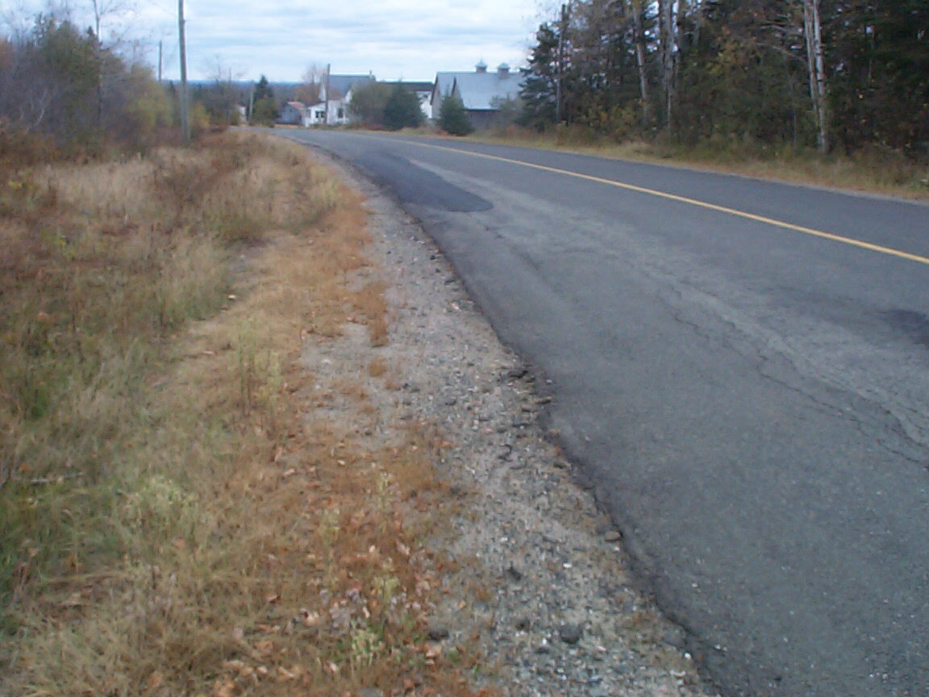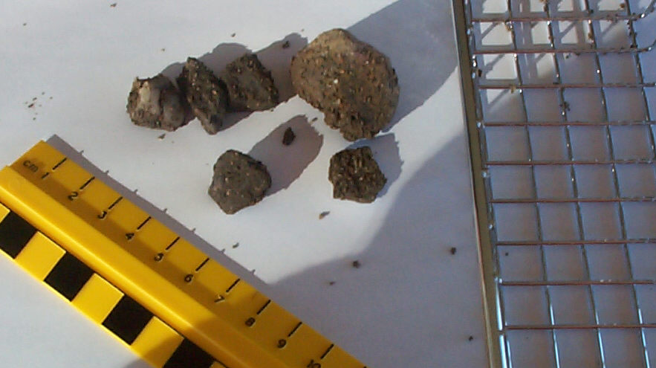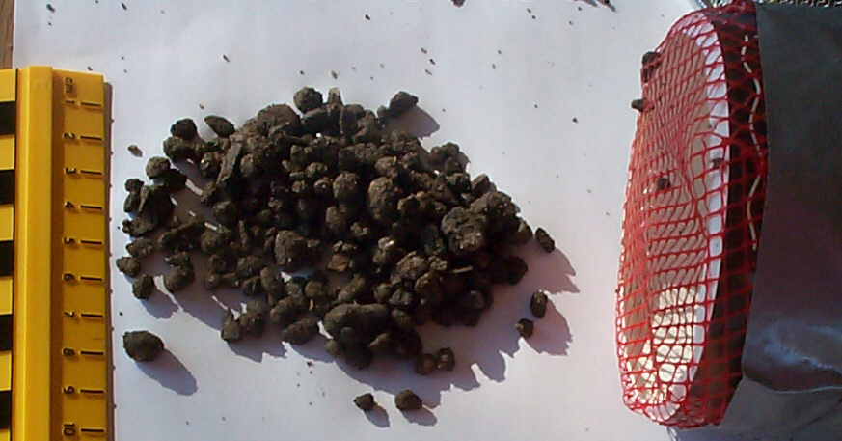
Sampled site First sieve Second sieve

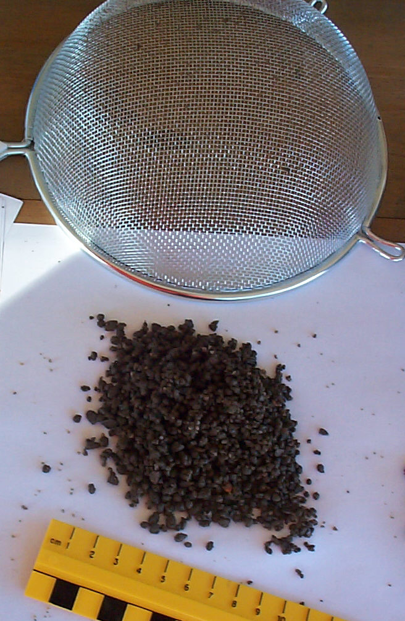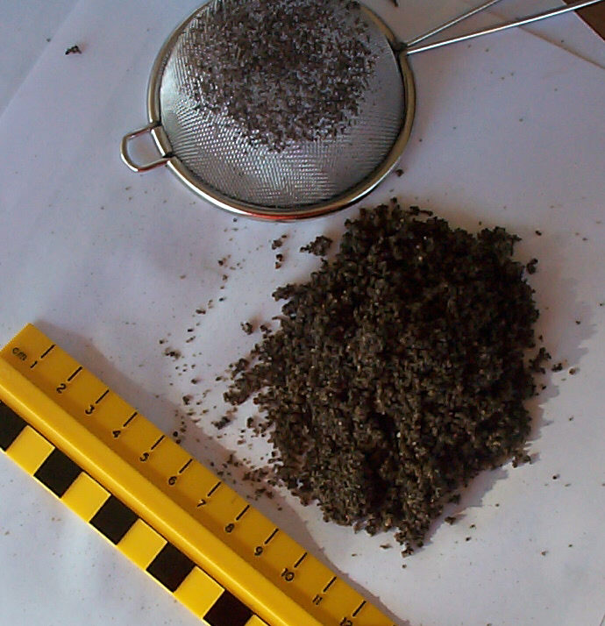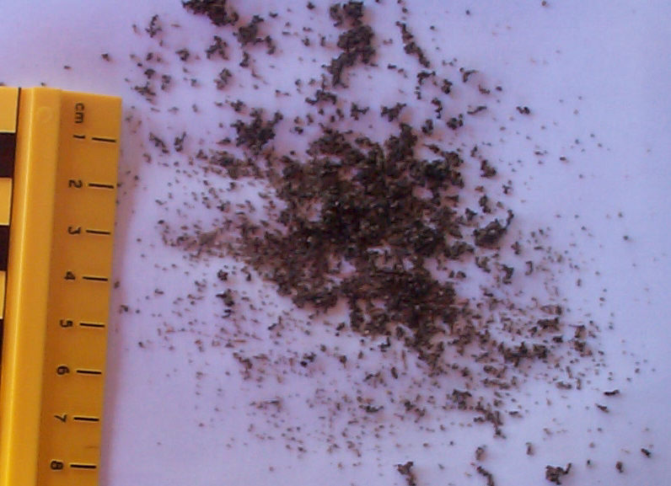
Third sieve Fourth sieve through the smallest sieve
Station 3 – Mixing soil and water

Materials | Test | Teacher note
Waterproof container  Soil  Water | Put soil in the container until it is about half to two-thirds full.  Add water slowly until it is almost at the top of the jar.  Record your observations. | Air bubbles should be observed rising to the surface of the water.  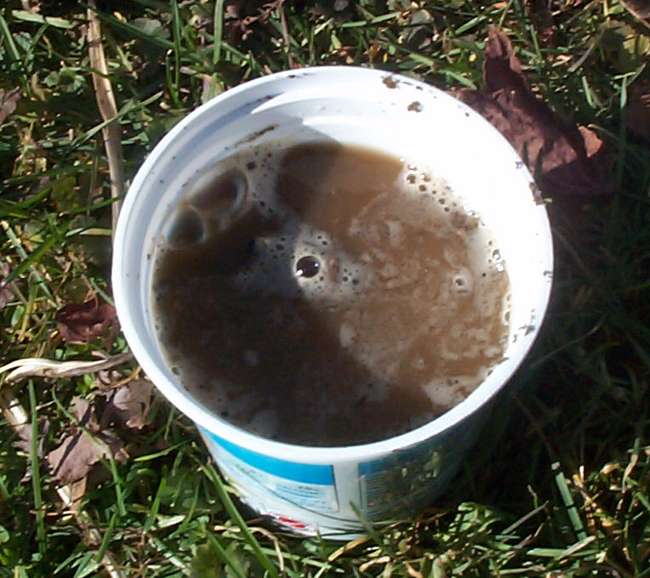

Station 4 – Separating soil with water

Materials | Test | Teacher note
Jar with clear sides and tight lid (tall and narrow is better than wide)  Soil  Water | Put soil in the container until it is about half to two-thirds full.  Fill the jar, almost to the top with water and screw the lid on tight. (You may wish to check.)  Students will mix the soil and water by turning it over, shaking and swirling. Then place it on the counter or table to settle.  Observe when settled.  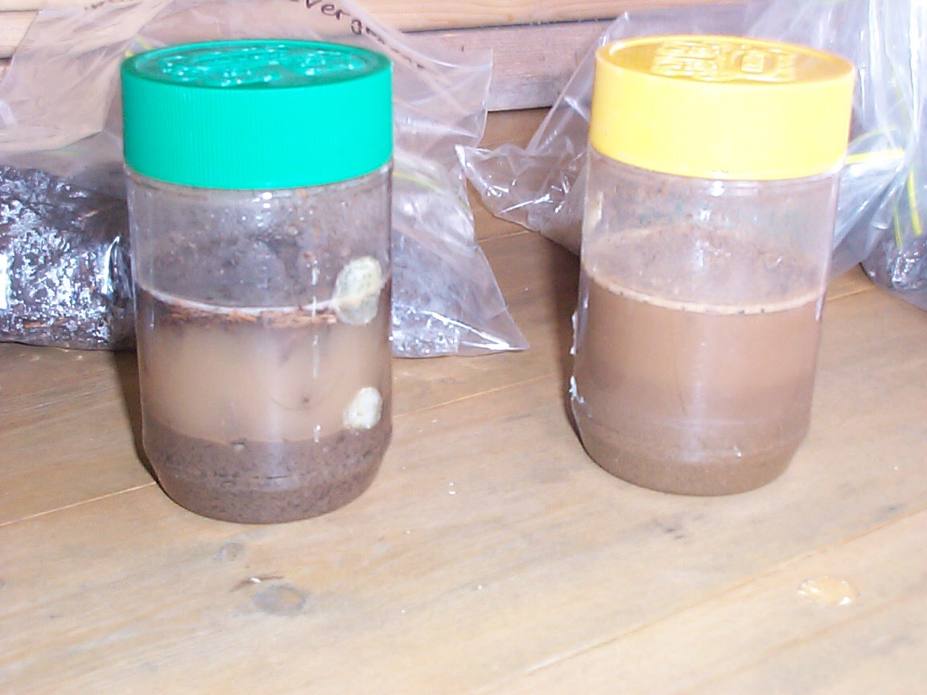 | There is a similar activity in the student book on page 17, however too much information is given. This activity is also described on pages 34-35 of the curriculum document.  Pictures can be taken of each settled jar to refer to later.  Students could be asked to predict by drawing, what they think they will see when the soil settles.  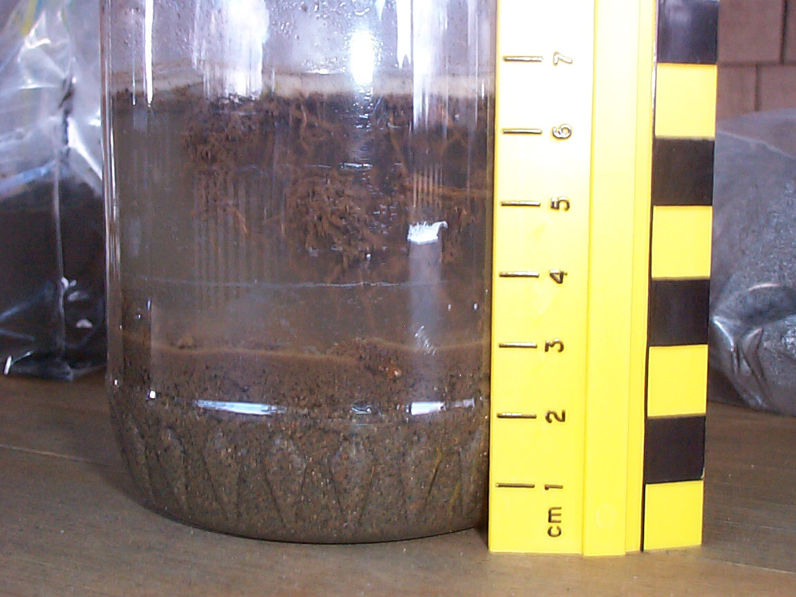

 Teacher note: Each sample will look different with varying numbers and thicknesses of layers. They should settle in this order, from bottom to top:
Gravel - large visible rocks
Sand – coarser grains
Silt – Mud formed from tiny pieces of rocks, finer grains than sand
Clay – slippery, slimy and made of very fine particles, smaller than sand and silt
Humus – dark, moist soil made when food, leaves, sticks, roots and insects die and rot

✓ Assessment:
On observation chart (or other record), note how students are performing on the skill outcomes.

 Reflection: Class Discussion
Cross-curricular links:
ELA
1. Students will be expected to:
a. Describe, share, and discuss thoughts, feelings, and experiences and consider others’ ideas
b. Ask and respond to questions to clarify information and to explore possibilities or solutions to problems
c. Express and explain opinions and respond to the questions and reactions of others
d. Listen critically to others’ ideas and opinions
2. Students will be expected to:
a. Participate in conversation, small-group and whole group discussion, understanding when to speak and when to listen
b. Adapt volume, projection, facial expression, gestures, and tone of voice to the speaking occasion

Health
Demonstrate the ability to interact effectively with others, showing an insight into their emotions and the ability to express their feelings clearly (Explain the importance of communication skills, as well as demonstrate the effective use of these)
Show respect for and attempt to understand the ideas, opinions and feelings of others

To clarify and consolidate vocabulary from the “Four Senses of Soils” activity and also other vocabulary associated with soil (such as sand, silt, clay, rock, organic matter), use the vocabulary during the discussion as it applies to different samples.
Have students share results from station 1. Record their results for sample A, B and C on a class chart. Is there agreement or do students need to discuss their evidence? This is easy to revisit if necessary. Ask:
Are all soils the same?
What kinds of soils fall apart? Make a ball?
Could this be used as a test for soil type?
Have students share results from station 2. Ask:
What did you notice about soils taken from different locations?
Did they have similar amounts of the different particles?
How are they the same and different?
What does this tell us about soils?

Have students share results from station 3:
Why do you think you saw bubbles come up?
What do you think the bubbles contain?
Where do the bubbles come from?
What can we infer is in soil?
Have students share results from station 4. Ask the students:
What happened?
Do all of the jars look the same?
Why does the soil form layers when we shake it and let it settle?
Draw attention to the idea of having a “fair test”. Was this a fair test? Did you use about the same amount of soil and water in the jars? Was there anything that wasn’t the same? (You may have different sized jars that would affect the activity).
What conclusions can we make about soils from all our work? This is information that may need to be added to the ongoing chart begun in the Accessing Prior Knowledge Activity, “Four Senses of Soils” (page 5).
Most soils are a mixture of sand, silt and clay particles, possibly with a few rocks. The following website shows how to make a model for soil with different sized balls and beads. The model also shows how there is room for air and water in soil.
http://www.wtamu.edu/~crobinson/DrDirt/SSTA_TX08.html#balls
Also revisit the “Four Senses of Soils” chart to see if changes need to be made to information already there. Ask: Are there any items that should be added to or revised. Is there other information we could add? Remind your class about respectful discussion. The discussion tips on pages 20-21 may be helpful.

The video “Getting to Know Soil” can be found at http://learning.aliant.net/. The sections beginning at Soil Properties – Soil Types through to Let’s Review are particularly useful at this time as they discuss the various types of soil.
To access the video, type the title into the search box. Videos are available free of charge at this site. You will need to register, however registration is free. If you try to watch the video without logging in, you will be prompted to do so. Note that a table of contents opens beside the video so that you may select only certain sections for viewing if you wish. There is also an option to watch the video full screen.

 Reflection: Journaling
Cross-curricular links:
ELA
8a. Students will be expected to:
Use writing and other forms of representation to
- generate and organize language and ideas
- record experiences
- explore how and what they learn
- Draw, label and talk about what happens when you shake up soil and water and let it settle.
or
- Streams usually have sandy bottoms while ponds often have soft, mucky bottoms. Why do you think that might be?

✓ Assessment:
Journal entries should not receive a score or mark. A positive comment followed by a question to refocus attention or suggest the next step in learning is very effective.
Note whether students can identify that soil has different components with different-sized particles. These heavier particles settle to the bottom first (or stay put in a stream), the lighter particles settle on top (or have the opportunity to settle in a pond with little current).

 Think like a scientist
Asking good questions is an important skill in science. Initially students will need support. Model the skill with the whole class and students will begin to have the confidence to contribute. After some practice, students will be able to generate questions successfully individually.
Present students with a situation and ask them to generate questions that could be investigated scientifically. (These situations and questions do not have to be limited to those that can be done in a classroom.)

Situation:
Barn swallows build mud nests on barns and other structures. The nest is built under an overhang to protect it from the rain. Hundreds of trips are needed to carry the mud to build the cup-shaped nest.
What is one question concerning soil and barn swallow nests that could be investigated scientifically?
For example:
Is there a variety of different-sized soil particles used in the nest?
Which size of soil particle is most common?
Do barn swallows get the soil all from one place?

Possible Extension Activity:
Create edible soils for the students using the recipe from http://www.thekidsgarden.co.uk/TeachingKidsAboutSoil.html
Scroll down to find it under “Fun Activities”

 3rd Cycle

✪ Curriculum Outcomes
100-37 Investigate and describe soil components
100-38b Compare the absorption of water by different soils
200-1 Ask questions that lead to exploration and investigation
201-3 Use appropriate tools for manipulating and observing materials and in building simple models
201-5 Make and record relevant observations and measurements, using written language, pictures, and charts
203-1 Communicate questions, ideas, and intentions while conducting their explorations
203-3 Communicate procedures and results, using drawings, demonstrations and written and oral descriptions

 Soil and Water Activity
Cross-curricular links:
ELA
2c. Students will be expected to:
Give and follow instructions and respond to questions and directions
3a. Students will be expected to:
Use basic courtesies and conventions of conversation in group work
Math
N9 Demonstrate an understanding of addition and subtraction of numbers with answers to 1000
- Using personal strategies for adding and subtracting
SS4 Demonstrate an understanding of measuring mass by:
- Estimating mass using referents
- Measuring and recording mass

Students can work in pairs or small groups to carry out these activities. The students will pour water through samples of soils. By doing this the students will determine which soils absorb the most water. The students will do this twice. In the first test the variables will not be controlled and in the second test the variables will be controlled. The variables are the amount of water and soil. Not only are we determining which soil absorbs the most water, we are also exploring the idea of a fair test.

Ask students: Did you notice some soils are wet and some are dry? I wonder how much water soil can hold?

Materials:
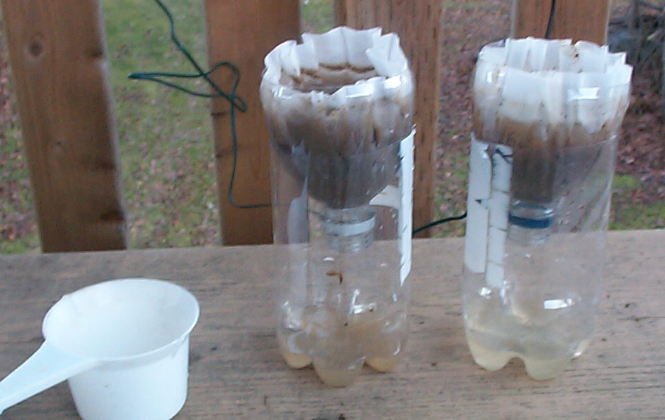
Dry soil samples (sandy soil, clay soil, humus, silt)
Plastic pop bottles with the top portion cut off to be a funnel
Coffee filter
Measuring cups or scoops
Water
Part 1
- Ask students to place the coffee filter into the funnel part of the bottle. It rests in the bottle portion of the bottle. (The photo shows 1L bottle but students would find it easier to use a 2L bottle because of the wider opening.)
- Have them put some soil into the coffee filter. Let them decide how much they would like to use. (Optional: students could use a balance to determine the mass of the soil or water)
- Provide students with a cup or scoop of water to pour onto the soil sample. Each group could be given a different size of scoop or spoon or amount of water in a cup to ensure there is a wide variety of results observed. (This will enrich the discussion about conducting a fair test.)
- The absorption of water by the soil sample can be measured by the amount of water caught in the lower cup. (Optional: have students use a balance to find the mass of the soil sample now or the amount of water that comes out)
Ask students to compare the amount of water they put on the soil with the amount that comes through the soil. The water may need to be transferred to a different sort of container for this comparison to be made. How much water did each group’s soil hold? Why are there differences?
Discuss why this was not a fair test. Different amounts of water were used. Different amounts of soil were used. Develop a fair procedure together as a class (the same amount of soil and the same amount of water used for each sample tested).

Part 2
Ask students to use the method developed by the class to test a variety of soils to see how much water different soils hold.
Make a class chart of results.
Cross-curricular links:
ELA
1. Students will be expected to:
a. Describe, share, and discuss thoughts, feelings, and experiences and consider others’ ideas
b. Ask and respond to questions to clarify information and to explore possibilities or solutions to problems
c. Express and explain opinions and respond to the questions and reactions of others
d. Listen critically to others’ ideas and opinions
2. Students will be expected to:
a. Participate in conversation, small-group and whole group discussion, understanding when to speak and when to listen
b. Adapt volume, projection, facial expression, gestures, and tone of voice to the speaking occasion

Health
Demonstrate the ability to interact effectively with others, showing an insight into their emotions and the ability to express their feelings clearly (Explain the importance of communication skills, as well as demonstrate the effective use of these)
Show respect for and attempt to understand the ideas, opinions and feelings of others

 Teacher note: Clay samples may already contain a lot of water and not provide a very good indication of its ability to hold water. This activity works best if soils are dry to begin with.

 Reflection: Class Discussion
Have students discuss the class results. Ask:
What kind of soil absorbed the most water? The least?
Why might one soil absorb more water than another? (A reference could be made to the balls in a beaker model from Cycle 2.)
Do the different types of soils have different purposes? (This could be tied to where the samples would be located naturally.)
When/where would you want to have soil that absorbs/holds a lot of water?
Would you rather build your house on well drained soil or wet soil?
If willow trees need a lot of water to grow, what sort of soil might it like best?
Why might soil be different in different places?
Students’ attention could also be drawn to the rate at which the water moves through different types of soils. While not required information for this unit, rate of movement is important for water filtration by rocks and soils.

Revisit the “Four Senses of Soils” chart created in the Accessing Prior Knowledge activity (page 5). Ask: Are there any items that should be added to or revised. Is there other information we could add? Remind your class about respectful discussion. This is also a good time to point out that the discussion of evidence leads scientists to change their minds. We can, like scientists, also change our minds.

 Reflection: Journaling
Cross-curricular links:
ELA
8a. Students will be expected to:
Use writing and other forms of representation to
- generate and organize language and ideas
- record experiences
- explore how and what they learn

If you were a groundhog in NB, what sort of soil would you like to dig your home in? Explain why.

✓ Assessment:
Journal entries should not receive a score or mark. A positive comment followed by a question to refocus attention or suggest the next step in learning is very effective.
Note whether students can correctly identify one or two properties of the soil component chosen for their groundhog home.

 Think like a scientist
Asking good questions is an important skill in science. Initially students will need support. Model the skill with the whole class and students will begin to have the confidence to contribute. After some practice, students will be able to generate questions successfully individually.
Present students with a situation and ask them to generate questions that could be investigated scientifically. (These situations and questions do not have to be limited to those that can be done in a classroom.)

Situation:
In Italy the Tower of Pisa has been gradually tipping sideways. One side was sinking into the soil.
What is one question concerning the soil and the tipping of the tower that could be investigated scientifically?
For example:
Does the soil under the tower have a lot of water in it?
What size of soil particles are in the soil around the tower?
What are the components of the soil in that spot?

This site may be helpful to review and summarize ideas learned about soil. S.K.Worm, the official annelid, or worm, of the Natural Resources Conservation Service answers students' questions about soil. http://www.nrcs.usda.gov/feature/education/squirm/skworm.html

Possible Extensions:
It is possible to search http://www.cbc.ca/news/ to find news items relating to the topic(s) under study to discuss as a class. For example:
Floods, mudslides and avalanches close B.C. highways
http://www.cbc.ca/canada/british-columbia/story/2009/01/07/bc-heavy-rains-avalanche-risk-close-highways.html
Hundreds rescued from Taiwan mudslides – also talks about the death toll which might not be appropriate. There is a good picture.
http://www.cbc.ca/world/story/2009/08/11/taiwan-typhoon-china-011.html
Greens see red over soil erosion – case of wind blowing soil from a farmer’s field into an adjacent yard in PEI.
http://www.cbc.ca/canada/prince-edward-island/story/2007/02/16/greens-soil.html
Anti-erosion plan simple but effective – a case of minimizing soil erosion from a farm
http://www.cbc.ca/news/story/2000/04/24/peiErosion24apr00.html

Supporting Class Discussion
No one person is as smart as all of us together.
Page Keeley, in the book “Science Formative Assessment” (2008), uses the analogy of ping-pong and volleyball to describe discussion interaction. Ping-pong represents the back and forth question-answer pattern: the teacher asks a question, a student answers, the teacher asks another question, a student answers, and so on. Volleyball represents a different discussion pattern: the teacher asks a question, a student answers, and other students respond in succession; each building upon the previous student’s response. Discussion continues until the teacher “serves” another question.
A “volleyball” discussion encourages deeper student engagement with scientific ideas. Students state and give reasons for their ideas. Through the interaction, ideas may be challenged and clarified. Extensions and applications of ideas may arise as well. Discussions should avoid the personal and always revolve around ideas, explanations and reasons. The goal is for students to achieve better understanding.
Share the ping-pong and volleyball analogies with your students. Good discussion takes practice. You and your students will improve. Many teachers find discussion works best if all students can see each other, such as in a circle, at least until they become accustomed to listening and responding to each other.
As the teacher, you will need to:
- establish and maintain a respectful and supportive environment;
- provide clear expectations;
- keep the talk focused on the science;
- carefully orchestrate talk to provide for equitable participation.
At first, discussions are apt to seem somewhat artificial. Initially, a bulletin board featuring cartoon talk bubbles with suggested sentence starters may be helpful.
I disagree because . . .
I had a different result . . .
Could you show how you got that information?
When I was doing ___, I found that . . .
Even though you said ___, I think . . .
The data I have recorded in my notebook is different from what you shared. I found . . .
I observed . . .
It is important to establish discussion norms with your class. Your expectations may include:
- Everyone has a right to participate and be heard.
- Everyone has an obligation to listen and try to understand.
- Everyone is obliged to ask questions when they do not understand.
- The speaker has an obligation to attempt to be clear.

It is helpful if teacher questions refer to a big idea rather than specifics. (Could humans and chickens move their bones without muscles?) Questions should be phrased so that anyone can enter into the conversation. Opinion questions are especially good for this (What do you think . . . ?
How do you think . . . ? What if . . . ? Why . . . ?).

Provide plenty of wait time for students. Students give more detailed and complex answers when given sufficient wait time. Allow wait time after student responses. When students are engaged and thinking, they need time to process other responses before contributing. If the discussion is not progressing, have students engage in partner talk. Partner talk enables the teacher the opportunity to insert “overheard” ideas.
Helpful teacher prompts:
- What outcome do you predict?
- Say more about that.
- What do you mean by . . . ?
- How do you know?
- Can you repeat what ____ said in another way?
- Does anyone agree or disagree with . . . ?
- Does anyone want to add to or build on to . . . ?
- Who understands ___’s idea and can explain it in their own words?
- Let me see if I have got your idea right. Are you saying . . . ?
- So you are saying that . . .
- What evidence helped you to think that?
- Okay, we do not agree. How does each position fit the evidence? What else could we find out?

References:
Keeley, Page (2008). Science Formative Assessment. Thousand Oaks, CA: Corwin Press and Arlington, VA: NSTA Press

Michaels, Sarah, Shouse,Andrew W., and Schweingruber, Heidi A. (2008). Ready, Set, SCIENCE! Washington, DC: The National Academies Press

Materials List
Baggies
Newspaper
Magnifying glasses
Trays (foil, plastic, or Styrofoam)
Various sieves (can be made from mesh and plastic containers)
Measuring cups, or scoops and/or spoons
Soil samples (silt, sand, humus, clay, pebbles, organic matter)
Clear jars with lids
Various containers
Water
Clear pop bottles (cut in two)
Coffee filters
Optional: balance scale

Grade 3 Science kits given to schools in 2010 contain:
Clear field tray with iron filings (1)
Large horseshoe magnet (1)
Bags of latch magnets (containing 6)
Bag of doggie magnets (containing 6)
Magnetic marbles (bag of 12)
Floating magnet set (with wooden dowel)
Pair of 1 ½ inch bar magnets
Pair of 2 inch bar magnets
Magnetic lodestone (1)
Cow magnet (1)
Horseshoe magnets – 3 inch (2)
Wand magnets
4 neodymium magnets
Set of 8 soil samples
Two squares of different sized screens

Small metal sieve

Student Version of Outcomes
100-36 I will tell ways that soils are the same and ways that they are different

100-37 I will explain what I observe in different soil parts

100-38a I will mix soil with water and let it sit for a while to see the layers in the soil

100-38b I will develop a fair test to compare different types of soil when they are mixed with water.

200-1 I will write questions that I can do experiments to answer.

200-3 I will make predictions based on a pattern I have seen.

201-3 I will use the right tools correctly to observe and build.

201-5 I will record my observations using writing, pictures and/or charts.

203-1 I will explain my questions, ideas and what I am trying to do during an investigation.

203-3 I will use drawings, demonstrations, writing and/or talking to share procedures and results.

Letter to Parents:

Dear Parents,

We will be starting our next science unit. To begin this unit the class will make observations of soil and its components.

I am sending home a baggie and would like to have your child collect some soil. Students should decide where they collect the “dirt” from. Any area they identify will do if free from pesticides and herbicides. They will need approximately two cups.

Have fun and please contact me if you have any questions.

Sincerely,

Characteristics of Soils Activities

Station 1
- Put a small pile of soil on the tray.
- Add enough water to make the soil moist.
- Try to roll a small ball of soil.
- Try to roll a worm of soil.
- Record the result with words and pictures.
- Repeat this for two other types of soil.
Can balls or worms be made with all the soils?
What sorts of soils seem to make the best balls or worms?
Would you expect other soils with those characteristics to make good balls or worms?

Station 2
- Break apart any lumps in the dried soil sample.
- Put the sample into the sieve with the largest holes. Shake over the tray until all the smaller particles have gone through the holes.
- Dump the soil particles still in the sieve onto a sheet of white paper.
- Put the material on the tray into the sieve with the next smallest holes and shake over the tray until all the smaller particles have gone through the holes.
- Put what remains in the sieve onto another sheet of paper.
- Continue sifting using a sieve with smaller holes each time.
- Record your results with words and pictures.
- Use a balance to determine the mass of soil particles on each piece of paper (different sizes). Create a bar graph of the amounts of soil from each sieve.
- Repeat the procedure for two other types of soils.
What do you notice? How are the graphs the same and different?

Station 3
- Put soil into a waterproof container until it is about one-half to two-thirds full.
- Add water slowly until it is about 2 cm from the top of the container.
- Record what you see happening with words and pictures.

Station 4
- Put soil into the container until it is about one-half to two-thirds full.
- Fill the jar almost to the top with water and screw the cover on tight.
- Mix the soil and water by turning the container upside down, shaking it and swirling it.
- Place the container on a counter or table to settle.
- Record your observations with words and pictures.
- Repeat with other soil samples.
What happened? Why do you think it happened? Do all of the jars look the same?

Soil and Water Activity

- Place a coffee filter into the funnel-shaped part of the pop bottle. Set it into the bottom part of the pop bottle.
- Put some soil into the coffee filter.
- Pour some water onto the soil, being careful to keep it inside the coffee filter.
- Compare the amount of water that soaks through with the amount you put in.
Compare your results to the results of other groups.

Observation Chart Sheet
Outcomes:
name | name |  | name |  | name |  | name
name |  | name |  | name |  | name |  | name
name |  | name |  | name |  | name |  | name
name |  | name |  | name |  | name |  | name
name |  | name |  | name |  | name |  | name
name |  | name |  | name |  | name |  | name

Observation Checklist
names | 100-36 Explore and describe a variety of soils and find similarities and differences among them | 100-37 Investigate and describe soil components | 100-38a Describe the effect of moisture on characteristics (e.g., cohesion-ability to hold together, texture, colour of the soils) | 100-38b Compare the absorption of water by different soils | 200-1 Ask questions that lead to exploration and investigation | 200-3 Make predictions based on an observed pattern | 201-3 Use appropriate tools for manipulating and observing materials and in building simple models | 201-5 Make and record relevant observations and measurements, using written language, pictures, and charts | 203-1 Communicate questions, ideas, and intentions while conducting their explorations | 203-3 Communicate procedures and results, using drawings, demonstrations and written and oral descriptions

Checklist Sheet

Outcomes | Correlations with Cycles | Yes | No
100-36 Explore and describe a variety of soils and find similarities and differences among them | 1st cycle: Student foldable chart; class discussion; journal  2nd cycle: station activities; class discussion; journal
100-37 Investigate and describe soil components | 1st cycle: student foldable chart; class discussion; journal  2nd cycle: station activities; class discussion; journal  3rd cycle: water absorption activity; class discussion; journal
100-38a Describe the effect of moisture on characteristics (e.g., cohesion-ability to hold together, texture, colour of the soils) | 2nd cycle: station 1 and 3 activities; class discussion; think like a scientist
100-38b Compare the absorption of water by different soils | 3rd cycle: activity; class discussion
200-1 Ask questions that lead to exploration and investigation | 2nd cycle: class discussion; think like a scientist  3rd cycle: class discussion; think like a scientist
200-3 Make predictions based on an observed pattern | 2nd cycle: class discussion; journal
201-3 Use appropriate tools for manipulating and observing materials and in building simple models | 2nd cycle: station activities  3rd cycle: activity
201-5 Make and record relevant observations and measurements, using written language, pictures, and charts | 1st cycle: Student foldable chart; journal  2nd cycle: station activities
203-1 Communicate questions, ideas, and intentions while conducting their explorations | 1st cycle: activity  2nd cycle: station activities  3rd cycle: activity
203-3 Communicate procedures and results, using drawings, demonstrations and written and oral descriptions | 1st cycle: student foldable chart; class discussion; journal  2nd cycle: station activities; class discussion  3rd cycle: developing fair test discussion; class discussion

Student Record
Outcome goal | Evidence
I can tell ways that soils are the same and ways that they are different. (100-36)

I can explain what I observe in different soil parts. (100-37)

I can mix soil with water and let it sit for a while to see the layers in the soil. (100-38a)
I can develop a fair test to compare different types of soil when they are mixed with water. (100-38b)

I can write questions that I can do experiments to answer. (200-1)

I can make predictions based on a pattern I have seen. (200-3)

I can use the right tools correctly to observe and build. (201-3)

I can record my observations using writing, pictures, and/or charts. (201-5)

I can write and draw how I did something and what I observed with my five senses. (203-3)

