Nutritional Analysis: A Day-Trip and the Choices You Make
On Saturday you’re going to Halifax for the day to go shopping (and maybe stop at the casino). You’ve planned to leave bright and early at 6:00 AM and head home at around 6:00 PM. You’ve set aside some spending money for merchandise, but you’ve also budgeted for eating three meals.

Meal 1 (6:05 AM): McDonald’s is right there before you hit the highway – too tempting to resist! You decide to buy an orange juice, one hash brown, and a bacon and egg bagel.
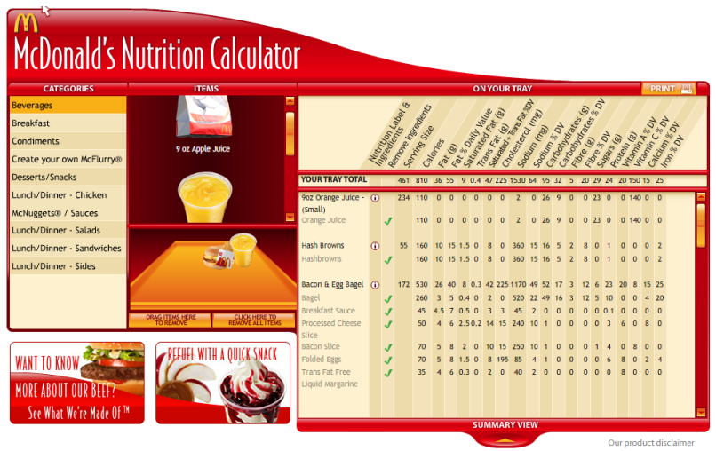

Meal 2 (11:45 PM): After a couple hours of shopping at the MicMac Mall, A&W is looking pretty good…besides, it’s not like you eat fast food all the time. You only have A&W once in a while and you deserve a treat. You decide to go big: A Cheddar Bacon Uncle burger, medium fries, a medium root beer, and a small coleslaw. Coleslaw is nutritious, right? Sure it is. That’ll cancel out some of the junk food. Good call.
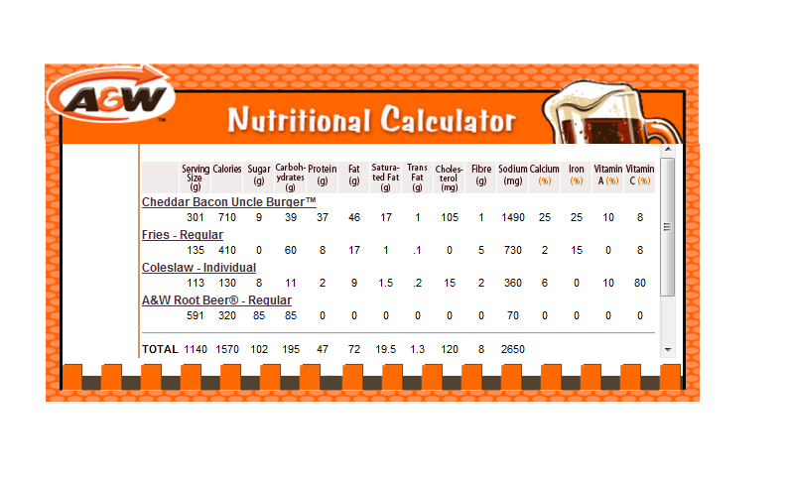

Meal 3 (5:20 PM): It’s suppertime - better find a Subway! You think you’ll feel better after a healthy meal than you did after lunch. You decide to get a foot-long Chicken and Bacon Ranch sub. Thank goodness Subway is there providing nutritious alternatives. You say no to the meal deal…you spot a Dairy Queen and a medium Cookie Dough Blizzard is calling your name once you start thinking ‘dessert.’
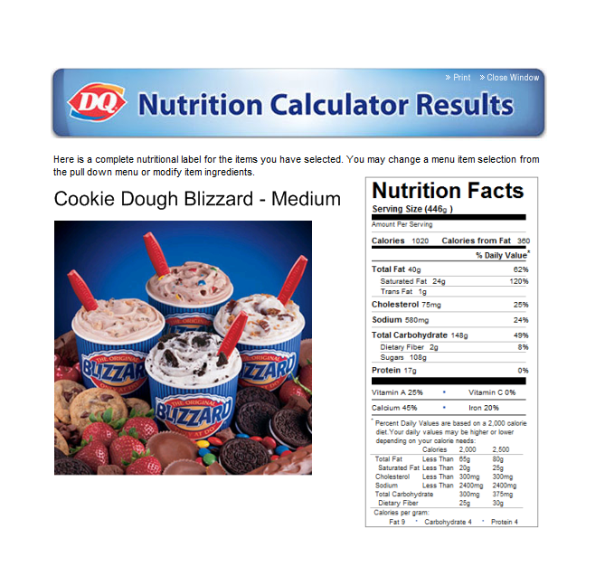
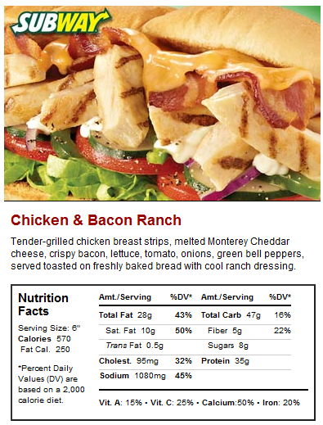

It’s been a long day but you’ve had fun. You even managed to come in under your food budget because of your meal choices. Some of the others made different food choices than you because they were concerned about what Mr. Gallant was saying about nutrition in class, but you still think that you did fairly well!

Questions:

- Without analysing the nutritional labels, what is your opinion about the food choices you made today? Explain.
- Fill in the table provided.
- In class, we calculated the number of calories you should be ingesting each day in order to maintain your current body weight. What was yours? What was your total caloric intake for your day in Halifax? By how much were you under or over?
- (a) For EACH of the items within your meals, calculate the percentage of calories that came from fat. Which items were over the recommended value?
(b) Considering the items that exceeded the recommended percent of calories from fat, how did the saturated and trans fats compare to unsaturated fat?
- (a) For the production of certain hormones and proper construction of cell membranes, it is recommended that people above the age of 4 consume a maximum of 300 mg of cholesterol per day. What was your total cholesterol intake for the day? How much were your under or over?
(b) If you continued making such dietary choices on a regular basis throughout your life, what type of health issues are at risk of developing?
- For proper blood volume and cell functions, it is recommended that people ages 9 to 50 consume 1500 mg of sodium per day. What was your total sodium intake for the day? How much were your under or over?
- For proper bone and tooth development, blood clotting, and muscle and nerve function, it is recommended that youth ages 9 to 18 consume 1300 mg of calcium per day. What was your total calcium intake for the day? How much were your under or over?
- You’re going on another day-trip shopping in Maine next month. What changes might you make to your regular eating habits so that you can still enjoy some treats like these? Consider what meals you might have throughout the day and discuss.

Items consumed | Serving Size (g) or (in) | Calories | Total Fat (g) | Saturated Fat (g) | Trans Fat (g) | Unsaturated Fat (g) | Cholesterol (mg) | Sodium (mg) | Total Carbohydrates (g) | Fiber (g) | Sugar (g) | Complex Carbohydrates (g) | Protein (g) | Vitamin A (%DV) | Vitamin C (%DV) | Calcium (%DV) | Iron (%DV)
Small OJ
Hash Brown
Bacon and Egg Bagel
Cheddar Bacon Uncle Burger
Medium Fries
Coleslaw
Medium Root Beer
6” Chicken and Bacon Ranch Sub
Medium Cookie Dough Blizzard
TOTAL

