December: Activity Periods
Mondays | Drama  Mrs. Sooley  Room 201/Cafe | Babysitting Course  Mme. Matthews  Room 210  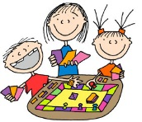 | Beginner Band  Mrs. Haughian  Music Room | Bracelets  Mme. LeBlanc  Room 305  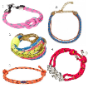 | Basketball  Mrs. Scott  Gym
Tuesdays | Band  Mrs. Haughian  Music Room  3pm | Badminton  Mr. Butler  Gym (30 max) | Snack Session Gr 6  Mrs. Oland/Mrs. Hussey  (16max) | Fencing  Ms. Marr  Cafeteria  (12 max)  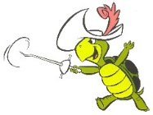
Wednesdays | Leadership  Mrs. Jensen  Mr. Shea  Room 307 | Christmas Cards  Mrs. Patullo  Art Room | Cursive Writing  Mrs. Horgan  Room 207 | Beginner Band  Mrs. Haughian  Music Room | Ultimate Frisbee  Ms. Marr  Gym
Thursdays | Band  Mrs. Haughian  Music Room  3pm | Glee²  Mrs. Salvea and  Ms. Marr/Mrs. Simon  Cafeteria  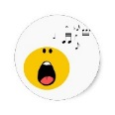 | Soccer Baseball  Ms. Marr  Gym | Christmas Crafts  Mrs. Horgan/Mrs. Haines/Mrs. Soodan  Room 207
Fridays | Drama  Mrs. Sooley  Room 201/Cafe | Board Games  D&D  Ms. Marr  Room 205 | Floor Hockey  Mr. Butler  Gym
Library/Consequence Room
 | MON  Mrs. Horgan | TUES  Mr. Butler | WED  Mrs. Matthews | THURS  Mme. Blanc | FRI  Mme. Simon

