February: Activity Periods
Mon | Ski Club  Mrs.Haughian  Ms. Marr  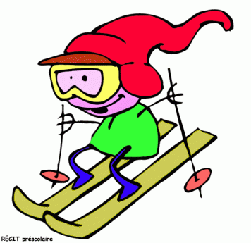  Poley (full) | Snow Shoeing  Mrs. Scott  Common  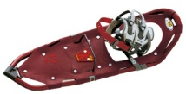 | Checkers Ping Pong  Mrs. Matthews  Cafeteria
Tues | Band  Mrs. Haughian  Music Room (3pm) | Drama  Ms. Marr  Room Cafeteria | Snack Session  Gr 8 (16 max)  Mrs. MacKinnon  Mrs. Hussey | Boot Camp  Mrs. McCallum  Gym
Wed | Leadership  Mrs. Jensen  Mr. Shea  Room 307 | Drama  Mrs. Sooley  Room 201/Cafe | Skating  Ms. Marr  Common | Badminton  Mr. D. Butler  Gym | German Part II  Mrs. Patullo  Art Room
Thurs | Band  Mrs. Haughian  Music Room (3pm) | Hockey  Mr. Wallace  Common | Talent Show  Mr. D. Butler  Tech Lab | Bench Ball  Mrs. LeBlanc  Gym | Science Challenge  Mme. Sooley  Room 201
Fri | Drama  Mrs. Sooley  Room 201/Cafe | Floor Hockey  Mini Sticks  Mr. E. Butler  Gym

