January: Activity Periods
Mon | Ski Club  Mrs.Haughian  Ms. Marr  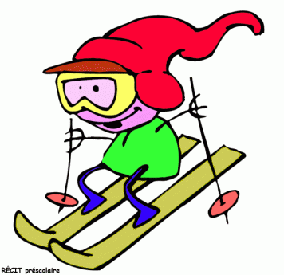  Poley (full) | Chess  Mme. Matthews  Room 210 | Knitting  Mme. Richard  Mme. Leblanc  Room 30
Tues | Band  Mrs. Haughian  Music Room (3pm) | Drama  Ms. Marr  Room Cafeteria | Snack Session  Gr 7 (16 max)  Mrs. Oland  Mrs. Hussey | Badminton  Mr. D. Butler  Gym (30 max)
Wed | Leadership  Mrs. Jensen  Mr. Shea  Room 307 | Drama  Mrs. Sooley  Room 201/Cafe | Skating  Ms. Marr  Common | Spoken Word Poetry  Mrs. Patullo  Art Room
Thurs | Band  Mrs. Haughian  Music Room (3pm) | Yoga  L. Young  Mrs. Jensen  Cafeteria | Art Journaling  Mme. LeBlanc  Room 305 | Talent Show  Mr. D. Butler  Tech Room | Hockey  Mr. Wallace  Common | Science Challenge  Mme. Sooley  Room 201 (full)
Fri | Drama  Mrs. Sooley  Room 201/Cafe | Floor Hockey  Mini Sticks  Mr. Butler  Gym | Board Games  D&D  Mrs. M  Room 205
Library/Consequence Room

