MAY: Activity Periods
Monday | Tuesday | Wednesday | Thursday | Friday
Badminton  (Grade 8)  Mrs. Horgan  Gym   | Board & Card Games  (Max. 20)  Mr. Urquhart  Room 302  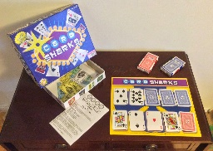 | Badminton  (Grade 7)  Mrs. Horgan  Gym | Badminton  (Grade 6)  Mrs. Horgan  Gym | Walking Club  (Max. 15)  Mrs. Hussey  Gym Lobby  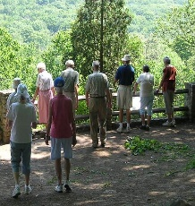
Soccer  (Grades 6-8)  Mme. Matthews  Commons   | Soccer Baseball  Mrs. MacDonald  Commons   | Healing Group  Ash Sewell  Mrs. Hussey  Room 305  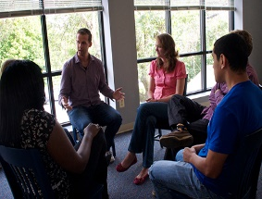 | Board Games  Mrs. Hussey  Room 305  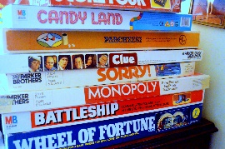 | Garden Club  Mme. Simon  Room 209  
Clay Earrings ($4.00/person)  (Max. 15)  Mrs. MacDonald  Room 301   |  | Tech Club  Mr. Gray  Room 101   | Basketball  Mrs. McCallum  Commons  
Diversity Club  Mrs. C. McGrath  Room 205   |  | Extra Review  (Grade 7/8)  Mr. Urquhart  Room 302  
Math Support  (Grade 8)  Mrs. McCallum  Room 310   | Drama Rehearsal  (Until 3:45 pm)  Mme. Sooley  Cafeteria   | Math Support  (Grade 6)  Mme. Matthews  Room 210 | Drama Rehearsal  (Until 3:45 pm)  Mme. Sooley  Cafeteria  
Library  Mme. Simon | Library  Mme. Simon | Library  Mme. Simon | Library  Mme. Simon | Library  Mr. Urquhart
Consequence Room  Ms. Derrah | Consequence Room  Ms. Derrah | Consequence Room  Ms. Derrah | Consequence Room  Ms. Derrah | Consequence Room  Ms. Derrah

