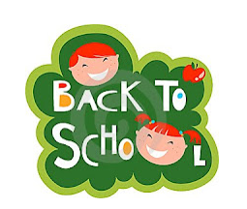
4imprint

BRHS 2021-2022 School Supply List (revised June 29, 2021)

Students must supply at least 2 of their own masks everyday preferably with their name on it.

All students are required to bring their own water bottle as well preferably with their name on it.

1 Memory Stick (8 gig or more)
5 - 6 Packages of Loose-leaf
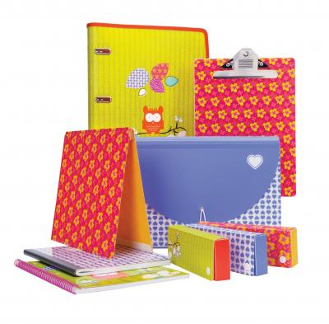
* Enough pens, pencils and erasers for the entire year (several packages)
1 Protractor
1 Scientific calculator
1 Ruler
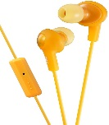
1 Head set/ear buds for computer work
1 Pair scissors
1 Package of graph paper
2-4 Packages of notebooks
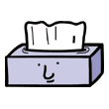
1 Large zipped binder with dividers OR 6 separate smaller binders
1 Sketch book
1 Glue stick
1 Pencil case
1 Package of computer paper (given to homeroom teacher)
2 Boxes of Kleenex (to be given to homeroom teacher)
Gym clothes
Gym sneakers

