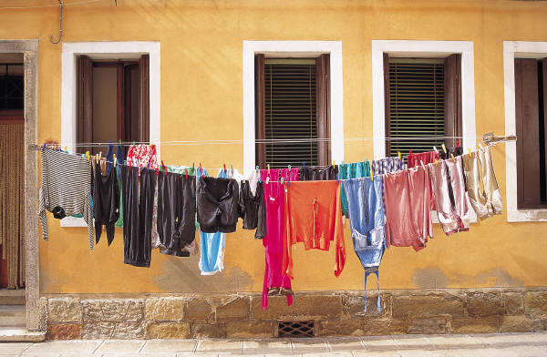
Bon Vivant’s Packing List
Here is a list of packing items that we’ve put together to help you prepare for the tour. We have also included a few tips that have helped students and teachers on previous tours!
Packing Tips

- Since you will be walking a lot, comfortable shoes are essential.
- Make sure that your luggage is light enough so that you can carry it on your own.
- You may want to take a look at the weather forecast right before packing, so that you can plan accordingly.
- You may also want to save some space for gifts and souvenirs upon your return from the tour.
- Shampoo, conditioner and soap will be available at your hotel. Not bringing your own can save space and weight.
Items

- Comfortable walking shoes (running shoes and or sandals)
- Shirts and t-shirts
- Shorts, pants and jeans
- 1 pair of nicer pants/dress for dinner or boat cruise
- Socks and underwear
- Night wear
- Raincoat/wind breaker/small dollar store plastic rain poncho
- Compact umbrella (if there is forecast for lots of rain)
- Toothbrush and toothpaste
- Deodorant
- Hairbrush or comb
- Sunscreen and sunglasses
- Hat or cap
- Contact lenses and solution (if applicable)
- Soap and shampoo (unless you choose to use the ones provided by the hotel)
- Medication (if applicable)
- Alarm clock
- Watch
- Water bottle
- Small day pack to carry a sweater/umbrella, water bottle, etc.
- Camera with memory cards and battery charger
- Wallet, with a bit of cash and/or gift cards and/or a debit card *** It is strongly recommended that you set up a Debit Card now if you do not already have one. It takes several weeks for the card to arrive in the mail.
- Medicare card
- Travel insurance (If applicable: company, policy number and phone number in case of emergency)
- Friends and family’s addresses in case you want to send them postcards while on tour

