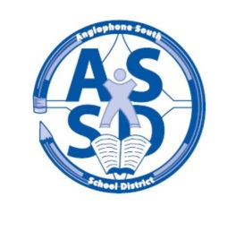
ANGLOPHONE SOUTH SCHOOL DISTRICT
2016-17 SCHOOL CALENDAR

2016
August 29 Administration Day for Staff
30-31 Council Days for Staff

September 1 Administration Day for Staff
5 Labour Day – No Classes
6 Grade 9 students only
7 Classes for all students K-12 in the District

October 6-7 Professional Learning Days for Staff – No Classes
10 Thanksgiving Day – No Classes

November 11 Remembrance Day – No Classes
25 Parent Teacher Student Conferences K-12 – No Classes

December 23 Last Day of First Term – half day of classes

2017
January 9 Professional Learning Day for Staff – No Classes
10 First Day for Students
23-27 High School Exam Week (Grades 9-12)
30-31 Turnaround Days (Grades 9-12 only – No Classes)

February 1 Start of Second Semester
24 Professional Learning Day for Staff – No Classes

March 6-10 March Break – No Classes
31 Grades K-12 Parent Teacher Student Conferences – No Classes

April 14 Good Friday – No Classes
17 Easter Monday – No Classes
28 Professional Learning Day for Staff – No Classes

May
5 Provincial Council Day – No Classes

19 Hampton Education Centre only - AEFNB & NBTA Meeting - No Classes
22 Victoria Day – No Classes

June 12-16 High School Exam Week (Grades 9-12)
23 Last Day for Students
26-27 Administration Days for Staff

