Hampton High School
School Improvement Plan
2017-2020
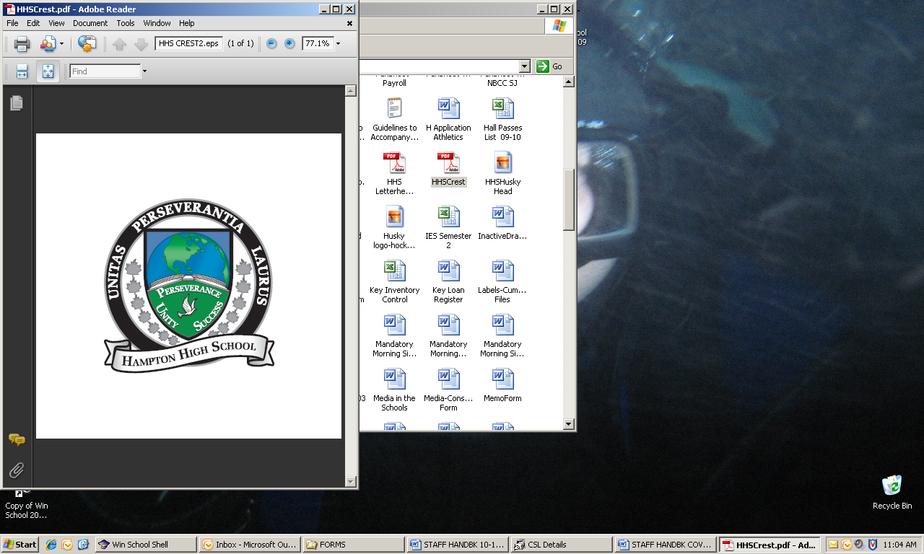

Vision Statement
To develop students’ character and integrity by providing encouragement and opportunities for student success.

Mission Statement
To prepare students to be productive citizens of integrity through the development of their potential in academics, athletics and the arts.

Values
Our school community will support and recognize academic success
Excellence will be modeled through responsible citizenship within our school community
Teachers will encourage life-long learning
Students will take responsibility for their learning

Code of Conduct
The Husky Way
Be Responsible
Be Respectful
Be Committed

School Profile
Hampton High School is a comprehensive school comprised of grades 9-12. Along with a strong connection to community, we nurture the academic, emotional and physical needs of our students. By instilling a sense of pride in all we do, we create a positive learning environment where the individual needs for students are met. The opportunity for each student to meet their full potential is encouraged by the whole school community.
Geographic Boundaries of Student Population
The Town of Hampton, as well as the Kingston Peninsula, Bloomfield, Passekeag, Lakeside, Smithtown, Titusville, Barnesville, Upham, Darlings Island, Nauwigewauk and French Village make up the school’s drawing area.
Summary of Enrollments by Grade
All data is as of 30 September 2017
Pupil Data
Grade (English Prime) | Number of Students | Grade (French Immersion) | Number of Students
9 | 58 | 9 | 60
10 | 83 | 10 | 64
11 | 83 | 11 | 60
12 | 108 | 12 | 57
Total |  |  | 573

Staff Data
Teachers | Educational Assistants | Librarians | Admin Assistants
37.3 | 10 | 1 | 2

Programs and Services Offered
Hampton High School offers a full range of programs including:
- Advanced Placement (AP) exams offered in the following areas:
- English Language and Composition
- English Literature and Composition
- Calculus AB
- Psychology
- Level 1,2,3 and 0 Academic Programs
- French Immersion (Early and Late) Maintenance Grades 9-12
- Skilled Trades
- Justified Accommodations, Modifications and Individualized Programs to fit the educational needs of students
- Partnership with New Brunswick Association for Community Living transition to the workplace
- UNESCO Associated School
History
Hampton High School opened its doors to students in September 1992 as a grade 10-12 school of approximately 613. Prior to the school’s opening, the last time high school students were educated in Hampton was at Hampton Consolidated School which closed its doors to high school students in 1975 with the opening of Kennebecasis Valley High School.
In 1996, grade 9 students from Hampton Junior High School moved to Hampton High as part of the transition to a 9-12 high school model. In 1997, grade 9 students from Macdonald Consolidated School moved to Hampton High School. With a population of 836 an addition of four classrooms was added to the building.

2017-2020
SMART GOALS
FOR
STUDENT ACHIEVEMENT

PLC – Literacy and Learning Commons

SMART Goal: Implement the emotional resilience project in grade 9 curriculum units by September 2018 based on the text Strong Teens: A Social & Emotional Learning Curriculum
PIP Objective #__3____ |  | DIP Ends Policy #___3__
Performance Target: By June 2020, all grade 9 English classes will include elements of social-emotional learning.
Foci | Strategies | Indicators of Success | Time Line | Responsibility | Status Updates
With the number of students unable to deal with stress, this is a recognition that students need training to help them deal with the challenges of life. | - Implement CASEL (Collaborative for Academic, Social and Emotional Learning on website, CASEL.org.). CASEL breaks it down into 5 sections to assist with lesson planning: Self-awareness, self-management, social awareness, responsible decision making and relationship  skills. Create mini lessons and incorporate into regular curriculum lesson. Goal is to adapt it to the novel Cue for Treason.  - Design assessments around the emotional resilience training. Rob Mather visited grade 9 classes Jan. 16 &17, 2018 and presented info to students about emotional resilience and physical consequences of stress. | - Emotional resilience will be integrated into assessment and evaluation. Ex: List different emotions and then find precise vocabulary to describe these emotions. Then apply this specific vocabulary to the novel.  - Students are better able to describe their emotions and to deal with emotional challenges. Include writing options about emotional resiliency in formative and summative evaluation. | 1. At the end of the Cue for Treason unit in semester 2, 2018, students demonstrate knowledge of vocabulary that precisely describes a character’s emotions. Assess how the character deals with emotions in the text and to examine the decision-making process of the character.  2. 2018-2019 – The action research project begins. The Emotional Resilience framework will be expanded and adapted to the Short Story unit and the semester 1 novel unit (the Chocolate War or The Outsiders).  3. June 2019 – The action research project is evaluated and revised. | 1. Grade 9 teachers of both English and Social Studies.  2. Grade 9 teachers in both English and Social Studies. | - Toby Stoddart has created lesson plans that are embedded in grade nine curriculum. These Emotional Resilience themed lesson plans are being piloted in all grade nine English classes.
Data Collection | Regular meetings for grade 9 teachers of English and Social Studies to share and to make suggestions for improvement. | Students demonstrate expanded vocabulary and skills regarding emotions. | Once per semester or when professional learning time is available. | Grade 9 teachers of both English and Social Studies. | End of each semester 2018-19

PLC- Humanities

SMART Goal: To create a syllabus for each Humanities course which includes 3 sections: a breakdown of the course content and outcomes, a section which outlines assessment (formative and summative) and well as the use of triangulation in marking schemes, teacher contact
PIP Objective #____7__ |  | DIP Ends Policy # 2
Performance Target: By June 2020, all Humanities courses will use the common format for course syllabi ensuring that all components are included and being adhered to.

Foci | Strategies | Indicators of Success | Time Line | Responsibility | Status Updates
Assessment | - Reviewing syllabi at the beginning of each semester to ensure that all assessment objectives are discussed. | - All teachers have common syllabi which adhere to the SMART goal. | 2018-2020 | Humanities SPR  Humanities teachers | - Planning Stage
Curriculum | -To ensure that proper categories are being used in Power School (bins) | -That all teachers are putting the same weight formulas for each of the assessment methods | 2018-2020 | Humanities SPR  Humanities teachers | - Planning Stage
Data Collection | - To consistently monitor syllabi each semester and make adjustments where necessary | - Common syllabi for each course | 2018-2020 | Humanities SPR  Humanities teachers | - Planning Stage
PLC- Languages

SMART Goal: To create a syllabus for each Languages course (FI, PIF) which includes 3 sections: a breakdown of the course content and outcomes, a section which outlines assessment (formative and summative) and well as the use of triangulation in marking schemes, teacher contact (with some exception in PIF courses).
PIP Objective #__7,8____ |  | DIP Ends Policy # 2
Performance Target: By June 2020, all Languages courses will use the common format for course syllabi ensuring that all components are included and being adhered to.
Foci | Strategies | Indicators of Success | Time Line | Responsibility | Status Updates
Assessment | - Reviewing syllabi at the beginning of each semester to ensure that all assessment objectives are discussed. | - All teachers have common syllabi which adhere to the SMART goal. | 2018-2020 | Languages SPR  Languages teachers | - Planning Stage
Curriculum | -To ensure that proper categories are being used in Power School (bins) | -That all teachers are putting the same weight formulas for each of the assessment methods | 2018-2020 | Languages SPR  Languages teachers | - Planning Stage
Data Collection | - To consistently monitor syllabi each semester and make adjustments where necessary | - Common syllabi for each course | 2018-2020 | Languages SPR  Languages teachers | - Planning Stage

S.T.E.M. (Science, Technology, Engineering, Math)

SMART Goal: To create a syllabus for each S.T.E.M. course which includes 3 sections: A description and overview of course outcomes; an assessment section which includes formative assessment, reporting using triangulation of data and a marking breakdown; a teacher contact information section.
PIP Objective #4 & 5 |  | DIP Ends Policy # 2
Performance Target: 100% of S.T.E.M. courses will have modified their syllabus to include the 3 sections noted above by September 2018
Foci | Strategies | Indicators of Success | Time Line | Responsibility | Status Updates
Curriculum: | Each STEM course syllabus will include a description and overview of course outcomes taken directly from the curriculum document. If there is no curriculum document, then these outcomes must be clearly stated and be a true reflection of what students are expected to have learned by the end of the course. | All course syllabi will include a course description and outcomes that match the curriculum documents. Those with no curriculum documents, will be a true reflection of what students are expected to have learned by the end of the course. | By September 2018 | All members of the STEM PLC.
Assessment | Syllabi will include a definition of assessment (including formative and summative) as well as an explanation of how assessment will be used to support student learning. It will also include a marking breakdown and category weighting based on outcomes/themes being covered in the course. | Students and parents will be able to articulate the benefits and differences between formative and summative assessment.  Category weighting, as indicated on the syllabus, will be available to both students and parents on Power School (live). | By September 2018 | All members of the STEM PLC.
Data Collection | Ongoing evidence will be collected through conversations, observations, and products. | Data collected will be used to inform teaching both for individual students as well as groups of students. Teachers will be able to speak to the individual strengths and weaknesses of students and have a plan for how to address these weaknesses. | Ongoing | All members of the STEM PLC.

PLC- Fine Arts, Trades/ Technology and Wellness

SMART Goal: 1) Promote all STTE, HPE and Fine Arts courses to HHS Students; 2) Gather evidence of student learning through a variety of Balanced Assessments and use this information to further instructional decisions and effectively assess student comprehension.
PIP Objective #__1,6,7__ |  | DIP Ends Policy # 1
Performance Target: By June 2020, The Fine Arts, STTE and Wellness PLC will continue to demonstrate course options to students, promote program growth and student success through a variety of balanced assessment methods. Students will continue to receive opportunities for conferencing, self-reflection and career exploration. Students will continue to feel a sense of mental fitness and belonging in a safe and inclusive learning environment (DIP 1; Links to objectives 1, 6 and 7 of the 10 year plan).
Foci | Strategies | Indicators of Success | Time Line | Responsibility | Status Updates
Curriculum | 1) Continue to circulate and discuss options with potential students prior to courses selection time.  2) Continue to receive Professional Development and time to discover and implement new assessment practices. | 1) Fine Arts, STTE and Wellness courses will maintain current level and/or increase number of student applications.  2) Teachers acquire information on student needs and use balanced assessment to positively impact student learning and success rates within our classrooms. | 1) Noticeable enrollment increases prior to Sept.2019.  2) Teachers should feel comfortable using a variety of balanced assessment practices and should start implementing them Sept. 2018. | 1) Fine Arts, STTE and Wellness department staff.  2) Fine Arts, STTE and Wellness department staff. | 1) Strategies in progress.  2) Strategies in progress.
Assessment | 1) Course selection forms – quantitative data (numbers)  2) Student success rates- quantitative, quality and variation of student assessments- qualitative, and teacher reflections. | 1) and 2)  Higher level of engagement from students with formative assessments.  Students can communicate what they have learned through a variety of methods.  Students are assessed using balanced assessment practices (e.g. formative, summative, triangulation of data, etc.)  Increased student engagement yields fewer behavioral issues.  Students will have better understanding of best-suited post-secondary program options for future success. | 1) Late Spring 2019 – quantitative data (enrollment) available upon completion of course selection.  2) Ongoing assessment practices 2018-2020- Quantitative data (student success rates) available upon completion of the course.  Qualitative data (quality of student work and variation of assessments given) will be ongoing and monitored by the teacher throughout the semester as well as teacher reflections. | 1) Fine Arts, STTE and Wellness department staff (for application courses), guidance, administration.  2) Fine Arts, STTE and Wellness department staff. | 1) Strategies in progress.  2) Strategies in progress.
Data Collection | 1) Quantitative data on student enrollment and formative assessment.  Qualitative data (feedback forms) on students’ course experiences.  2) Quantitative data on student success and formative/summative assessments.  Qualitative data (feedback forms) on students’ course experiences. | 1) Hard and digital data available through course selections, grades, and feedback forms.  2) Higher success rates in subject areas, feedback forms, portfolio evaluations, etc. | 1) Beginning Spring 2019.  2) Beginning Fall 2018. | 1) Fine Arts, STTE and Wellness department staff, guidance, administration.  2) Fine Arts, STTE and Wellness department staff, SPR, administration. | 1) Strategies in progress, and ongoing.  2) Strategies in progress, and ongoing.

