HAMPTON HIGH SCHOOL

STUDENT HANDBOOK
2015-2016

34 Elizabeth Avenue
Hampton, NB E5N 5P7

Telephone: (506) 832-6024
Fax: (506) 832-6054

Web: www.hamptonhigh.ca

Principal: Mr. A. Davis Vice-Principal: Mr. R. Chapman
Vice-Principal: Mrs. R. Southard
Counselor: Mrs. K. Hovey

This agenda belongs to:

NAME
ADDRESS
CITY/TOWN
POSTAL CODE
PHONE
STUDENT NO.
HOMEROOM

Mission

To prepare students to be productive citizens of integrity through the development of their potential in academics, athletics and the arts.

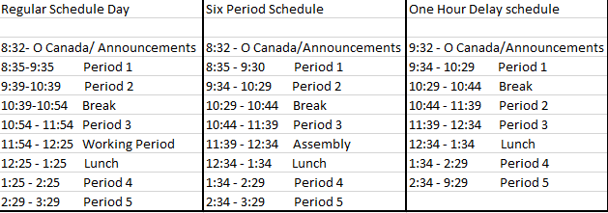

SCHOOL CALENDAR 2015-2016

September 8 Grade 9 Students Only
9 All students grades 9 – 12
October 8-9 Professional Learning Days for Staff – No Classes
12 Thanksgiving Day – No Classes
November 11 Remembrance Day – No Classes
26 Parent Teachers Interviews – 4:30 to 7:30 pm
27 No classes- Parent Teacher Interviews – 8:30 to 11:30 am
December 18 Last Day of First Term – full day

January 5 First Day for Students
25-29 High School Exam Week (Grades 9-12)
February 1-2 Turnaround Days (Grades 9-12 Only – No Classes)
3 Start of Second Semester
March 7-11 March Break – No Classes
25, 28 Good Friday & Easter Monday – No classes
31 Parent Teacher Interviews- 4:30 to 7:30 pm
April 1 No Classes- Parent Teacher Interviews 8:30 to 11:30am
May 6 Provincial Council Day – No Classes
20 Hampton Education Centre only - AEFNB & NBTA Meeting - No Classes
23 Victoria Day – No Classes
June 13-17 High School Exam Week (Grades 9-12)
24 Last Day for Students

NOTE: Two Professional Learning Days to be determined.

STUDENT FEES
Each grade 9 student at Hampton High School is required to pay a student fee of $40.00 which covers the cost of having a locker, a HHS data stick, student agenda, a student ID card, and helps the Student Council purchase and finance a host of programs, activities and materials. It also covers the cost of a lock which they are expected to keep until they graduate.
Each grade 10, 11 and 12 student is required to pay a student fee of $25.00 which covers the cost of a HHS data stick and student ID.
Replacement locks cost $5; only school locks can be used on lockers. Lockers are assigned with the expectation that all book bags will be stored in them. Agendas and USBs can also be purchased in the office.
Additional course fees for 2015-2016 include:
Mill & Cabinet 120 $15.00 each
Framing & Sheathing 110 $15.00 each
Residential Finish 120 $15.00 each
Applied Technology 110 $15.00 each
Intro to Electronics 110 $10.00 each
Culinary Tech 110 and 120 $20.00 each
Visual Art 9 and 10 $20.00 each
Visual Arts 110 & 120 $40.00 each
Outdoor Pursuits 110 $85.00 each
Computer Aided Design $5.00 each
Robotics $10.00 each
Band Fee $40.00 each
Glee Fee $15.00 each

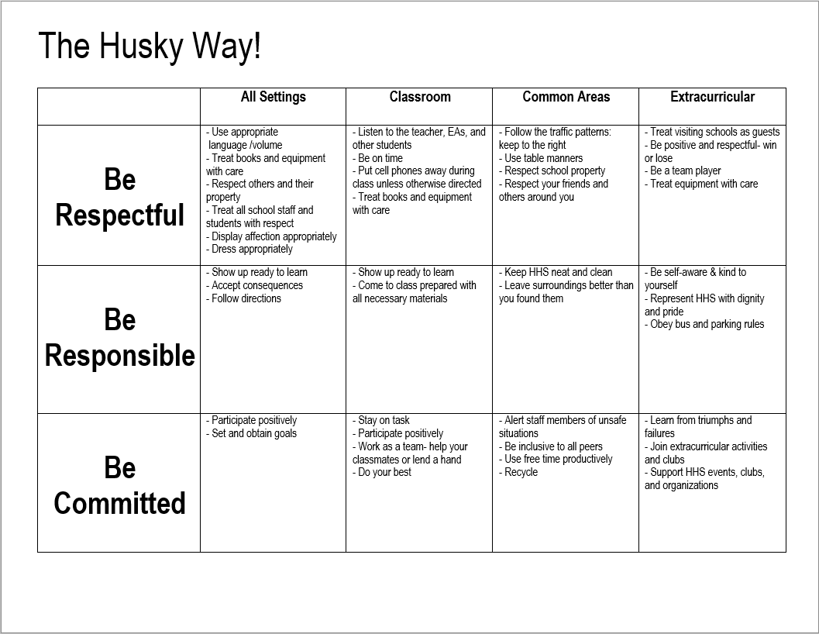
POLICIES AND PROCEDURES
STUDENT BEHAVIOUR
Students are expected at all times to treat school property, school staff, fellow students and themselves with consideration and respect. All staff and other people affiliated with the school through extracurricular activities at Hampton High have the right and responsibility to expect acceptable student behavior.
Some specific expectations are as follows:
- Students are to be punctual for class and for handing in assignments.
- Students are expected to come to class prepared, and to keep course materials, lockers neat and well-organized.
- Students are expected to complete all homework assignments and to be responsible for catching up on work they have missed.
- Students are permitted to have only water during class time. There is to be no food during classes.
- Profane language is not permitted.
- Students are not permitted to have any illicit substances (including alcohol) and/or paraphernalia on school property.
- Students are not permitted to fight under any circumstances.
- Cheating on tests, exams and assignments will result in parents being notified and no value being given for the work.
- The throwing of snowballs is not permitted on school property.
- Students are not permitted in the wooded area surrounding the school at any time during the school day.
- Personal electronic devices are not permitted to be used during instructional hours unless explicit direction is given by the teacher.
- Washroom use should be limited to breaks. Students are no permitted out of class during the first and the last fifteen minutes in a period. When emergencies do rise the students are expected to take an appropriate time out of class and to use the closest washroom.

DRESS CODE
Students are expected to be neat, clean and modest in appearance. Anything with offensive messages or which promotes drugs, profanity, sex, racism or violence is not permitted to be worn in school.
Clothes should not expose undergarments; shorts and skirts must be at least at mid-thigh in length and tops are to connect with the bottoms covering the waist and chest. No spaghetti straps, tied halter or tube tops are permitted.
Head covering of any sort for both genders are not permitted unless they are a prescribed religious article.

DISPLINARY PROCEDURES
(Specific consequences will be outlined on our website)

If students do not abide by the rules within a classroom, they can expect to be disciplined by the classroom teacher. Continued poor behavior may include a referral to the Vice Principal, loss of school privileges or the assignment of detentions. In addition, and in accordance with Anglophone South School District policy, a warning letter will be sent to parents. After this, the student faces suspension from school. In the case of very serious infractions, students can be suspended immediately without a warning letter being sent. Fighting, playing with fire, smoking on school grounds, possession of illegal substances, or extreme insolence towards a staff member are examples of serious infractions.

Suspensions can vary in length from one day to the remainder of the semester. If a student is suspended from school for a second time, he/she and at least one parent may be required to meet with a school administrator to review the student’s behavior and establish conditions for a return to school. A third suspension from school may result in a request to the Senior Education Officer to suspend the student for the remainder of the year.

After-school detentions are held from 3:30 – 4:30 pm every Tuesday and Thursday in room 110. Students who choose to miss their detention will have a follow up meeting with their Vice-Principal and receive a one day suspension. Periodically, searches of lockers will be conducted by school administration to ensure cleanliness and absence of contraband materials.

According to Anglophone South District policy, the Principal is required to report to the RCMP any act which could result in criminal charges being laid. This includes fighting, theft, sexual offenses, possession of illegal drugs or any incident involving fire. The possession, use or association with alcohol or illegal drugs on school property or at any school event is viewed very seriously and will automatically result in a 5 day suspension from school and charges being laid by the police. This type of activity will not be tolerated at Hampton High School.

APPEALS PROCEDURE
Appeals of suspensions are possible if the student has accumulated more than five (5) days suspension in any one school year. Appeals should be made to the School Principal within 10 days of receiving the suspension letter.

NON-SMOKING
Hampton High School is a smoke free environment. Therefore, smoking is not permitted anywhere on school grounds. Each classroom is provided with a map of the school property with indicated the smoke free area. Students who wish to stand and smoke must walk to Main Street and stand on the Main Street side of the railroad tracks in order to smoke.
Once off the school property, students may light cigarettes and smoke while walking toward Main St.

Consequences for not abiding by this policy are:
1st offence – Confiscate material, telephone parents, warning letter
2nd offence – 1 day out of school suspension
3rd offence – 3 day out of school suspension
4th offence – 5 day out of school suspension

Some student smokers share cigarettes. Therefore, it should be quite clear that, if a student is on school property and one or more members of the group are smoking, all students in the group will be punished.
To assist students with their efforts to stop smoking, HHS is working with Ridgewood Addiction Services to provide program and support. This policy includes e-cigs.

SCHOOL PROPERTY
All students are encouraged to take pride in their school and treat school property with respect. This includes not only the building itself, but the textbooks, equipment, lockers and library books. If students damage or lose school property, they are expected to make restitution.

ATTENDANCE PROCEDURES
It is vitally important that students attend school and classes on a regular and punctual basis. With semester courses, every class is very important and should not be missed without a very good reason. If a student must be absent, or tardy, following are some general guidelines:
- A phone call or note in advance from a parent or guardian to the teacher is helpful to assist with planning.
- A note to the office should be submitted when the student returns, or the student is subject to a school detention
- Students must provide each of their teachers with advance notice if they will be absent because of a school related activity.
- Students who arrive at school late or leave early must sign in/out at the office
- Teachers will enter a mark of zero for any forms of evaluation missed due to an absence. This zero will be replaced with an actual mark once the student has completed the evaluation report upon their return to that class.

ATTENDANCE GUILDLINE
When a student misses at least one subject period Synervoice will make a call home each evening to notify parents of any absence(s). After five (5) missed subject periods, a message will be sent home stating the student has missed said time without providing an excuse. The homeroom teacher will meet with the student and determine if a referral to the Guidance department is necessary. When a student has missed ten (10) subject periods, a second message will be sent home and a Vice Principal may choose to meet with the student and call home.

If vacation time is taken outside of the prescribed holidays as indicated in the school calendar, please be aware that it is not the responsibility of the teacher to provide class work, assignments, projects etc. in advance of the vacation, or, to tutor the student upon their return. It is strongly recommended that the student make arrangements with a classmate to complete any missed notes, handouts, etc. upon return. It is also strongly advised that if a student is facing academic struggles that parents will reconsider taking the student away from valuable class time. Assignments and tests missed during time away will be recorded as zero until missed work is completed for each subject teacher. All missed work must be completed within a reasonable time (preferably a week upon return to school) and will be at the discretion of the subject teacher.

Research clearly confirms the strong connection between regular attendance at school and success.

PROMOTION POLICY
In accordance with the Department of Education, all students at Hampton High School are required to maintain a mark of 60% in each course in order to be successful in the course.
Students in Grades 11 and 12 are on a credit system and are required to successfully complete 17 out of 20 possible credits, as outlined in the Course Calendar, available on the school’s website.

Students in grades 9 and 10 have a common curriculum consisting of Math, English, French, Social Studies, Science and specialty subjects Art, Music, Physical Education and Broad Based Technology. Students in grade 10 may take one elective and upon successful completion will have one credit towards graduation.

Promotion meetings are held at the end of each school year and, on the basis of input from all the student’s teachers, a determination is made as to whether the student should repeat the year, attend summer school, or be recommended for a specific program.

ADVANCED PLACEMENT (AP) EXAMS
Students writing an exam in Advanced Placement courses are:
- Required to pay a fee of $115.00 per exam and register through Mr. Davis
- Able to miss other classes the day of an AP exam (May)
- To be marked with an ‘S’ in attendance for a school related absence and
- Are responsible for all missed work (teachers will continue teaching as usual)

LITERACY INITIATIVES
The grade 9 Professional Learning Community completed an English Language Proficiency Assessment (E.L.P.A) Preparation Manual, and it will be used by all grade 9 teachers at HHS again next year (and available to all teachers provincially). The manual now functions as the foundation for genre mapping, currently being undertaken at the high school level in our district. We will continue to promote literacy across the curriculum, especially at the grade 11 and 12 levels. Improved scores in the ELPA have reduced the number of required class sections of Literacy 110, but that course continues to run for students struggling with the provincial assessment.
We will also continue to promote those literacy initiatives developed at the school level, including: book clubs, library acquisitions and promotions, PISA strategies, website pages etc…, as well as district literacy initiatives. Many teachers in the English Learning Community have websites available to support student success. The resources provided and linked on those pages are there to assist students in their literacy development.

STUDENT COUNCIL
Engagement in Democratic process is an important role that all Canadians should take seriously. Hampton High School’s Student Council is committed to this idea and places great importance on the election process so that students know their voices are well represented.
Staff Advisors: Ms. Finnigan, Mrs. Fry, Mrs. Lawson, Ms. Merry, Mrs. Perkins
Student Executive: President: Riley Cosman
Vice President: Ben Gesner
Secretary: Kadie MacDonald
Treasurer: Levi Willet
Grade 9 reps: Jack Kelly, Erica Stoddard
Grade 10 reps: Josh LeBlanc, Haley VanWart
Grade 11 reps: Jordan Davis, Benjamin Agrell
Grade 12 reps: Reece Kelley, Julia Golding
Volunteer Coordinators: Paige Stevenson, Madeline Levesque

The Student Council conducts student government in the school, looks after finances for student groups (in accordance with administration and advisors), represents interests of the students, does some fund-raising and organizes student activities such as SRC assemblies, presentations, transition day and special events. HHS spirit clothing will also be on sale at various times throughout the year.

PARKING/DRIVING ON SCHOOL PROPERTY
It is a privilege to drive to school and students who wish to bring vehicles to school must park in the assigned student parking areas. Students may park at the back of the school on the gravel/paved area but do so at their own risk. Any student who parks in an area not designated for their use risks being towed at the owner’s expense. A student who chooses to drive recklessly at school will no longer be permitted to drive on school property. All vehicles must be registered in the office and be showing their parking permit at all times. Parking permits may be purchased at the main office for $2.

SCHOOL/COMMUNITY PARTNERSHIPS
It is of great importance to us that Hampton High School maintains a close and supportive relationship with parents and the community. We therefore encourage parents to seek involvement in school programs and activities. Some areas in which parents might be able to assist include: driving students to games and events, assisting with Drama productions, acting as guest speakers in classes and coaching sports teams. If any parent would like to help or has questions or concerns, please contact us.

PARENT SCHOOL SUPPORT COMMITTEE (PSSC)
Parents will be receiving information when school beings on our Parent School Support Committee. By government mandate, every school in New Brunswick has a PSSC which serves in an advisory capacity on school issues. Elections for a number of positions take place in September. This Committee has served a very valuable role in the past helping develop a School Improvement Plan, Mission Statement, erecting a Reader Board in front of the school, conducting a Parent Perception survey and developing a number of initiatives to improve school life.

HAMPTON HIGH SCHOOL EXTRA CURRICULAR PARTICIPATION GUIDELINES
Students who participate in extracurricular activities and represent the school through their participation are expected to maintain an acceptable level of behavior in class, attend all classes, go to class prepared (with homework completed) and be passing a minimum of 3 out of 5 courses. When considering academic standing the reporting periods of January and June will be used to determine continuing eligibility. Regarding eligibility, participation is based on the last semester enrolled. Thus, if a student drops out/quits school, then they must complete the entire semester prior to the season. Should a student be absent without excuse from school on the day of a game or event, they will not be able to participate in any extracurricular activities that day. In the case of drama productions, students may risk eligibility for future participation in school based and/or out of school productions.
If these guidelines are contravened by a student participating in an extracurricular activity, he/she will be warned by the teacher involved and corrective action will be at the teacher’s discretion. At this point the teacher will contact the Athletic Director who will then follow through contacting both the faculty advisor/coach and the parents about the student’s situation. If the problem continues, the student risks suspension from the extracurricular activity. The teacher will contact an administrator and review the case. The administrator will then contact the Athletic Director who in turn will contact the faculty advisor/coach involved about the action to be taken.
Any discipline referrals to the office resulting in an out of school suspension will also include, as a minimum, a suspension from the student’s next game/event. Continued failure to comply with these stipulated conditions may result in the student being suspended from participation in any extracurricular activities for the remainder of the semester. Other consequences may follow from a student’s failure to adhere to school law and/or District policy.
Any student involved in the use of drugs and/or alcohol while at school or during a school event, will be suspended for 5 days and become ineligible to participate in any extracurricular activities for the remainder of the athletic season or until the end of the exam period of each semester, whichever is longest. If the incident occurs within two weeks of the end of any semester the suspension from any and all extracurricular activities will carry over until the end of the subsequent semester.
Students participating extracurricular activities will be informed of these guidelines by the faculty advisor/coach. Given the above guidelines, it is also recognized that each case will be unique and any action will be considered in that light.

EXTRA CURRICULAR ACTIVITIES
Hampton High School offers a wide variety of extracurricular activities and encourages all students to participate in at least one of these in order to expand and develop their interests. All athletic fees and participation fees are non-refundable. Included in our huge variety of activities are the following:

- Sports
- Intramural sports (at noon)
- Student Council
- Yearbook Committee
- Drama
- Tech Crew
- Reach for the Top
- Grad Class Committee
- Band
- Glee
- Green Team
- Amnesty International
- Girls Group
- Gay/Straight Alliance
- John Peters Humphrey Model U.N. Team
- Hampton Ed Center –Strings Orchestra
- MINGA

Students who choose to become involved in sports will also be expected to pay an athletic fee which is a portion of the substantial costs involved in the operation of a high school sports team. Students must pay their student fee in order to participate on a varsity school team. Please see Athletic Director for accurate sport fees.

EXTRA-CURRICULAR RECOGNITITION
An end of year extra-curricular awards banquet will be held to recognize the achievement, participation and success of students involved in all extracurricular activities. This includes activities related to the arts and athletics.

SCHOOL CHEER

WE ARE THE HUSKIES!
WE CAN, WE CAN, WE CAN FIGHT!
WE CAN, WE CAN, WE CAN BITE!
WE WILL, WE WILL WIN TONIGHT!
WE ARE THE HUSKIES!
WOOF!

