Hat Policy/Bikers

We ask that student take their hats off once they enter the school. As well, we kindly ask that students disembark from their bikes once they are on school property. Students are responsible for locking their bikes to the bike rack. The school is not responsible for lost or damaged bikes.

Homework Policy

The collective philosophy of staff at Chris Saunders Memorial in regard to “homework” is that literacy and numeracy skills development take place between a parent and child in a manner that is both positive and enjoyable. Therefore, we do not promote the practice of students taking work sheets home to practice reading, writing and numeracy concepts through simple repetition. Instead, we believe more targeted and meaningful learning will occur if a parent reads a “good fit book” with their child each night for 15 to 30 minutes. In numeracy, we suggest that parents, with their child, play “math games” that support basic, but important math concepts. Teachers will provide parents with a suggested list of math games and activities and/or easy-to-use websites that reinforce numeracy skills. The main purpose of homework is for parents to work closely with their child to develop a better understanding of their child’s strengths and weaknesses in both literacy and numeracy. Learning at home should be fun, positive and stress-free.
Student Behaviour

Student Behaviour: Please be aware of the behaviour expectations for our students and the consequences for misbehaviours:

Based on the beliefs that all students can and want to learn in a safe and positive environment, school personnel will intervene when the misbehaviours of individuals disrupt the school environment.

Behaviours which interfere with student learning and the right to a positive educational environment for all students are not acceptable at school or school sponsored events.

When they occur, there will be consequences. Some behaviour may be curbed through the collaborative effort of home, school and community. Significant and ongoing disruptive behaviour may result in removal from school or classroom environment for a period of time. When behaviour poses an immediate threat to the safety of others (posing a physical and/or emotional threat), the student will be removed from the situation at once. Chris Saunders Memorial has created a New Responsibility/Behaviour Code:

Caring, Honest, Respectful, Inclusive & Safe

All staff will be constantly reviewing this code with all students to ensure a safe and positive learning environment. Any student who fails to practice Caring, Honest, Respectful, Inclusive and Safe will be subject to consequences. Some examples of consequences are: detention, loss of privilege, removal from co/extra-curricular events, etc. Repeated behaviours against this code will result in a written warning or possible suspension. After two warnings, the student will be suspended and/or may lose extra-curricular privileges. Severe behaviour for example: fights, threats, weapons, belligerence, extreme defiance or illegal substances will result in immediate suspension without warning.

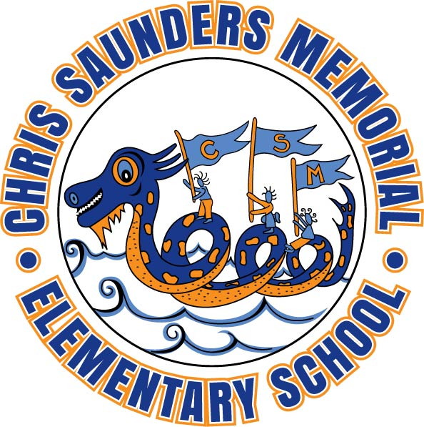

CHRIS SAUNDERS MEMORIAL SCHOOL
PARENT HANDBOOK

2016 - 2017

