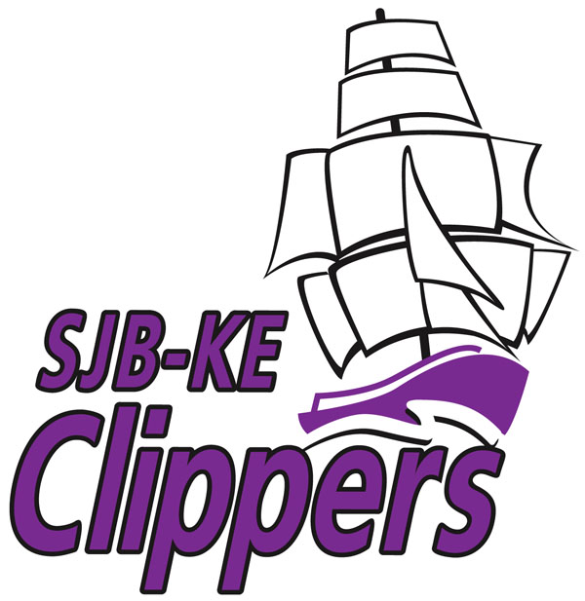
ST. JOHN THE BAPTIST-KING EDWARD SCHOOL
223 St. James Street, Saint John, NB E2L 1W3

Telephone: (506) 658-5357 Fax: (506) 643-2818

Principal Vice-Principal

Mrs. Christine Roy Mrs. Hamilton -Brown

January 6, 2021
Dear Clipper Families
As you know, we are once again in the Orange Phase. Thank you to all families for a successful return to school. Starting Monday, we participated in the ‘mask up’ campaign- all students and staff wore masks on Monday and Tuesday- our students are very resilient and easily adapted to wearing them. Staff have been very sensitive to student’s needs through this time, giving them various mask breaks throughout the day. As a result, today’s transition to Orange was a bit easier as we have already been operating with major COVID precautions. We were very glad to see that attendance today was normal.
We know it is disheartening for people to be back in the Orange Phase. We encourage parents to model calm for their children. We are practicing Social-Emotional learning in our classrooms, supported by our Guidance Counsellor, Mrs. Datta. Students are understanding their different emotions and are learning to recognize when these cause stress and anxiety. Staff are working to implement strategies to effectively manage these issues. If families are struggling in any of these areas, please reach out to us at the school- we are here to help support you and your children.
A few reminders about Orange Phase:Before sending your child to school each morning, please make sure you have completed the COVID Screen Test (see attached sheet). It is very important not to dismiss or overlook even mild symptoms- as per Dr. Russell’s directives, if your child is not well, KEEP THEM AT HOME, and follow all public health directives- these are posted on www.gnb.ca/coronavirus or call 811.
It is imperative that the school has emergency contact numbers in case your child is sick. If your child becomes ill, they MUST go home.
Please remind your children about the importance of wearing a mask, frequent hand washing, keeping proper distance, and limiting contacts to one household bubble. Thank you to all parents who have been wearing their masks on school premises during drop off and pick-up times. This will continue, as per standard protocols in September; while on school grounds, please be mindful of the need to maintain 6 feet of distance from others wherever possible.
Microsoft Teams:Since September, the province and school district have re-iterated the importance of having parents and students connected to Microsoft Teams in the event school is ever closed. WE recognize that many of our parents ARE connected, especially at the Middle School level, however, we are not having as many parents connect at K-5 levels. We need your support in this area. We understand this is a new way of doing things and that not everyone is comfortable with this technology. We are here to help! Elementary teachers will once again be sending out your child’s computer username and password. It is important to remember that when your child gets their username, it is followed by @nbss.nbed.nb.ca - Please recognize that the password provided by the school is case sensitive.
Please see attached ‘Parents Guide’ on how to use Microsoft Teams. We encourage all parents and students to be connected to Microsoft Teams by Friday- those who participated in getting their children onto teams will be entered into a draw for a full pizza supper for your family! When you connect to the Teams Site, simply leave a message on the page saying ‘hi’ or ‘hi, we’re connected’ to inform the teacher that you are logged on.
For students and families connecting to Microsoft Teams on a regular basis, there will also be a monthly draw at the end of the month for some fun prizes!
It should be noted that Microsoft Teams is also an app which can be downloaded onto phones, tablets, and IPODS, and is easily navigated from those devices.

