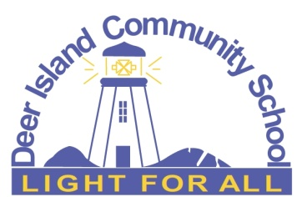

**Deer Island Community School**

**711 Route 772  
Fairhaven, NB  
E5V 1T1**

**Phone : (506) 747-7003**

ear parents/guardians:

On Wednesday, February 28th, the students, and staff of DICS will be heading to Blacks Harbour for a skating field trip. The bus will be picking up students at the regular time, go to the school for morning Pink Shirt Activities and then proceed to the ferry landing to catch the 10:00am ferry. Skating will be from 11am-12:30pm, followed by a pre-ordered Subway lunch on site. We will be catching the 1:30pm ferry back to Deer Island and students will be dropped off at their homes starting at around 2pm.

Students will need both a helmet (bike helmet is fine) and a pair of skates. If your child does not have skates, we may be able to find some for them if we know ahead of time. Please fill out the bottom portion of this letter and return it to the school as soon as possible.

I, ______________________________, give my son/daughter __________________________________, permission to attend the field trip to Blacks Harbour Arena on Wednesday, February 28th, 2024.

_______________________

Parent/guardian signature

My child needs a pair of skates ______ yes _______ size

______ No