**NOVEMBER NEWSLETTER**

Editors: Brooke G, Rachel C, Erin I. **Junior Editors: Alicia N, Ariana M.**

School Events

* No School Remembrance Day Nov.11th.
* Choir after school every Tuesday from 3:00-4:00pm.
* Remembrance Assembly Nov.8th at 10:30
* Craft fair Nov.9th.
* Grade 6 English classes go to the Huntsman Marine on the13th and 6N goes on the 14th.
* Report cards 25th
* No school the 29th
* Carer Fair Nov.7th

November Birthdays

Nov.1 Matei Dudau

5th Maddison Chase

5th Makayla Chase

5th Mariah McFarlane

5th Emily Hill

6th Taylor Young

7th Kiki Salazar

8th Tonya Lord

10th Kiera Small

11th Emma Spear

12th Colby McLeese

14th Caleb Dwyer

15th Dakota Earle

15th Grant Mason

19th Ainsley Ramsdell

19th Avery Ramsdell

21st Rebecca Travis

21st Joel O’Donnell

22nd Heidi Hubbard

25th Aurora Manuel

26th Kenton Boddy

28th Jonathan Negus

Coloring Contest

This month we will be having a Remembrance Day coloring contest. Please put your name And grade on the back of the paper so we can judge fairly. Sheets will be due Nov.15th. Please do not send them to the office. People will be around to collect.

**Give me 5**

* **Be Respectful**
* **Be Resposible**
* **Be there be ready**
* **Follow directions**
* **Keep hands and feet to self**

[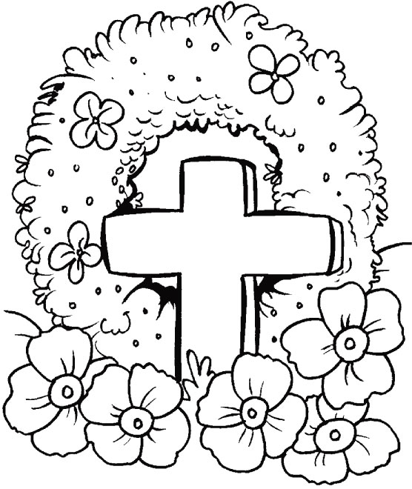](http://www.google.ca/url?sa=i&rct=j&q=&esrc=s&frm=1&source=images&cd=&cad=rja&docid=hqGrY0bl5iWMAM&tbnid=bY5NK-bafNG7rM:&ved=0CAUQjRw&url=http://www.bestcoloringpages.com/floral-tributes-for-you,-you-are-always-in-my-heart-coloring-pages_1d1332.html&ei=6zhMUsODKeyuyAG_goDQDg&bvm=bv.53371865,d.aWc&psig=AFQjCNFpuBlkatMQaDrGJhoSbOcVg1iQKA&ust=1380813312696824)

**Riddles**

Q: I have an eye but cannot see.  
I'm faster than any man alive and have no limbs.  
What am I?

A: A tornado!

Q: A boy fell off a 100 foot ladder. But he did not get hurt. Why not?

A: He fell off the bottom step.

Q: The first man is the master of priceless gems;   
The second man is the master of love;  
The third man is the master of shovels;  
The fourth man is the master of big sticks;  
Who are they?

A: They're the Kings in a deck of cards.

**FUN FACTS**

* There are over 400 types of sharks -- at least 30 of these species have been known to attack humans.
* Did you know that sharks bite first with their lower jaw first then there upper jaw.
* A shark can grow and go through 20 000 teeth in its life.
* Did you know that there are over 4000 types of mammals?
* Apple is 25% air that is why it floats on water.
* Cabbage has 91% water.
* *The first diesel engine ran on peanut oil.*
* Women blink nearly twice as much as men.
* The average person falls asleep in seven minutes.+

Jokes

Q: What is the center of gravity?  
A: The letter V!

Q: Does your shirt have holes in it?  
A: No, then how did you put it on?

Q: Why do dragons sleep during the day?  
A: So they can fight knights!

Q: Why did the man run around his bed?  
A: To catch up on his sleep!

Q: What kind of car does Mickey Mouse's wife drive?  
A: A minnie van!

Q: What's the difference between a TV and a newspaper?  
A: Ever tried swatting a fly with a TV?

**November Newsletter Page 2**

L’automne! Par :Chenny Nam

Dans notre école, élémentaire de saint George nous sommes passées un l’automne occupé comme un écureuil jusqu'à maintenant! L’automne est toujours une saison occupée. Dans l’automne, il y a plus de chose que tu peux faire que tu imagines! L’automne est une saison parfaite de jouer les sports comme ballon-panier, soccer, sauter dans la pile de feuilles, équitations ou marcher dans le parc! Aussi il y a les fêtes spéciales comme l’action de grâce, jour de souvenir et l’halloween. C’est toujours amusant d’avoir les fêtes spéciales! Mais pas seulement d’avoir divertissement, le jour de souvenir et l’action de grâce sont les fêtes importantes de remercier les nourritures qu’on à récolter ou qu’on a et les soldats qui sont battre pour notre pays durant la guerre. Je crois que l’halloween est les fêtes la plus agréable pour les enfants car tu peux déguiser dans les costumes effrayant, faire de truc ou traite et réussir les bonbons délicieux. Cette année, l’halloween est jeudi 31 octobre. Dans l’halloween, l’enfant faire du “truc ou trait.” C’est quoi truc ou traite? Truc ou traite est un costumier célébration pour les enfants. Les enfants déguisent dans le costume effrayant et cogne la porte, ensuite ils disent “truc ou traite” et les personnes qui sont dans la maison doivent donner les bonbons. J'espère que tu passes un l’automne excellent !