[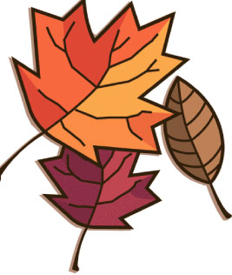](http://www.google.ca/url?sa=i&rct=j&q=&esrc=s&frm=1&source=images&cd=&cad=rja&docid=rKORzC_ErTG-mM&tbnid=SRYm2r6dDIvc2M:&ved=0CAUQjRw&url=http://bestclipartblog.com/30-fall-clip-art.html&ei=AwJDUuGZDoGDrAGWqYGgBA&bvm=bv.53077864,d.b2I&psig=AFQjCNG37n4zZEX6McJdNq-nkOjZorDDSg&ust=1380209508025550)

**OCTOBER NEWSLETTER**

Editors: Rachel C, Brooke G and Erin I.

**Give Me 5**

Happy Birthday To:

Oct.1st Joshua Kinney

3rd Eli Williams

4th Emilia Ingalls

6th Allie Maxwell

7th Spencer Graham

9th Simon MacKinnon

12th Benjamin Gaudet

13th Breann Ainsworth

14th Paras Mawhinney

15th Sarah Domres

15th Makenzie Domres

17th Paige Hawkins

17th Lucas Chapman

17th Trinity porter

18th Kyle Schwarze

18th Marcus Kernighan

22nd Janessa Clark

25th Edward Bratz

26th Emily Doherty

27th Cathleen Bagley

30th Rory McKiel

30th Autum Holland

30th Brett Frost

School Events

* Walking school bus ends Oct.4th.
* Choir starts Oct.15th
* No school October 10th and 11th.

Be Respectful

Be Responsible

Be There Be Ready

Follow Directions

Keep hands and feet to self

[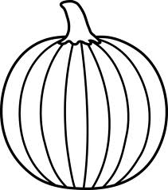](http://www.google.ca/imgres?um=1&safe=active&sa=N&biw=819&bih=521&hl=en&tbm=isch&tbnid=d6Hs6MsvLqh_zM:&imgrefurl=http://sweetclipart.com/black-and-white-pumpkin-lineart-465&docid=flS7xQt_XMyTIM&imgurl=http://sweetclipart.com/multisite/sweetclipart/files/imagecache/middle/holidays_halloween_or_food_pumpkin_lineart.png&w=487&h=550&ei=HwFDUs7xFamg2gXagYHwAg&zoom=1&ved=1t:3588,r:36,s:0,i:195&iact=rc&page=4&tbnh=190&tbnw=168&start=32&ndsp=12&tx=68.80000305175781&ty=110.60000610351562)

HALLOWEEN SAFETY TIPS

1. Look both ways before crossing the street.

2. Wear bright colours.

3. Carry a flashlight with you at all times.

4. Only trick or treat at people’s houses that you know who live there.

5. Don’t eat homemade treats made from strangers.

S.G.E.S Choir

If you are interested in joining choir this year please go see Mrs. Hill for a permission slip. Practices start the Oct.15th on every **Tuesday** from 3:00-4:00

[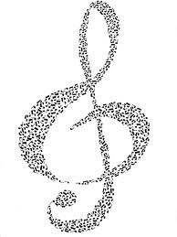](http://www.google.ca/imgres?safe=active&hl=en&biw=837&bih=537&tbm=isch&tbnid=2my8L08gpyKPQM:&imgrefurl=http://wallpapers.windowsace.com/music-notes-creates-the-by-myprinces08-on-deviantart/deviantart.com*download*114464869*Music_Notes_creates_the_Music__by_MyPrinces08.jpg/&docid=a9LRJ0c5ZGOYrM&imgurl=http://wallpapers.windowsace.com/pics/m/u/music-notes-creates-the-by-myprinces08-on-deviantart-n-a-ibackgroundz.com.jpg&w=2460&h=3280&ei=wf46UobAMqmMyQGtzYDYAw&zoom=1&ved=1t:3588,r:22,s:0,i:153&iact=rc&page=3&tbnh=205&tbnw=154&start=17&ndsp=11&tx=97&ty=89)

**October Newsletter Page 2**

Riddles

Q: What can you catch but not throw?  
A: A cold.

Q: What is at the end of a rainbow?  
A: The letter W!

Q: What kind of tree can you carry in your hand?  
A: A palm

Q: How do you make the number one disappear?  
A: Add the letter G and it’s “GONE”

Q: We see it once in a year, twice in a week, and never in a day. What is it?  
A: The letter “E

Q: Mary’s father has 5 daughters – Nana, Nene, Nini, Nono. What is the fifth daughters name?  
A: If you answered Nunu, you are wrong. It’s Mary!

Q: What does a cat have that no other animal has? A:Kittens.

Fun Facts

* Babies yawn before they are born.
* If you fell into a black hole, you'd stretch out like spaghetti.
* The Bahamas once had an undersea post office.
* Monkeys can go bald in old age, just like humans can.
* The Empire State building was built with ten million bricks!
* First novel ever written on a typewriter was Tom Sawyer.
* There are more chickens than people in the world.

Jokes

**Q. How do you make seven an even number?**

**A. Take the s out!**

**Q: How do you make a fruit punch?**

**A: Give it boxing lessons.**

**Why is a horse like a wedding ?**

**Because they both need a groom!**

**Q: What did the math book say to the other math book? A: Boy do I have problems.**

**Q: Why did the egg go to the doctors?**

**A: Because he had a cracking headache.**

**HAPPY HALLOWEEN**

**Happy HALLOWEEN!!**