All Aboard!!!!!!!!!!!

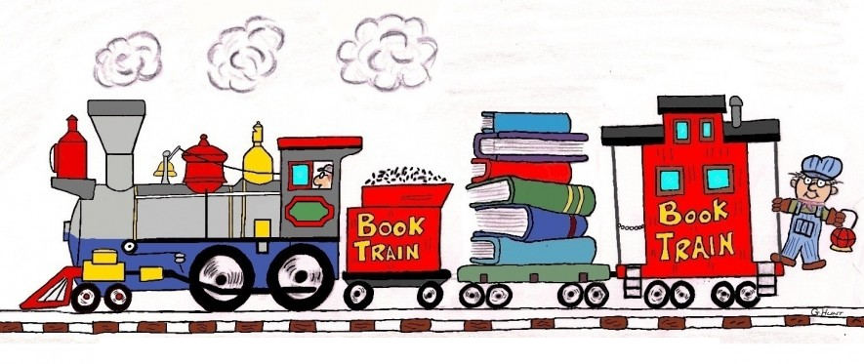

On Monday, January 28, 2013, the elementary wing of Campobello Island Consolidated School hosted Family Literacy Night. Families were asked to come at 6:20 to board the Viking Express that would leave the station at 6:30. Each participant was given a boarding pass and the conductor checked the pass for each stop. Excitement built as students anticipated the evening as the stops were a surprise. There were 4 exciting stops along the trip: Wild West, Tropical Paradise, Slumberland and Undercover. Each stop lasted 15 minutes and included various literacy activities. In the Wild West they learned a square dance and created Wanted posters. In Slumberland, families listened to a N.B. author talk about the writing process and then chose a favorite book to enjoy together.

In Undercover, families went to spy training by going through a lazer walk, making ID cards, decoding secret messages and searching through I Spy books. Tropical Paradise included the students writing their names in a Hawaiian language and learned to hula dance.

Literacy Night 2013 was a tremendous success! Students, siblings, parents and even some grandparents attended the fun-filled evening!

