**October**

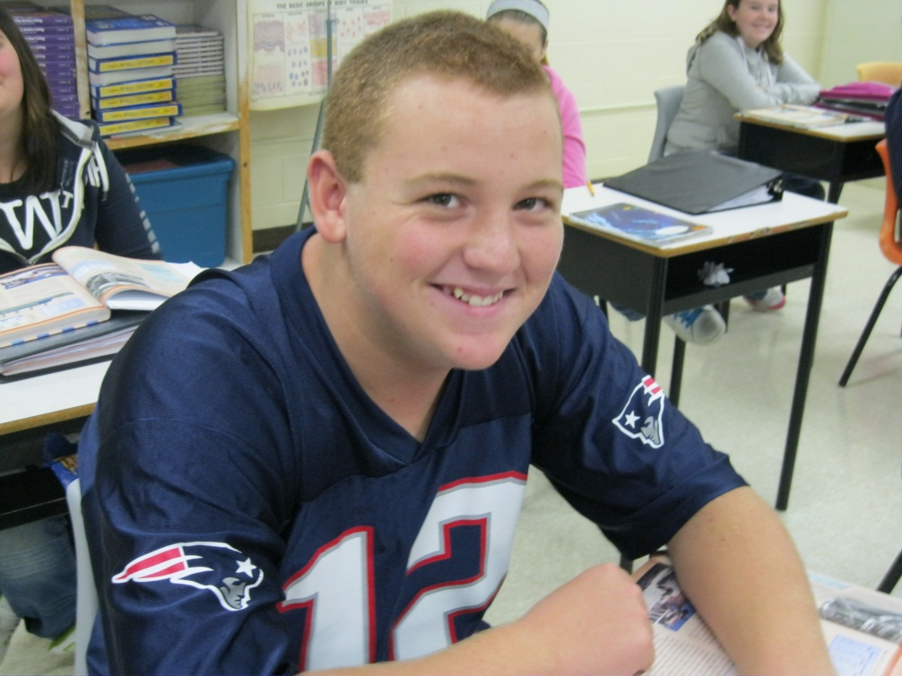

**Jamie Mitchell**

* **Jamie knows what he wants to do after school. Jamie is a realistic person and sets realistic goals for his life.**
* **Jamie is trying his best in school – I think his lowest mark is an 80%.**
* **His marks really show his motivation and his dedication. Jamie is determined to do well in school.**
* **Not only has Jamie been responsible with his own school work, he is always willing to help his friends with their work. Jamie works in a group at a table in study hall, and if one person doesn’t understand, they work together until everyone gets it.**
* **Jamie has been passing in all of his assignments on time, and is hoping to be on the Honour Roll.**
* **Jamie is kind to others – he doesn’t bother others, and is good at getting people to laugh.**
* **Jamie is an awesome student, and an outgoing guy. Keep up the good work, Jamie!**

**Baylee Stanley**

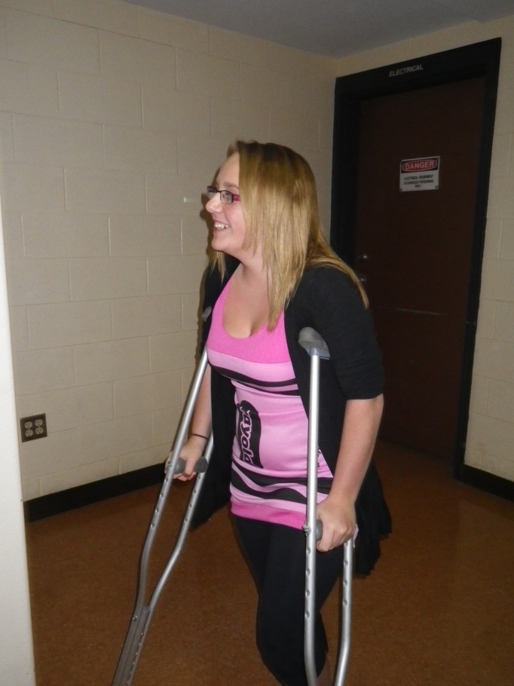

* Baylee struggled with school growing up, but since she got to high school, she’s been working extra hard. She’s been passing ever since, and when she needs help, she asks the teacher. She makes a good role model for the students coming to high school.
* Baylee has a great attitude! She stays positive with her friends and teachers, and makes a good impression on them. She has worked hard to get where she is, and it really shows.
* Baylee has made quite the improvement, and makes us all proud.

**Micaela Matthews**

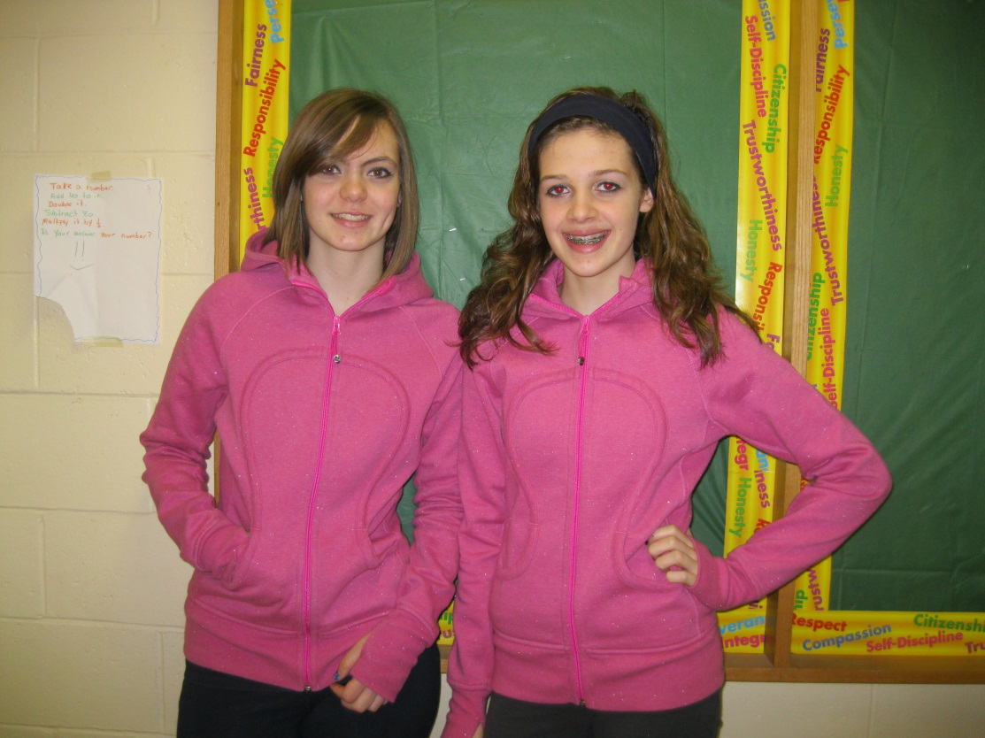

* Micaela is a respectful and responsible student. She is always nice and kind-hearted towards others.
* If there was something wrong, Micaela would go out of her way to try and make it better.
* Micaela is very involved in school – not only extra-curricular, but other things as well. She always finds a way to help out.
* Micaela always gets done whatever she is asked to do, whether it is at school or at her house.
* I think she is an excellent student, and I am proud to have her in my class.