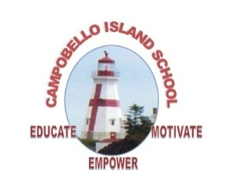**Campobello Island Consolidated School**

**2014-2015 SCHOOL CALENDAR**

**2014**

**August** **25** Administration Day for Staff

**26-27** Council Days

**28** Administration Day for Staff

**September** **1** Labour Day – No Classes

**2** First day of classes

**October** **1** Early Dismissal – 12:00

**9-10** Professional Learning Days for Staff – No Classes

**13** Thanksgiving Day – No Classes

**November** **5** Early Dismissal – 12:00

**11** Remembrance Day – No Classes

**14** Parent Teacher Student Conferences K-12 – No Classes

**December 3** Early Dismissal – 12:00

**19** Last Day of First Term – full day

**2015**

**January**  **5** Professional Learning Day for Staff – No Classes

**6** First Day for Students

**19-23** High School Exam Week (Grades 9-12)

**21** Early Dismissal – 12:00 (K-8)

**26-27** Turnaround Days (Grades 9-12 Only – No Classes)

**28** Start of Second Semester

**February 13** Professional Learning Day for Staff – No Classes

**18** Early Dismissal – 12:00

**March**  **2-6** March Break – No Classes

**27** Grades K-12 Parent Teacher Student Conferences – No Classes

**April** **3** Good Friday – No Classes

**6** Easter Monday – No Classes

**May**  **1** Provincial Council Day – No Classes

**4** St. Stephen Education Centre only – NBTA Meeting - No Classes

**18** Victoria Day – No Classes

**June**  **3** Early Dismissal 12:00

**8-12** High School Exam Week (Grades 9-12)

**19** Last Day for Students

**22-23** Administration Days for Staff