 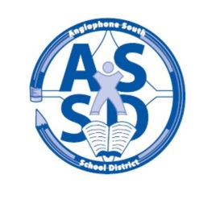

**CAMPOBELLO ISLAND CONSOLIDATED SCHOOL**

**2017-18 SCHOOL CALENDAR**

**September** **4** Labour Day – No Classes

**5** First day of classes for all students

20 Early Dismissal 11:30 (Professional Learning for staff)

**October 9** Thanksgiving Day – No Classes

**25** Early Dismissal 11:30 (Professional Learning for staff)

**November** **8** No Classes for K- 8 students (Professional Learning and Report Card Preparation)

Early Dismissal for 9 – 12 11:30 (Professional Learning for staff in afternoon)

**13** Remembrance Day – No Classes

**24** Grades K-12 Parent Teacher Student Conferences – No Classes

**December**  **6** Early Dismissal 11:30 (Professional Learning for staff)

**22** Last Day of First Term – dismissal at 12:00

**January**  **8** First Day for Students

**2018** **17** Early Dismissal 11:30 (Professional Learning for staff)

**22-26** High School Exam Week (Grades 9-12)

**29-30** Turnaround Days (Grades 9-12 only – No Classes)

**31** Start of Second Semester

**February** **19** Family Day – No Classes

**March**  **5-9** March Break – No Classes

**14** No Classes for K- 8 students (Professional Learning and Report Card Preparation)

Early Dismissal for Grades 9 – 12 (Professional Learning for staff in afternoon)

**29** Grades K-12 Parent Teacher Student Conferences – No Classes

**30** Good Friday – No Classes

**April** **2** Easter Monday – No Classes

**25** Early Dismissal 11:30 (Professional Learning for staff)

**May**  **4** Provincial Council Day – No Classes

**7** Branch NBTA/AEFNB Meetings – No Classes

**21** Victoria Day – No Classes

**June**  **11-15** High School Exam Week (Grades 9-12)

**22** Last Day for Students