**Pink Shirt Day (February 28th) is fast approaching. This year, the New Brunswick Red Cross will be producing T-Shirts to mark the day. All Shirts cost $8 which includes taxes, shipping and handling**.

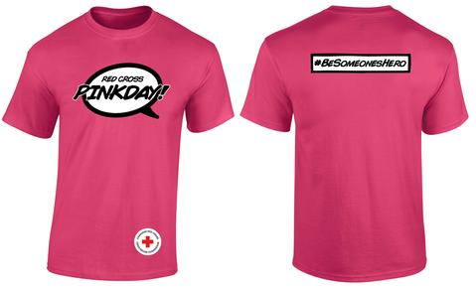

**Youth sizes Check out this page:** [**https://www.redcrosspinkday.com/**](https://www.redcrosspinkday.com/) **for details on the campaign and t-shirt sizes**

|  |  |  |  |  |  |
| --- | --- | --- | --- | --- | --- |
| **Size Youth** | XS | S | M | L | XL |
| **Quantity** |  |  |  |  |  |

**Adult sizes**

|  |  |  |  |  |  |  |  |  |
| --- | --- | --- | --- | --- | --- | --- | --- | --- |
| **Size Adult** | S | M | L | XL | 2XL | 3XL | 4XL | 5XL |
| **Quantity** |  |  |  |  |  |  |  |  |

**If you would like to order a t-shirt, please return this form with cash payment (correct change)by Friday Feb 2nd and shirts will be ordered and arrive before February 28. This purchase is voluntary.**