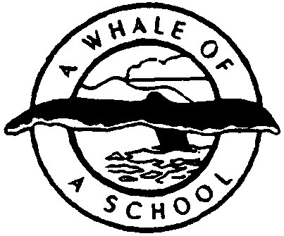
Vincent Massey Elementary School
Share, Grow, Succeed
166 Frederick Street, St. Andrews, NB E5B 1Z7
Tel: (506) 529-5011 Fax: (506) 529-5099

________________________________________________________________

Feb. 23, 2023

Dear Parents/Guardians,

VMES is pleased to offer a student leadership program that allows students to earn recognition for reaching their goals. Students are invited to participate in activities, demonstrate leadership and model good citizenship at school and in our community.

The VMES Leadership Program allows all students to have the opportunity to be recognized at 3 different levels- Bronze, Silver and Gold. Students will receive a VMES Leadership pendant necklace and certificate when they reach the Bronze, Silver or Gold Level. You will notice that there is space in all categories to write in other activities not listed. Please note: Students can earn the award from participating in events solely at school as all students will be offered activities throughout the school year. Activities can only be used once and must have taken place this school year. Students can apply anytime throughout the school year. Students have as many years as they attend VMES to complete the entire program.

This program is modeled after the Duke of Edinburgh National Awards Program which promotes community and school leadership. Research shows that children who are connected to their school and community experience more success in school. This program has been approved by your Parent School Support Committee and Home & School Association. Please contact me with any concerns, comments, or questions at 529-5196.

Sincerely,

Lesley O’Leary
(Principal of VMES)

