
Vincent Massey Elementary School
Share, Grow, Succeed
Partager, Grandir, Réussir
166 Frederick Street, St. Andrews, NB E5B 1Z7
Tel: (506) 529-5011 Fax: (506) 529-5099

PSSC Meeting Minutes
Monday, Jan. 23, 6:30p.m.

In attendance: Lesley, Sharon, Gerald, Gene, Matt, Mary, Suzanne, Sean, Christina and Jenny McDougall

- Call to Order & Introductions- Matt - done

- Approval of Agenda - approved

- Reports /Correspondence
- DEC Agenda (circulated via Email) – minutes posted on DEC website after approval.
- 6 copies of the 10 year education plan were provided to deliver to PSSC Members (Lesley will have the copies available at our meeting). - shared

- Business arising from the minutes -

- Sean and Gene will contact Kurt Gumushel regarding requirements for sound system, source battery- Sean got the information needed to source out the battery from Lesley. Sean shared that a battery cannot be attached to our model. Sean will look into an eliminator. March 15 deadline

- Lesley will look into finding provincial Reading results for grade 2 and 4 from past years and send link; do we need to send a request to Dept of Education for further results/recommendations?- Lesley has provided the link here;
http://www1.gnb.ca/0000/results/ASD-S/vincentmassey_assessment.asp
& copied the info. below;
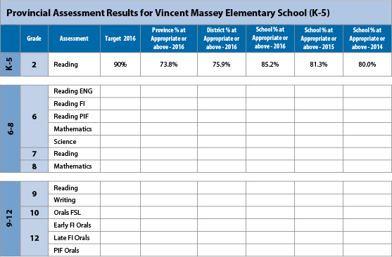
- Sharon will draft letter for Wed/Matt will contact Superintendent Zoe Watson and DEC chair Rob Fowler regarding meeting to discuss FI options at VMES- a draft was sent out to members , not sent to Ms. Watson

- Lesley will notify Jenny McDougall about our concerns regarding FI- Jenny will attend our meeting tonight. A survey to all kindergarten parents was sent home as per district protocol. Results were communicated to members via email- 7 yes,6 no, 19 undecided, 11 forms not returned.

- Lesley and Gerald will look into alternative programs for FI- Gerald sent out info. on AIM program. Some resources are available at VMES.

- Lesley will send new members the school improvement plan to review- done

- Lesley will ask district about who can do work on school website – asked but no answer received to date. Can improvements be made? Addition of tabs, sharing information, etc. Sharon is willing to work on this.

- New Business
  - French Immersion – 3 St. Andrews families have signed up for FI in St. Stephen for grade 1; there will possibly be 2 classes
-Jenny shared that there will be alternatives for schools that don’t offer FI, for example Grand Manan and Campobello, would VMES be considered for this? Jenny would advocate for this, province is aware of our desire to offer more French at VMES
-there is a commitment to providing more access to rural areas; willing to hear additional ideas, something from 2-3 pm?
-Christina asked what could be done about the 19 families who were undecided; VMES has provided many opportunities for parents to seek information in order to decide
-questions/ideas can be emailed to Jenny.McDougall@gnb.ca
-PSSC would like to know the options asap, and be part of any pilot projects
- PSSC will send an outline of our accelerated IF program wants/wishes as a pilot project; send to Minister Kenny, Zoe Watson, Chris Treadwell
  - Early Years International Baccalaureate- Sharon
    - A pilot project focused on personalized learning is coming, Lesley has expressed our interest in participating
    - IB is offered in 2 bigger high schools in NB, program is very expensive, limited numbers of students are involved
  - PSSC Budget(schools have approx.$500)
Expect to spend $160.00 on synervoice.
Suggested additional: send home magnets with emergency/snowline #’s, eliminator/battery, food, signage
  - School Website- Sharon
    - Sharon will meet with Audrey to see what improvements can be made

- Action Items-

-Lesley will find literacy/math assessment results from 2010 to today to compare results to the province
-Sean will look into an eliminator/battery for sound system, email cost to PSSC
-contact Jenny McDougall with any questions/ideas for more French at VMES
-Sharon and Gerald will write AIF pilot program outline

Agenda items for next meeting

  - School Improvement Plan
  - Tell them from me survey results from grade 4 &5 students.

- Next Meeting - Monday, February 20 @6:30

- Adjournment - 8:20 pm

