|  |
| --- |
|  |
| St. Stephen Middle School |
|  |

Adopt-A-Chair



**Thank you very much for supporting our Adopt-A-Chair campaign! Your support is very much appreciated. Any donation over $25 is eligible for an income tax receipt.**

**To make a donation online, please read the directions below and then press on the link at the end to make your donation.**

1. At the end of this document is a link tothe **School Cash Online** website. This is where all online donations are made for schools in our district. The link will take you to the home page:

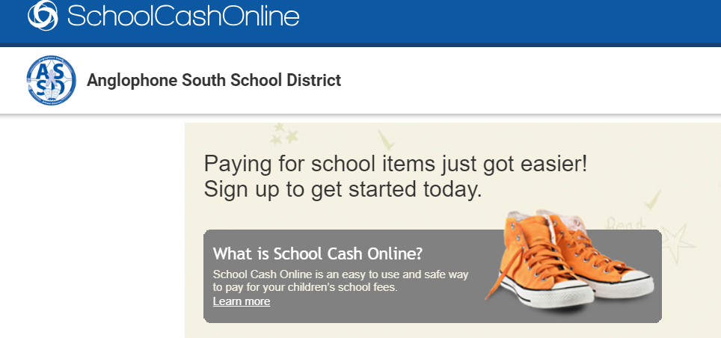

1. Click on the **REGISTER** button: (Please note there is NO financial commitment at this time. It is solely to register.)

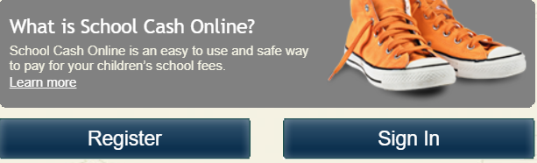

1. Follow **Steps 1 – 2 - 3** and then press continue. You will receive the following message:

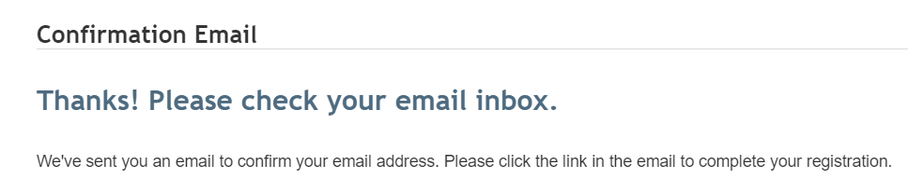

1. Once you have clicked the link in your email, you will be able to make a donation. You will be directed back to the **School Cash Online page** and will see a list of items to purchase for various schools in our school district. Please choose:



1. Select your donation amount. All donations will be put towards our Adopt-A-Chair campaign. Installment plans are available. For instance, you may choose to make a $50 donation for five months in a row to purchase a chair.

If you choose to purchase a chair there is certain information that is required. You will notice at the bottom of the donation option screen the question ***"Who are you purchasing this for?"*** Please type in the following information:

1. **What you would like to appear on the plaque.** (Please see samples below)
2. **Your full name and mailing address to receive an official tax receipt.**

**Plaque sample texts:**

**In honour of John Doe In memory of John Doe In honour of John Doe**

**From his children, From his family SSMS teacher**

**Jane and Sam 1935 – 2010 35 years service**

**Creative Business Co.**

**St. Stephen, NB**

**Please note: If you are making a donation towards a group chair purchase, Class of 1984, for instance, please note this information in this section as well.**

1. Choose submit and your donation is complete! You will receive a confirmation of your purchase/donation. Please note that the official income tax receipts are mailed from ASD-S District Office in Saint John.

**Thank you very much for your support! If you have any questions please call the school at 466-7311.**

[**PLEASE CLICK HERE**](https://asd-s.schoolcashonline.com/)

[**https://asd-s.schoolcashonline.com/**](https://asd-s.schoolcashonline.com/)