September 2016
Dear Parents and Guardians:
Anglophone South School District welcomes you and your family to the new school year. We hope everyone had a restful and enjoyable summer. Over the coming weeks, schools will be holding their Meet the Teacher and Open House sessions and at these meetings you will be hearing from your Principal once again about our initiative called, “Attendance Matters.”
This fall we will again have an awareness campaign for students and families on the importance of attending school, and being on time for class. We know that being present and on time has a positive impact on learning from K-12. It is difficult to “catch up” when time is missed, and for some children starting the day late can impact their entire day. Good school attendance helps to build habits that will last a lifetime and transfer to life beyond public school. School comes first for students!
Schools are able to track data on student attendance, and they are committed to contacting you if they see irregular attendance. Schools will have this initiative as part of their School Improvement Plan and it is supported by the District Education Council. If you require support and advice about attendance, teachers and school administrators want to help you. Schools care about each child and want them do their best and feel they belong at school. It is important for school and home to work together for the success of your child.
On the Anglophone South website (www.asd-s.nbed.nb.ca) you will find information on “Attendance Matters” and a link to a helpful brochure. As well, there is a short video prepared by the District and featuring our students. We ask that you please take a few minutes to read the brochure as it contains helpful information for all families. Each classroom K-12 also has a poster to remind students that “Attendance Matters.”
As parents and guardians, you hold the greatest influence with your children, and we are seeking your support for this important initiative, “Attendance Matters.” All the best for a great school year!
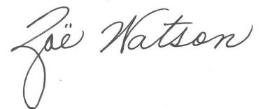
Robert Fowler, Chair Zoë Watson
District Education Council Superintendent

