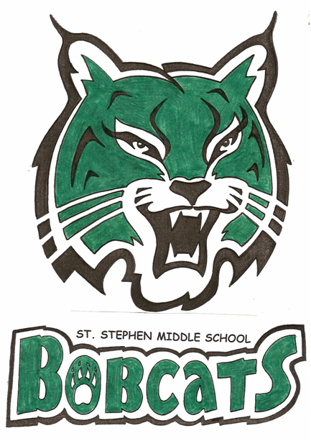
St. Stephen Middle School
11 School Street,
ST. Stephen, NB
E3L 2N4

Tel: (506) 466-7311
Fax (506) 466-7336
WEBSITE - ssms.nbed.nb.ca

A. Dunfield, Principal
C. MacDougall, Vice-Principal

ST. STEPHEN MIDDLE SCHOOL

SCHOOL REQUIREMENTS FOR 2016 – 2017
(THIS IS A BASIC LIST, SOME TEACHERS MAY ASK STUDENTS TO BRING OTHER MATERIALS)

Pens | Protractor (Gr 6)  COMPASS (GR 7) | RINGED SKETCH BOOK (ART)
4 Dry Erase markers | GLUE STICK | WHITE ERASERS
Pencil Crayons/MARKERS | 6 – 80 page NOTEBOOKS | KLEENEX
Calculator(PERCENT & SQUARE ROOT) | 8 ½” PHOTO COPY PAPER | LOOSELEAF
PENCILS | HIGHLIGHTERS | 6 DUOTANGS
- 2” BINDER (GRADE 8 ONLY) | 30 CM RULER | PENCIL CASE

REFISTRATION FEE: (CHARGED ACCORDING TO NUMBER OF STUDENTS AT SSMS)
$40.00/ 1 STUDENT, $60.00/ 2 OR MORE STUDENTS.
STUDENT FEE’S WILL BE COLLECTED ON THE FIRST DAY OF SCHOOL
SEPT 6 & 7, 2016

NOTE:
- PLEASE SEE THAT YOUR CHILD HAS HIS/HER NAME ON ALL ITEMS SUCH AS JACKETS, SWEATERS, AND FOOTWEAR
- ALL STUDENTS WILL BE REQUIRED TO HAVE A CHANGE OF FOOTWEAR, WHICH IS TO BE LEFT IN SCHOOL TO BE WORN IN THE CLASSROOM.
- EACH STUDENT IS TO HAVE A PAIR OF RUNNING SHOES, SHORTS, SWEAT PANTS, AND T-SHIRT IN A GYM BAG, FOR USE IN GYM CLASS. (THESE RUNNINGSHOES COULD ALSO SERVE AS THE CLASSROOM FOOTWEAR).

