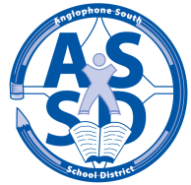
SCHOOL SUSTAINABILITY REVIEW
and
SCHEDULE OF PUBLIC CONSULTATIONS
The Anglophone South District Education Council (DEC) will host Public Consultations as per Provincial Policy 409 Multi-Year School Infrastructure Planning to study the sustainability of Lawrence Station Elementary School.
Under Policy 409, the DEC will be holding two public information sessions at the school. The initial meeting will be to deliver the proposal to the public and to allow the DEC and staff to explain the process involved in a Policy 409 review and be available to answer questions about the process.
A second meeting at the school will be scheduled in late November to allow the public an opportunity to ask questions about the proposal, voice their concerns and provide feedback to the review.
The first meeting at Lawrence Station School is scheduled for Wednesday, October 7th at 7:00 pm

Everyone is welcome to attend, and encouraged to do so. Throughout this process, written feedback can be submitted via email to: asds.schoolreview@gnb.ca or you may send a letter to the attention of Robert Fowler, Chair, District Education Council, 490 Woodward Avenue, Saint John, NB E2K 5N3.

