Student Registration Form

Anglophone South School District Summer School, St. Malachy’s High School

Grades 8, 9&10, EAL, June 29 – July 24, 2015; Grades 11&12, June 29 – July 31, 2015

To register, complete this form and return it to your school no later than
Monday, June 22, 2015

Personal Information

Student Name: ___________________________________________________________
First Middle Last

Address: _____________________________________
_____________________________________

Postal Code: _____________________________________
Telephone: Home: ______________ Emergency: ______________

Parents/Guardians: ______________________________________________

School: ___________________________________________Grade:_______

Medical Information
Please describe any medical condition and procedures to follow in case of emergency.
____________________________________________________________________________________________________________________________________________________________
______________________________________________________________________________

Course Registration
Grades 8,9,10 - $200.00 for one or two courses. Check no more than two:
English 8 (Mark during year___) Math 8 (Mark during year___)
English 9 (Mark during year___) Math 9 (Mark during year___)
English 10 (Mark during year___)
Geometry, Measurement & Finance 10 (Mark during year ___)
Number, Relations & Functions 10 (Mark during year___)

Grades 8-12 English as Another Language -$200.00 _________

Grades 11&12 - $250.00 for one course or $300.00 for two courses.
Course #1: ___________________________________ (Mark during year___)
Course # 2: __________________________________ (Mark during year___)
Alternate Course: ______________________________ (Mark during year___)
Amount Paid: Cheque: __________ Money Order:________ Cash:_________
(Please make cheques and money orders payable to READ Saint John.)
CHEQUES MUST BE CERTIFIED.

Signature of Principal or Designate:__________________________________________
Student Signature: _______________________________________________________
Parent Signature: _______________________________________________________

Please read reverse side for details.
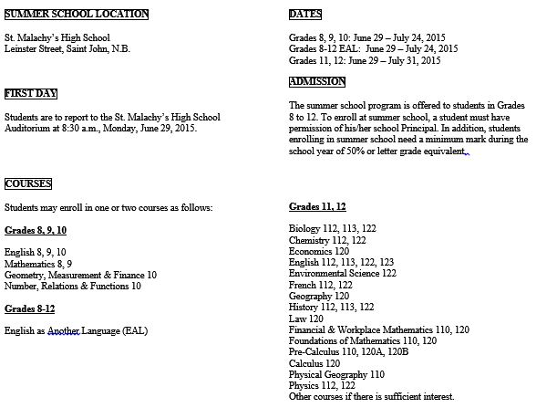

TUITION FEES

The tuition fees are as follows: EAL- $200.00, Grades 8,9 &10 - $200.00 for one or two courses; Grades 11 & 12 - $250.00 for one course or $300.00 for two courses. Payment may be made by cheque, money order or cash. Cheques and money orders are to be made payable to “READ Saint John”. CHEQUES MUST BE CERTIFIED.

DAILY SCHEDULE

The daily schedule is as follows:

Period 1: 8:30 a.m. to 10:20 a.m.
Break: 10:20 a.m. to 10:40 a.m.
Period 2: 10:40 a.m. to 12:30 p.m.

Students taking one course attend Period 1 or Period 2.
Students taking two courses attend the whole morning.

REFUNDS
A full refund of tuition fees will be issued by June 29 if:

- Summer School is cancelled due to lack of registrations.
- A student cannot be timetabled.
- The course/courses in which a student has registered cannot be offered due to lack of registrations.

WITHDRAWAL POLICY
The following shall be considered sufficient reason for requiring a student to withdraw from Summer School without refund of tuition fees:
- Aggressive, disruptive, disrespectful or other unruly behaviour.
- Not working to his/her maximum.
- Absenteeism (for emergency, sickness, or approved absence only) greater than a total of two summer school days.
- Tardiness.
- Failure to do assignments.
- Truancy.

TEXTBOOKS
Textbooks will be loaned to students for use during the Summer School. Students who lose or damage textbooks will be required to pay the replacement/repair cost before final marks are released.
ASSESSMENT

Student achievement will be assessed in a variety of ways including assignments, tests, and final exams.

