Thinking about possible Occupations or Careers?

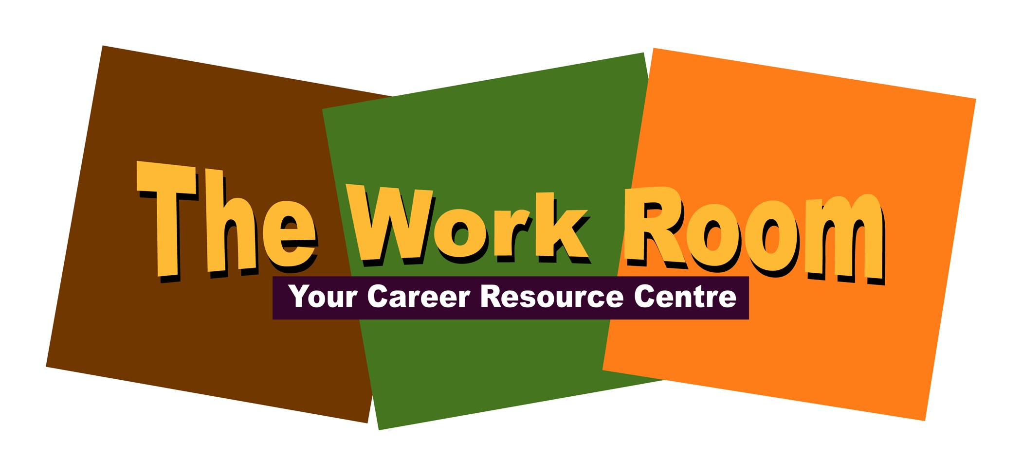

Furthering your Education?...Start Here!

Speak with representatives from a variety of Post Secondary Institutions

Post Secondary Days! OPEN HOUSE

Exhibitors from more than 50 Post Secondary

Institutions from Atlantic Canada and beyond.

**Thursday, November 5, 2015 at 5-7pm**

HMCS Brunswicker, 160 Chesley Dr. Saint John

FREE and open to all Community Members, Students & Parents

