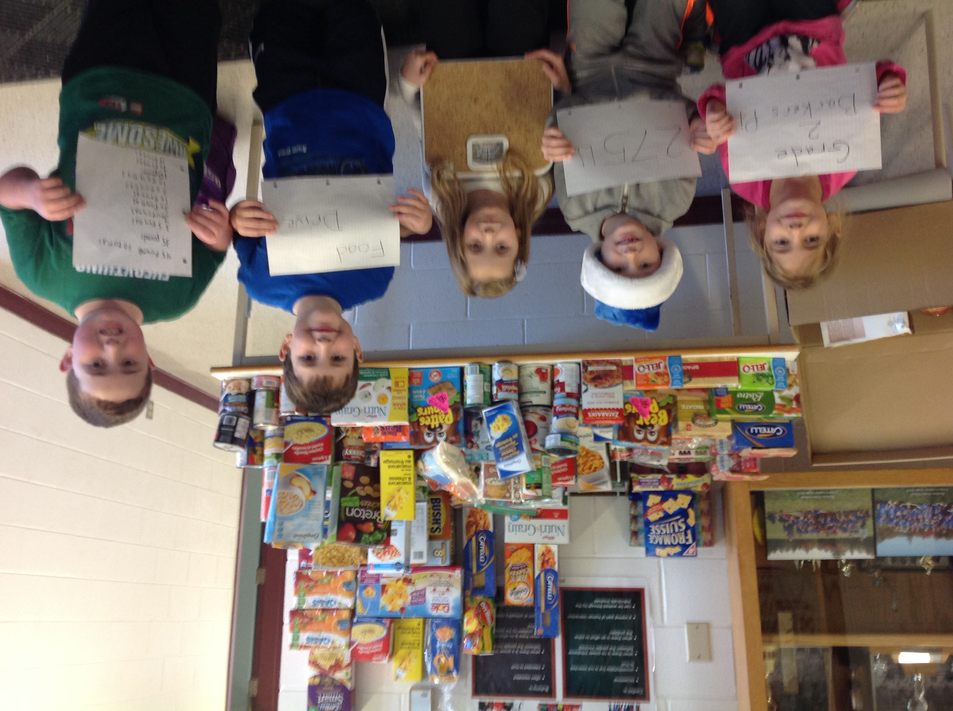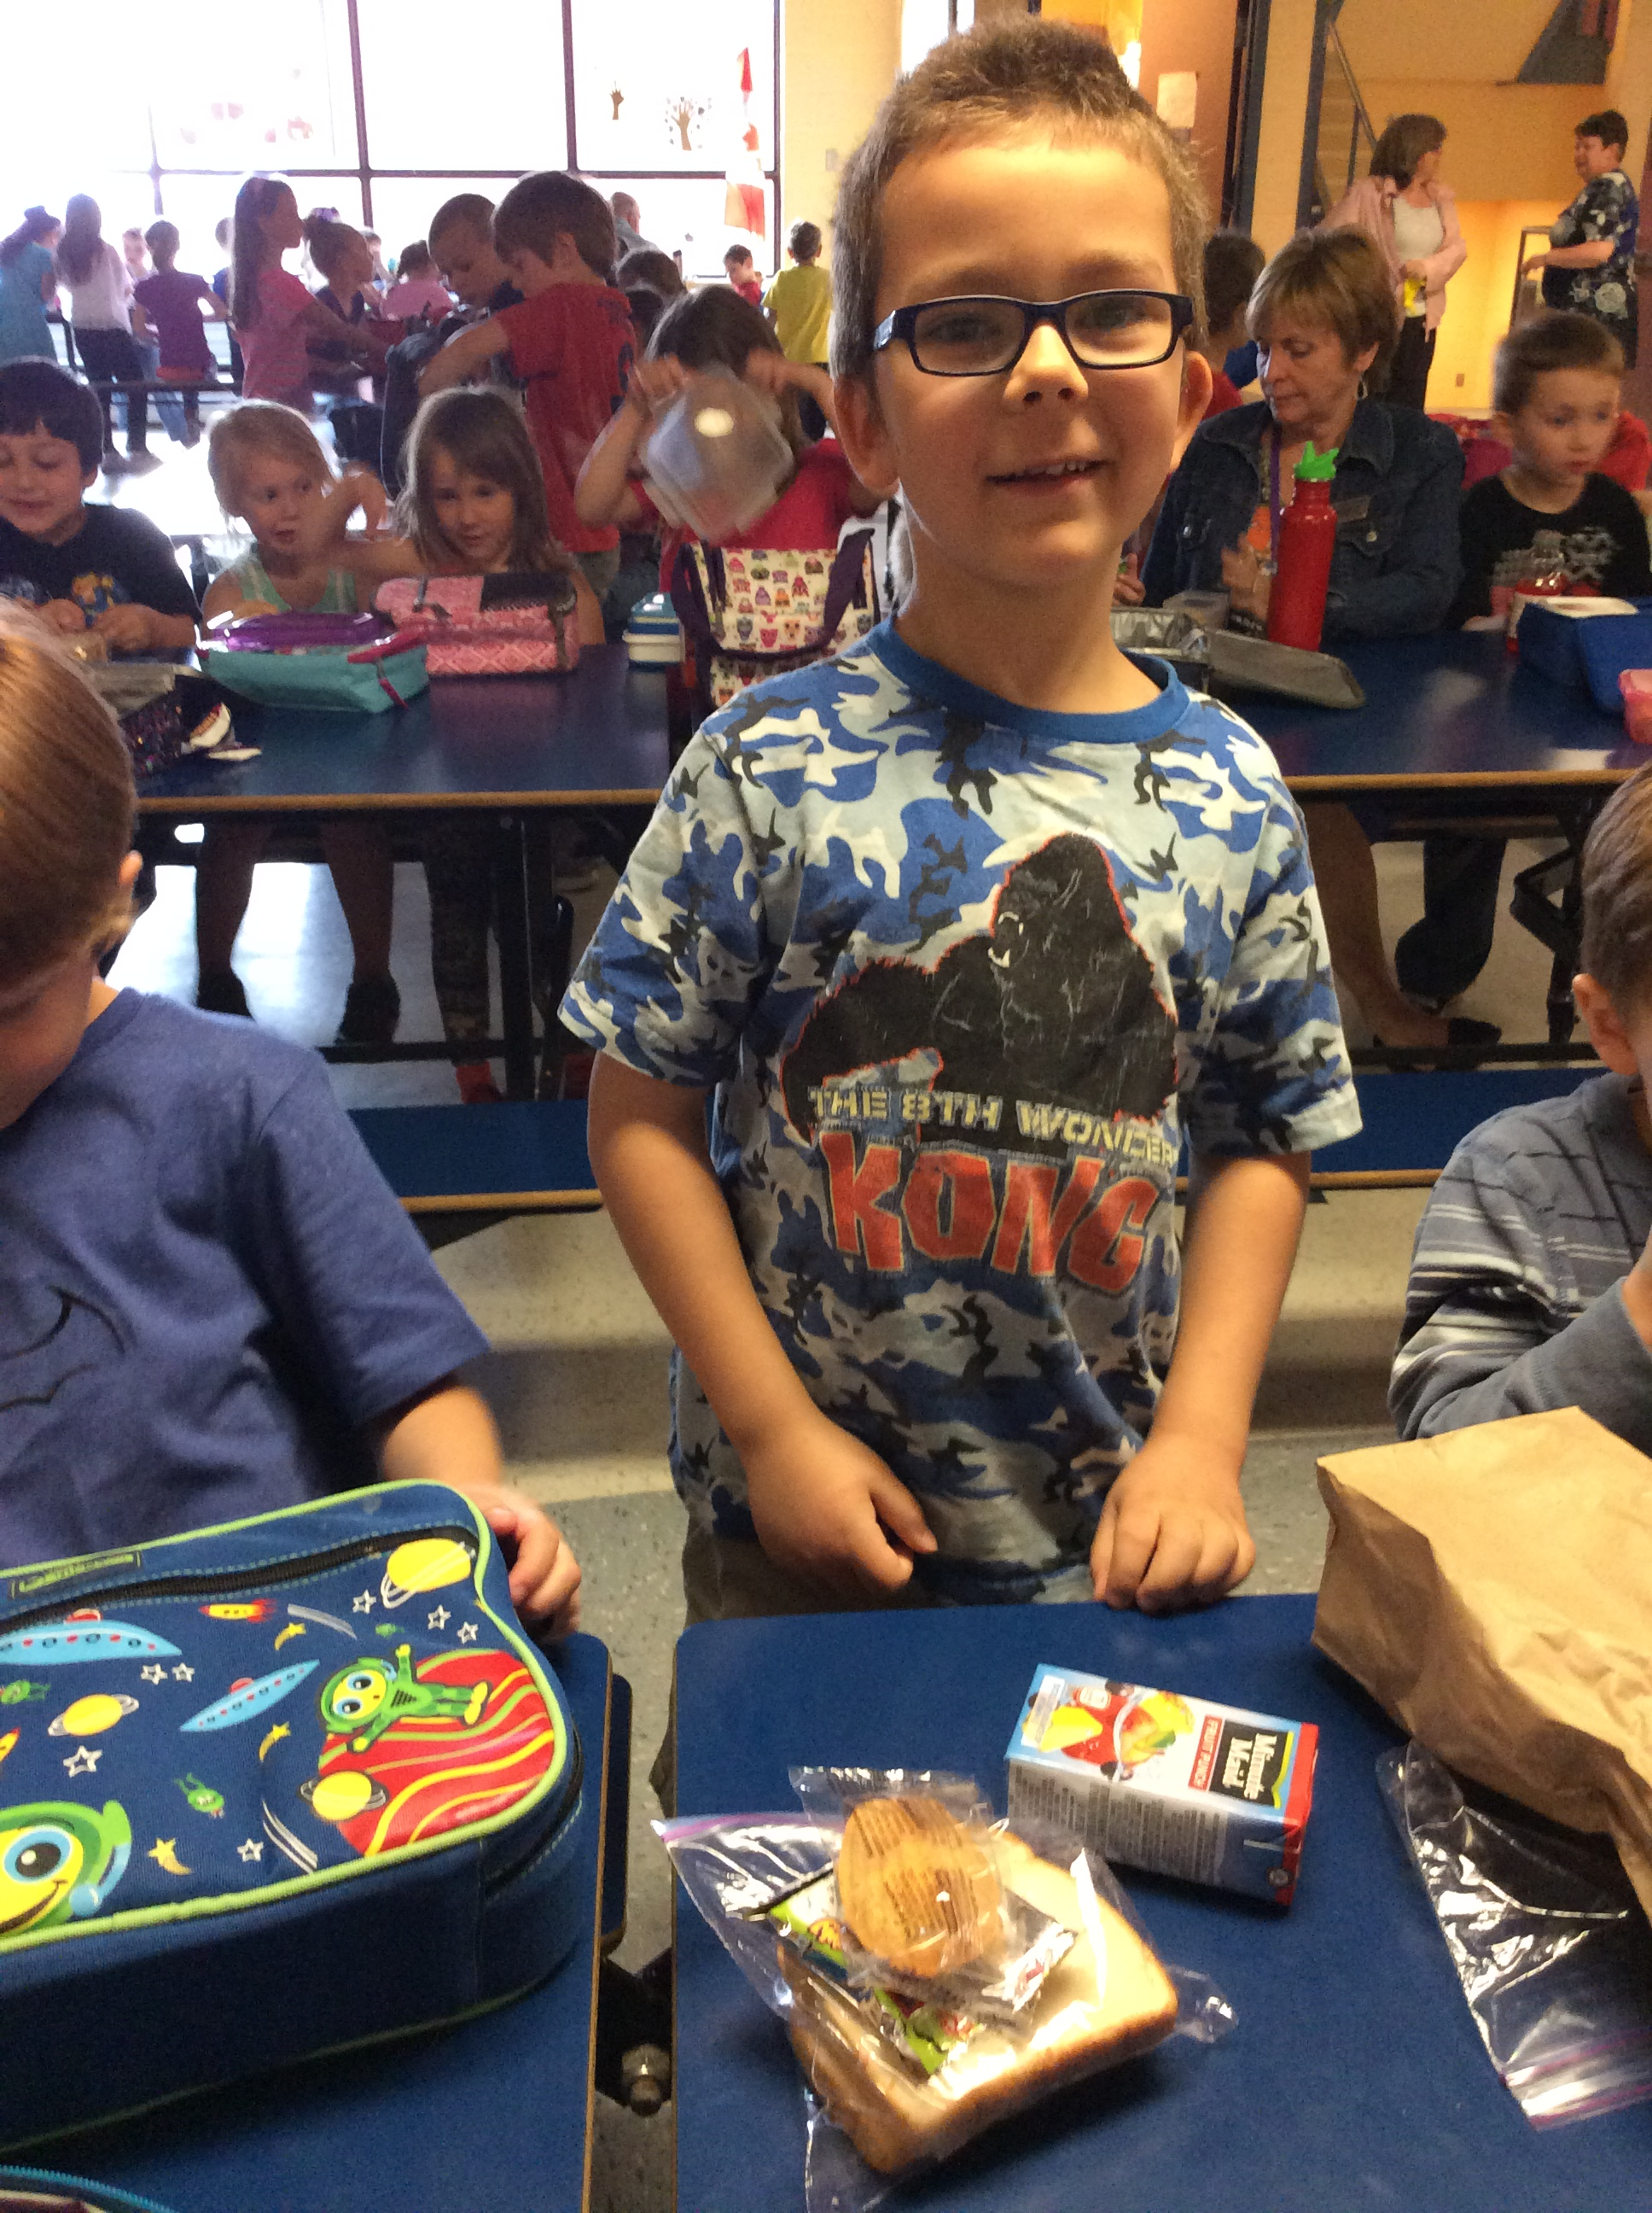

B.P.S. Breakfast Program Needs Volunteers!
Would you be willing to volunteer only two mornings per month between 7:00 A.M. and 8:10 A.M? B.P.S. needs you to help prepare and deliver healthy nutritious breakfasts for the children of B.P.S. You would work with another experienced parent. Call or email me if you have any questions or if you’d like more information.

Patrick Campbell at Guidance (453-2777, patrick.campbell@nbed.nb.ca)

B.P.S. FOOD FOR THOUGHT PROGRAMS
LUNCH:
B.P.S. is continuing its free lunch program this year! The free lunch program is for families who may not have the resources they need to send a lunch for their child every day. If you are interested please contact your child’s teacher or Patrick Campbell at Guidance (453-2777, patrick.campbell@nbed.nb.ca). We would be happy to add your child to our lunch list.

BREAKFAST PROGRAM:
We are continuing our free breakfast program this year, which will be offered to any and all B.P.S. students! The program will continue to be a grab and go style. Toast, fruit, yoghurt etc. will be handed out just inside the school after which students will return outside to eat their breakfast. A well fed child in the morning means a smarter and happier child at school! So encourage your son or daughter to get something to eat before the 8:00 bell in the morning!

Please contact Patrick Campbell, Guidance, at 453-2777 or patrick.campbell@nbed.nb.ca if you think you can volunteer your time or if you have any questions.

