Grade 4 Biography Report
Date Due: Friday, March 02
The majority of students have been provided with books for their Biography Report. I have asked and asked if anyone did not have a book. A couple of students had indicated that they would get their own Biography Book. However, on Friday when I asked, they indicated they did not have a book. I purchased a couple of Biography Books from Chapters on Saturday. I will provide students who are in need with a book.
If a student has misplaced the book I have provided he/she with they will have to locate it or find another Biography Book. I do not have any extras.
I would like for students to keep their Biography to keep their book and Biography Organizer in their Communication Bags. They will be provided with time to work on their outline/ finish their book in class. The actual project will be completed at home.
On Friday, I gave students a pamphlet to use as a Guideline regarding what they could include in their report. They do not have to answer all the questions in their project. I also presented them with a couple of options:
- A Power Point Presentation – This should include written information as well as pictures and a Timeline. Students should use the handout they were provided with as a guide to what is expected to be included.
- A poster---Students were shown what the poster should look like, how it should be laid out. Once again they should use the handout as a guide for what should be included.
- A written report Students can use the booklet they were provided with. They would need to answer the questions in complete sentences and pretty up the booklet or they produce their own written report.
- Students Choice – Students are free to come up with their ideas for presenting their information. Whatever, they select they must include the information included in the booklet and MUST include a Timeline.
All students are required to include a Timeline and to complete and pass in the Biography Information Organizer. This is to be passed in with the finished projects.
I have included a couple of options
Students will be provided with a marking rubric on Tuesday, February 20, 2018.
What is a Biography?
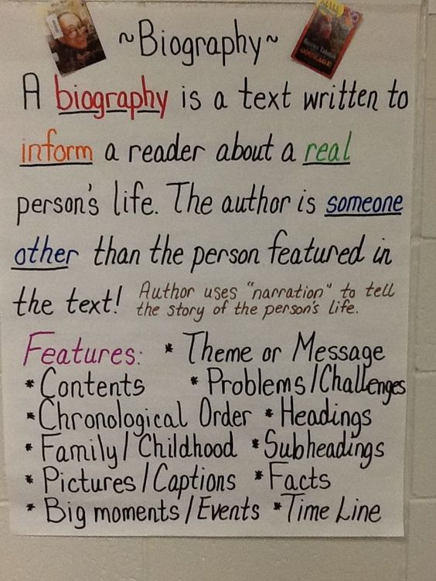

Example of Poster
ht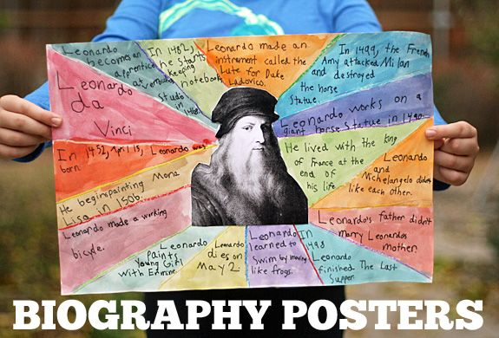tps://i.pinimg.com/564xEx