Bliss Carman Middle School  615 Kimble Drive  Fredericton, NB  E3B 0N4  Tel: (506) 453-5401  Fax: (506) 444-4301  Principal: Chantale Cloutier  Vice-Principal: Jamie Chiasson | 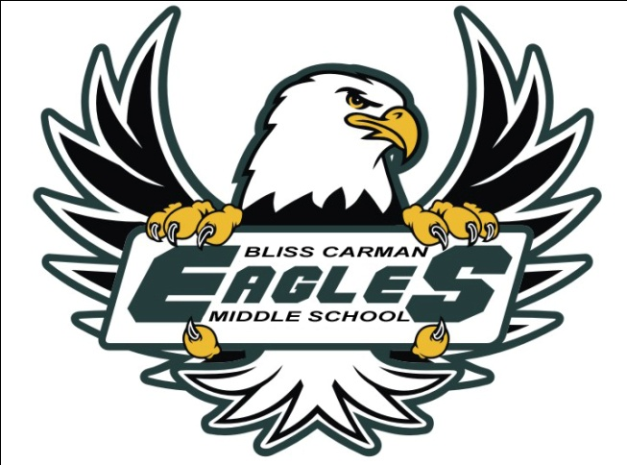
Magic Mountain “What to Pack” Checklist:

- Allergy Medication / Inhaler / Epi-pen
- Water-Resistant Sunscreen
- T-Shirt (mandatory when out of pool)
  - Sunscreen and t-shirts are essential for safety
- Footwear (mandatory when out of pool)
- Towel
- Change of Clothes
- Water Bottle (labelled with student name)
- Bagged Lunch
  - Canteens tend to be expensive
  - There are no microwaves

*Students are not permitted to bring water toys or floatables. They are also responsible for any devices that they choose to bring. There are lockers available at Magic Mountain ($10 – with $5 refund when lock is returned or $2 – $2 will need to be paid each time you want to relock the locker). Putting their name on everything will make it easier for them to find their possessions at the end of the day, especially if they don’t plan to use a locker.

* Magic Mountain has strict height and weight restrictions for slides. Please check the website for details.

If you have any questions, please contact Mrs. Lingley
natasha.lingley@nbed.nb.ca / 453-5401

Sincerely,

Mrs. Lingley Mme. Stewart-Munn Mrs. Merasty

