Bliss Carman Middle School
615 Kimble Drive  Fredericton, NB  E3B 0N4  Tel: (506) 453-5401  Fax: (506) 444-4301  Principal: Chantale Cloutier  Vice-Principal: Jamie Chiasson | 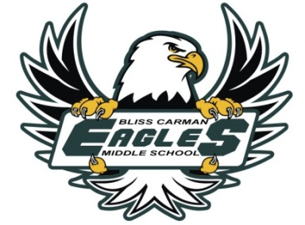
April 1, 2019
Dear Parents / Guardians,
Today your child has received his/her second report card of the 2018-2019 academic year. We encourage you to examine this report and to discuss the results with your son or daughter.
Parent/teacher interviews will be held Thursday evening, April 4th, from 4:30 to 7:20 and then again on Friday morning, April 5th, from 8:30 to 11:50. Appointment times will be a maximum of 10 minutes long. Please use the directions in the following textbox to reserve your appointment time.
Doodle Directions
- To schedule an interview, go to https://tinyurl.com/bcms72019
- Click arrow to show all available time slots.
- Enter your student’s name and your email address in the box “Enter Your Name”.
- Select and click on your preferred time slot (note that each time can only be selected by one individual – if the time is taken already it will be “grayed” out).
- Click green “Save” button.
- There is no confirmation message but we will use the email you have entered to send you a confirmation email within 24 hours.

If you are unable to meet with us during these times, and would like to arrange a phone interview, please contact your child’s homeroom teacher to set up an alternate mutually convenient time.
Thank you for your continued support.
Sincerely,
The BCMS Grade 7 English Prime Team (7A, 7B, 7C, 7D)

Mrs. Merasty (7A) Annette Stehouwer (7B) Ms Richard (7C) Julie Robinson

celeste.merasty@nbed.nb.ca annette.stehouwer@nbed.nb.ca jennifer.richard@nbed.nb.ca julie.robinson@nbed.nb.ca

