CNBA Spring Clothing Order 2017
Name __________________________________ Grade______ Contact # _______________________
ITEM | DETAILS OF ORDER  - Please indicate the quantity in the first space & size(s)in the second | TOTAL COST FOR ITEM (S)
Moisture Wicking  T-shirt  - Sizes XS – 3XL  - $20 each | ___ black → size(s) ________________________  ___ charcoal → size(s) ________________________  ___ Royal blue → size(s) ________________________  ___ yellow → size(s) ________________________
Tank Top  Ladies  - Sizes S – XL  - $20 each | ___ black → size(s) ________________________  ___ white → size(s) ________________________  ___ baby blue → size(s) ________________________  ___ soft pink → size(s) ________________________
Tank Top  Unisex  - Sizes S – 3XL  - $20 each | ___ black → size(s) ________________________  ___ white → size(s) ________________________  ___ royal blue → size(s) ________________________  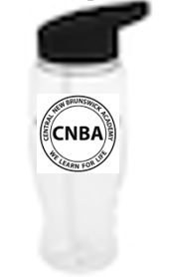  ___ red → size(s) ________________________
Moisture Wicking  9” Shorts  - Sizes XS – 2XL  - $22 each | ___ black → size(s) ________________________  ___ navy blue → size(s) ________________________
Hoodie  - Sizes S – 2XL  - $40 each | ___ black → size(s) ________________________  ___ charcoal → size(s) ________________________  ___ royal blue → size(s) ________________________  ___ red → size(s) ________________________
Sweatpants  - Open bottom  - Sizes S – 3XL  - $40 each | ___ black → size(s) ________________________  ___ charcoal → size(s) ________________________
Water bottle  - 27 oz  - $10 each  - logo is circle | ___ bottles  If you are purchasing through a middle school volleyball boy, indicate their name here:  ___________________________________________
Total Money Due
(please include exact change/ No cheques please)
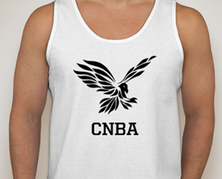
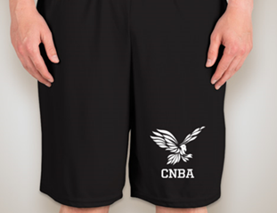
All orders & money
due by
May 19, 2017

